Competitive and Sustainable Growth (GROWTH) Programme

SAMARIS
Sustainable and Advanced MAterials for Road InfraStructure
Management report

01.01.2003-30.06.2003

Document number: | SAM-MG-MR01 | Date: | 31.8.2003

TABLE OF CONTENTS
 | Name and signature | Date
Drafted: | Management Committee members | 1 July – 29 August 2003
Reviewed: | (signature)  Jørgen Christensen | 31 August 2003
Verified: | n.a.
Validated: | n.a.
Approved by SAMARIS Management Group: |  | (signature)  Jørgen Christensen
1. PAVEMENTS 3
1.1 Overview for WP 2 – Review, development of pavement programme 3
1.1.1 Summary of the objective 3
1.1.2 Overview of the work done and comparison with planned activities 3
1.1.3 Planned activity for the next period 4
1.2 Technical overview for WP 3 – Assessment of alternative materials 4
1.2.1 Summary of objectives for the period 4
1.2.2 Overview of technical progress 4
1.2.3 Comparison of planned activities and work actually completed 5
1.2.4 Planned activities for the next period 6
1.3 Technical overview for WP 4 – Safety and environmental concerns in Material Specifications 6
1.3.1 Summary of objectives for the period 6
1.3.2 Overview of technical progress 7
1.3.3 Comparison of planned activities and actual work accomplished 7
1.3.4 Planned activities for the next period 7
1.4 Technical overview for WP 5 – Performance based specifications 8
1.4.1 Summary of objectives for the reported period 8
1.4.2 Overview of results achieved in the period 8
1.4.3 Comparison of planned activities and actual work accomplished 9
1.4.4 Planned activities for the next period 9
1.5 Technical overview for WP 6 – Techniques for recycling 9
1.5.1 Summary of objectives 9
1.5.2 Overview of results achieved in the period 10
1.5.3 Comparison of planned activities and actual work accomplished 10
1.5.4 Planned activities for the next period 10
2. STRUCTURES 11
2.1 Technical overview for WP 12 – Strategies for rehabilitation 11
2.1.1 Summary of objectives for the period 11
2.1.2 Overview of technical progress 11
2.1.3 Comparison of planned activities and work actually completed 11
2.1.4 Planned activities for the next period 11
2.2 Technical overview for WP 13 – Corrosion Inhibitors 11
2.2.1 Summary of objectives for the period 12
2.2.2 Overview of technical progress 12
2.2.3 Comparison of planned activities and actual work accomplished 12
2.2.4 Planned activities for the next period 13
2.3 Technical overview for WP 14 – HPFRCC 13
2.3.1 Summary of objectives for the reported period 14
2.3.2 Overview of results achieved in the period 14
2.3.3 Comparison of planned activities and actual work accomplished 16
2.3.4 Planned activities for the next period 16
2.4 Technical overview for WP 15 – Survey 17
2.4.1 Summary of objectives 17
2.4.2 Overview of results achieved in the period 17
2.4.3 Comparison of planned activities and actual work accomplished 17
2.4.4 Planned activities for the next period 18
3. Management and coordination aspects 19
3.1 Project commencement and kick-off 19
3.2 Management Committee meetings 19
3.3 Contractors’ committee meetings 19
3.4 Preparation and submission of the inception report 20
3.5 Change in key personnel 20
3.6 Planned management events 20
4. Dissemination issues 21
4.1 SAMARIS internet web site. 21
4.2 Reference Group of End Users 21
4.3 SAMARIS Brochure 21
4.4 Coordination with other projects 21
4.5 Planned dissemination activities 22

PAVEMENTS

Overview for WP 2 – Review, development of pavement programme
Work Package leader: Jean-Michel Piau, LCPC, France

Summary of the objective
The aim of this work package scheduled from month n°1 to month n°7 is to supervise and coordinate the elaboration of the detailed work programme for the four technical work packages in the pavement stream (WP3 to WP6). The resulting research project shall ensure an integrated and consistent approach to pavements in general, aiming for better use of the various sources of pavement materials in the different countries within the framework of sustainable policy.
It was also the objective of this WP, as well as WP1, to respond to the advice from the SAMARIS end-users group and to link with the other European project FORMAT dealing with road maintenance techniques.
A website must also be developed and QA rules established, in relation with WP1 and WP12.

Overview of the work done and comparison with planned activities
After the kick-off meeting (see 4.1), each WP leader has consolidated the links and relationships between the partners participating to the WP and cooperated with them in developing a detailed research plan, in line with the plans and objectives of SAMARIS and to be conducted on the next 30 months.
These programmes were gathered and mutually harmonized them to become the draft project presented to the Reference Group of End Users at the meeting in Lausanne (cf. 5.2). Some more specific goals, within the general objective of SAMARIS were suggested and have been used to help building consistent and solid links between the plans of the different work packages. Following the constructive discussion held with the End Users’ Group some further adjustments were done in order to reach the final detailed and validated version of the research project of the pavement stream.
This programme was included by this WP into the Inception Report of SAMARIS.
Besides, productive contacts have been established between SAMARIS and FORMAT, especially with work package WP3 from FORMAT (leader Maria de Lurdes Antunes, LNEC, Portugal), which deals with the selection of repair techniques and the realisation of full scale experimentations, concerning asphalt pavements. This information will be especially valuable in SAMARIS for tasks 4.1, 5.1 and WP6.
Reciprocally SAMARIS will make available to FORMAT the survey expected in WP6 about the recycling of by-products used in Europe for road construction or maintenance and the surveys expected from WP5 about the detailed database of full-scale experimentation and the modelling of rutting.
SAMARIS and FORMAT have also exchanged their Inception Reports and SAMARIS group has received the FORMAT survey report (D3) on the selection of maintenance techniques.
It has also been decided that each group would take the opportunity of the planned workshops and major meetings to invite speakers from the other group to present the work and progress realised in their project. This was already the case during the Lausanne meeting of SAMARIS’ reference group, where Jean-Claude Turtschy from LAVOC presented the main guidelines of FORMAT.
Concerning SAMARIS website, the private pages related to the pavement stream have been delayed by the contractor’s unexpected lack of expert resources and this important project management tool is still not in operation. The project management committee is aware of this problem and is with the contractor searching for a urgent solution to this predicament.

Planned activity for the next period
The WP scheduled function period has ended, but its work on the website has still to be completed.

Technical overview for WP 3 – Assessment of alternative materials
Work Package leader: Denis François, LCPC, France

Summary of objectives for the period
The objective of this Work Package is to develop a general frame for optimising the use of alternative materials in road construction with satisfactory certainty for the environmental harmlessness and the physical integrity of the structures obtained throughout their life.

Overview of technical progress
The WP is organised in two tasks to:
Task 3.1: Review the present approaches to the assessment of alternative material for recycling across a number of countries in Europe and states in the USA, and to analyse the present European Union documents (legislative, standards), developed or under development, with respect to the issues of handling recycled material and assessment of materials for subsequent recycling.
Task 3.2: Build a methodology for alternative material assessment for road construction based on the definition of a set of use scenarios which take into account the main characteristics of the local environment, the material and the road structure.
For the reported period, the more specific objectives assigned to these tasks were:
- To define the detailed programme for WP3 and contribute to the Inception Report
- task 3.1 : to define, in cooperation with WP6, a list of the generic alternative materials used in road construction to be considered throughout the SAMARIS project, and to start developing a questionnaire to help further gathering of the information required in this task
- task 3.2: to define and share between the partners of WP3 the main guide lines of the methodology to be elaborated in this task.

Comparison of planned activities and work actually completed
The objectives defined for the period have been reached.
The detailed programme for the WP has been established through numerous contacts with partners and other WP leaders, especially in “opportunity” meetings (Paris Kick-off meeting, Madrid meeting, Lausanne meeting) and a specific WP3 meeting in Copenhague. The debate with the End Users’ Group in Lausanne resulted in some last adjustments and the validation of the WP proposal as it now appears in the Inception Report.
Task 3.1 : the list of generic materials which will be considered throughout this project has been defined between members of WP3 and WP6. They are representative with regard to the existing re-cycling practice in the European countries and they span a variety of properties:
- Steel slag (basic oxygen furnace slag and electric arc furnace slag)
- Blast furnace slag, air cooled
- Coal fly ash
- Mining waste rock (colliery spoil)
- Blast furnace slag, ground granulated
- Scrap tyres
- Coal bottom ash
- Building demolished by-products (separated into waste concrete, tile/bricks and tile/concrete)
- Municipal solid waste incinerator bottom ash
- Waste glass
- Foundry sand
A first draft of the questionnaire has also been prepared. It is currently circulating between partners of WP3 and WP6 for completion and validation. Literature review has also started.
Task 3.2 : WP3 partners have agreed the main principles for developing a methodology to assess the impact of alternative materials used in road construction on the environment, especially on the ground water. One of them is to work on a limited-set of scenarios, representative of the real world, where the material in concern and its effects are considered at the global scale of the structure to which they belong. Then these effects will be compared with those that would be obtained with classical pavement materials. Another important principle is to derive an operational assessment methodology which must be simple and easy to implement by end-users.

Planned activities for the next period
Task 3.1: Finalize the questionnaire, mail it to target countries through SAMARIS members, who will choose the recipients, have them answered and returned, make the synthesis of the answers. Based on this synthesis and the literature review make deliverable D4 (State of the art report “Existing specific national regulations applied to material recycling”) available by December 2003.
Task 3.2: Finalize the methodology and start applying it to some of the alternative materials listed above.

Technical overview for WP 4 – Safety and environmental concerns in Material Specifications
Work Package leader: Cliff Nicholls, TRL Limited

Summary of objectives for the period
The general objective of the work package 4 is to address safety and environmental aspects in product standards. It is achieved through three main tasks :
Task 4.1: To identify practical means of identifying hazardous components in existing pavements prior to them being recycled.
Task 4.2: To investigate the necessity for an appropriate way to assess the reaction to fire of materials used in pavements.
Task 4.3: To prepare informative annexes on environmental aspects for CEN products standards in this area.
For the reporting period, the more specific objectives assigned to these tasks are:
Definition of the detailed programme for WP4 and contribution to the Inception Report
Task 4.1: Develop for issuing to national standard institutions within Europe a questionnaire about any investigation procedures and/or specific test methods for identifying hazardous materials. The questionnaire will be biased towards, but not exclusively on, investigation procedures and test methods for pavement materials.
Undertake a literature search on standardised and non-standardised procedures and test methods and on informal investigations into hazardous component materials in asphalt products.
Task 4.2: Develop for issuing to road authorities and regulatory institutions across Europe a questionnaire to assess their views on the relevance of requirements about reaction to fire of pavement materials and, more particularly, the pertinence of the question raised in the Mandate.
Commence a literature review of:
- Regulations on the reaction to fire of pavement materials that are in force elsewhere in the world.
- Fires on roads, particularly those in tunnels, to ascertain the influence of pavement materials on their incidence and on the damage they cause to road users and infrastructure.
- The basic thermodynamic phenomena in fires, especially in confined areas such as tunnels.
- Existing tests for the reaction to fire of pavement materials and on the reaction to fire of other materials (in particular building and roofing materials) that could be adopted for use with pavement materials.

Task 4.3: No activity scheduled, since the task is not due to start until September 2004.

Overview of technical progress
Definition of the detailed programme for WP4 and contribution to the Inception Report:
The Group of End Users indicated an interest in having sulphur and asbestos fibres included among the materials that may need to be identified before recycling can be carried out safely and efficiently.
These observations have been taken into account in the programme of WP4 and included into the Inception Report.
Task 4.1: LCPC and Shell have provided copies of some relevant literature for literature search. Formal literature search and development of questionnaire are delayed.
Task 4.2: Sub-contract has been taken out with Fire Research Station. FRS have initiated the literature search and developed a draft questionnaire.

Comparison of planned activities and actual work accomplished
At present the first task is behind schedule whilst the other two are progressing in accordance with the planned activities. However, no formal deviations are identified.

Planned activities for the next period
Task 4.1: Develop and issue the questionnaire and complete the literature search as soon as practicable.
Review the information gathered and categorise it based on the type of hazard, where hazardous materials are defined by how they can affect workers and/or travelling public. The categories envisaged are:
- Materials that produce fine particles when pulverised during milling off and/or crushing that are hazardous when ingested.
- Materials for asphalt which produce hazardous fumes when heated during mixing.
- Materials for asphalt that near or exceed their flash point during heating.
- Materials that could be leached out of the recycled asphalt or concrete once installed.
Make the synthesis of this information available through deliverable D7 (State of the art report on “Test methods for the detection of hazardous components in road materials to be recycled”)
Task 4.2: Issue the questionnaire and complete the literature search.
Review the information gathered and identify the preferred option for the development of a definitive method for assessing reaction to fire of highway materials.

Technical overview for WP 5 – Performance based specifications
Work Package leader: Erik Nielsen, Danish Road Institute

Summary of objectives for the reported period
The objective of the work package 5 is to develop the basis for setting up performance based specifications with respect to permanent deformation of both the granular part and the bituminous bound part of the pavement structure. Through performance based modelling of these phenomena it will be possible to incorporate both traditional and alternative materials irrespectively of their origin.
The objective is achieved through three main tasks:
Task 5.1: Collect data from well-documented field experiments and accelerated loading tests on test-tracks for calibration and validation of models.
Task 5.2: Model and validate permanent deformation of unbound materials.
Task 5.3: Model and validate rutting of bituminous pavements.
For the reported period, the more specific objectives were as follows :
Definition of the detailed programme of the WP and contribution to the Inception Report
Task 5.1: Search for and evaluate data for the database.
Task 5.2: Search for and/or develop models for permanent deformation of unbound materials.
Task 5.3: Search for and/or develop models for rutting of bituminous pavements.

Overview of results achieved in the period
Elaboration of the detailed programme forWP5 and contribution to the Inception Report :
Reference Group of End Users indicated a relationship between SAMARIS and the oncoming validation project in connection with the next generation of binder specification (CEN TC336 WG1) which is a continuation of the process started with the BiTSpec seminars. The validation project of the future specification framework to be conducted by FEHRL 2004-2007 will benefit from the findings of SAMARIS, as WP 5 will provide well-documented models for linking assessment of bituminous materials with the end performance of the road with respect to permanent deformation.
Task 5.1 has been initiated by launching a search in literature and among technical websites in order to establish the availability of well-documented field experiments and accelerated loading tests on test track, which can support the work in the two other tasks by providing data for calibration and validation of models on routine and advanced level. It has been decided to aim for two pavement structures for both materials; e.g. granular and bituminous bound materials, one representing traditional materials and the other alternative materials.
One structure set from the LCPC test track at Nantes has been selected, and a possible candidate structure for alternative materials in the granular base is under evaluation.
Task 5.2 and 5.3 run in parallel on their individual part of the pavement structure. Both tasks have started out identifying in literature and through own development possible candidates for laboratory protocols and models for describing permanent deformation on routine and on advanced level. Short stages of students have been undertaken at LCPC in that way between March and July.
Research level models are judged to be outside the scope of SAMARIS.

Comparison of planned activities and actual work accomplished
The three tasks have progressed in accordance with the plans. No deviations are identified.

Planned activities for the next period
Apart from a continuation of ongoing activities the planning of a telephone meeting August/September for the WP members is in progress. A meeting in person is reserved at this point for October 14th. Agenda items will focus on sharing information on the progress made so far, discussions on possible candidates for well-documented field experiments and accelerated loading tests on test tracks and structure of data base. Discussions will include test programme for laboratory tests on relevant materials.

Technical overview for WP 6 – Techniques for recycling
Work Package leader : Francisco Sinis, CEDEX, Madrid (replacing Aurelio Ruiz as WP leader)

Summary of objectives
The objective of this Work Package is to provide up-dated information and recommendations about the techniques and applications of recycling.
The WP is organised in two tasks:
- Task 6.1: To elaborate a technical guide on recycling techniques.
- Task 6.2: To review the situation on recycling in Central European countries.
The more specific objective for the relevant period were :
- Definition of the detailed programme of the WP and contribution to the elaboration of the Inception Report
- Collection of information and literature review in tasks 6.1 and 6.2

Overview of results achieved in the period
The detailed programme for WP6 has been defined ad agreed with the WP partners, but also in coordination with WP3 for the definition of the list of recycled materials and relevant recycling techniques to be contemplated in SAMARIS (cf. 1.2.3).

Comparison of planned activities and actual work accomplished
No deviation to note from the targets of the period in concern.

Planned activities for the next period
Task 6.1: continue to gather information and participate to the elaboration of the questionaire of WP3
Task 6.2: prepare the questionaire to collect information about the situation on recycling in Central European countries.

STRUCTURES
Work Package leader: Richard Woodward, TRL, United Kingdom

Technical overview for WP 12 – Strategies for rehabilitation

Summary of objectives for the period
The work package is divided into three tasks. The work undertaken during the reporting period focused on Task 12.1, Description of problem. The objectives were:
- Produce an Inception Report
- Review of methods available for the rehabilitation of highway structures
- Define scientific QA procedures.

Overview of technical progress
An Inception Report was produced which gave a detailed breakdown of the research that will be carried out under Work Packages 12, 13, 14 and 15. It built on the description of work given in the original submission and provided a detailed plan for the research that will be undertaken over the remaining 30 months of the project. The Inception Report also included detailed QA procedures (for the entire project) for an independent audit to ensure that Deliverables are to the required standard and meet the objectives of the project.
Existing reports on methods for the rehabilitation of highway structures were reviewed. This will provide background information for the project and will enable identification of the types of repair for which the two methods being investigated in this project could be applied.

Comparison of planned activities and work actually completed
The work accomplished corresponds with the planned activities for the period.

Planned activities for the next period
The planned activities for the next period are:
- review published work on the development of strategies for the rehabilitation of highway structures in order to determine what action should be taken.
- where it is decided to repair a structure, a study will be undertaken to investigate the different approaches for determining the most appropriate repair method.

Technical overview for WP 13 – Corrosion Inhibitors
Work Package leader: Mark Richardson, UCD, Ireland

Summary of objectives for the period
Four of the work package’s six tasks were activated in the reported period. These were Tasks 13.1 to Task 13.4 inclusive.
These tasks incorporated the following objectives for the period reported:
- review literature and existing data to identify the variables to be included in the study,
- identify the key properties of concretes that lead to inadequate service life,
- co-ordinate the parameters of the laboratory concrete mixes to be used by the contractors to maximise synergy between tasks,
- agree laboratory concrete mixes (Milestone M3),
- prepare detailed plans on the work package for the inception report.

Overview of technical progress
The primary variables to be studied were identified and discussed.
- Inhibitors: two generic types will be studied in the laboratory trials (amino alcohols and monofluorophosphates). The field trials will concentrate on amino alcohols to derive maximum value from new and existing data in the relatively short period of the contract.
- Binder Type: one binder type, CEM I (42.5), will be studied.
- Permeability: the permeability range of the laboratory concretes will span the lower and upper levels potentially amenable to repair by inhibitors. The extent of cover penetration is most relevant at the lower end of the range. The inhibitor concentration stability at the reinforcement is most relevant at the upper end of the range.
- Chloride Level: the chloride level range of the laboratory concretes will span the lower and upper levels of relevance. The lower level will be that which promotes depassivation of the reinforcement. The upper level will explore the boundary of inhibitor effectiveness.
- Application Procedure: the moisture state of the surface at time of application is a relevant factor. There are merits in both using dry and wet surfaces. The former optimises inhibitor take-up but the latter may be more representative of practice. This will be taken into account.
The key properties of concrete with potentially inadequate service life were identified. These are concretes with high permeability and low chloride diffusion resistance. It was agreed to replicate these properties in the laboratory by specimen preparation with a combination of high water/cement ratios and different curing regimes.
The mixes to be used in the laboratory programme were agreed (Milestone M3), following initial laboratory trials. The details are presented in Table 1.1. Specimens will be prepared using two curing regimes and details are presented in Table 1.2, which includes the distribution of mixes across tasks.

Comparison of planned activities and actual work accomplished
The work accomplished corresponds with the planned activities for the period. However two significant issues arose late in the course of discussions and these will require early resolution in the next period. They relate to the generation of inhibitor family to be used and to confidentiality issues in respect of penetration testing.
Table 2.1: Mixes to be used in the laboratory programme (Milestone M3)
Prelim. Ref. | Cement  (CEM I, 42.5) | Fine aggregate  (Sand) | Coarse aggregate  (Crushed limestone) | Water
Mix A | 1 (~ 300 kg/m³) | 2.64 (sea dredged) | 3.30 (10 mm max.) | 0.74
Mix B | 1 (~ 350 kg/m³) | 2.26 (sea dredged) | 2.83 (10 mm max.) | 0.63
Mix C | 1 (~ 400 kg/m³) | 2.0 (sea dredged) | 2.5 (10 mm max.) | 0.56
Mix D | 1 (~ 350 kg/m³) | 2.26 (natural sand) | 2.83 (10 mm max.) | 0.63
Mix E | 1 (~ 400 kg/m³) | 2.0 (natural sand) | 2.5 (10 mm max.) | 0.56
Mix F | 1 (280 kg/m³) | 2.89 (natural sand) | 1.32 of 10 mm & 2.71 of 20 mm | 0.65
Table 2.2: Curing regimes to be used in the laboratory programme
Prelim. Ref. | Description | Mix Reference / Task Reference
Curing (a) | 28 days, wet hessian + up to 28 days in air before inhibitor application | Mix A, Mix B, Mix C / Task 13.3  Mix D, Mix F / Task 13.2  Mix E, Mix F / Task 13.4  Mix D / Subtask 13.5.5
Curing (b) | 7 days, wet hessian, + up to 49 days in air before inhibitor application | Mix E, Mix F / Task 13.2  Mix D / Subtask 13.5.5

Planned activities for the next period
The planned activities for the next period are:
- order materials for preparation of laboratory test specimens,
- appoint additional researchers at UCD,
- selection and purchase of corrosion monitoring equipment,
- casting of specimens and commencement of laboratory trials,
- selection of structures for field trials and investigation of logistical considerations,
- selection of generation of inhibitor family to be used (existing commercial product, product under development, or both),
- investigation and resolution of contractual implications of confidential disclosure to TRL by Sika of the basis of their in-house test method for inhibitor penetration.

Technical overview for WP 14 – HPFRCC
Work Package leader: Emmanuel Denarié, EPFL, Switzerland

Summary of objectives for the reported period
The overall objectives of this work package are to: (1) demonstrate the applicability and advantages of ultra compact HPFRCC materials (UHPFRC) for the rehabilitation of concrete road infrastructure components (including aspects of global life-cycle-cost in relation to WP 12); (2) make a first step towards the optimisation of these materials for maintenance; (3) provide guidelines for the use of these materials and their further optimisation (conceptual design, numerical simulation tools, test methods, limit state criteria for design, etc.).
According to the initial planning, only task 14.1 was addressed in the reported period (1st and 2nd quartals) with following objectives:
- collate data and start the preparation of the State of the Art Review,
- determine the most important phenomena for defining the main test program,
- prepare the detailed working plan and inception report.

Overview of results achieved in the period
- Detailed work program for inception report.
- First draft of State of the Art Review on application of HPFRCC's for rehabilitation delivered by TRL.
- Presentation to Pierre Rossi (LCPC) from March 7 to 9, 2003, of the ongoing experiments at MCS-EPFL on materials and hybrid structural elements with ultra compact HPFRCC (UHPFRC, Ultra High Performance Fibre Reinforced Concrete). Discussions on the experimental results in view of the detailed work program for WP 14. Preselection of 3 material types – CEMTEC_{multiscale}® for the experimental works in WP 14.
- Confirmation of the protective properties of the UHPFRC CEMTEC_{multiscale}® towards ingress of aggressive substances. First series of water permeability tests on undamaged and damaged UHPFRC materials (CEMTEC_{multiscale}® ) and on concrete, started at MCS-EPFL (J.P. Charron – Post-doctoral student). Air permeability tests on damaged and undamaged materials (CEMTEC_{multiscale}® and concrete), on tensile specimens and on hybrid structural elements, see Figure 2.1: (K. Habel – doctoral student, J.P. Charron – Post-doctoral student).
Figure 2.1: presents two important results obtained in the reporting period. In Figure 2.1: a), the air permeability measured on hybrid beams for UHPFRC and normal concrete are compared. The very low permeability of UHPFRC materials is confirmed. In Figure 2.1: b), the Force deflection responses of hybrid structural elements composed of a substrate of normal reinforced concrete of 15 cm thickness and of a new layer of UHPFRC with various thicknesses are compared. For all thicknesses of the new layer, the hardening behaviour of UHPFRC in tension induces a stiffer behaviour than with usual reinforced concrete. With a new layer of 10 cm a pronounced reinforcement effect is observed.
- Identification of the most important phenomena for defining the main test program (Milestone M4), on the basis of the literature study, experimental tests and numerical simulations performed at MCS since 2000 on the topic of WP 14.
These phenomena are:
- In fresh state: effect of the fibrous mix on the workability, effect of curing.
- In hardened state: effect of the direction of casting (vertically as a wall or horizontally, as a plate) and of the layer thickness on the mechanical and physical properties; at early age: effect of viscoelasticity (relaxation) and of thermo-mechanical phenomena and autogeneous shrinkage linked to hydration of binders; at long term: effect of viscoelastic behaviour (relaxation and creep), effect of sustained loading or fatigue loading, effect of damage on the permeability of UHPFRC. Due to the very low permeability of the UHPFRC, the drying shrinkage should not be a significant cause of deformations at long term.
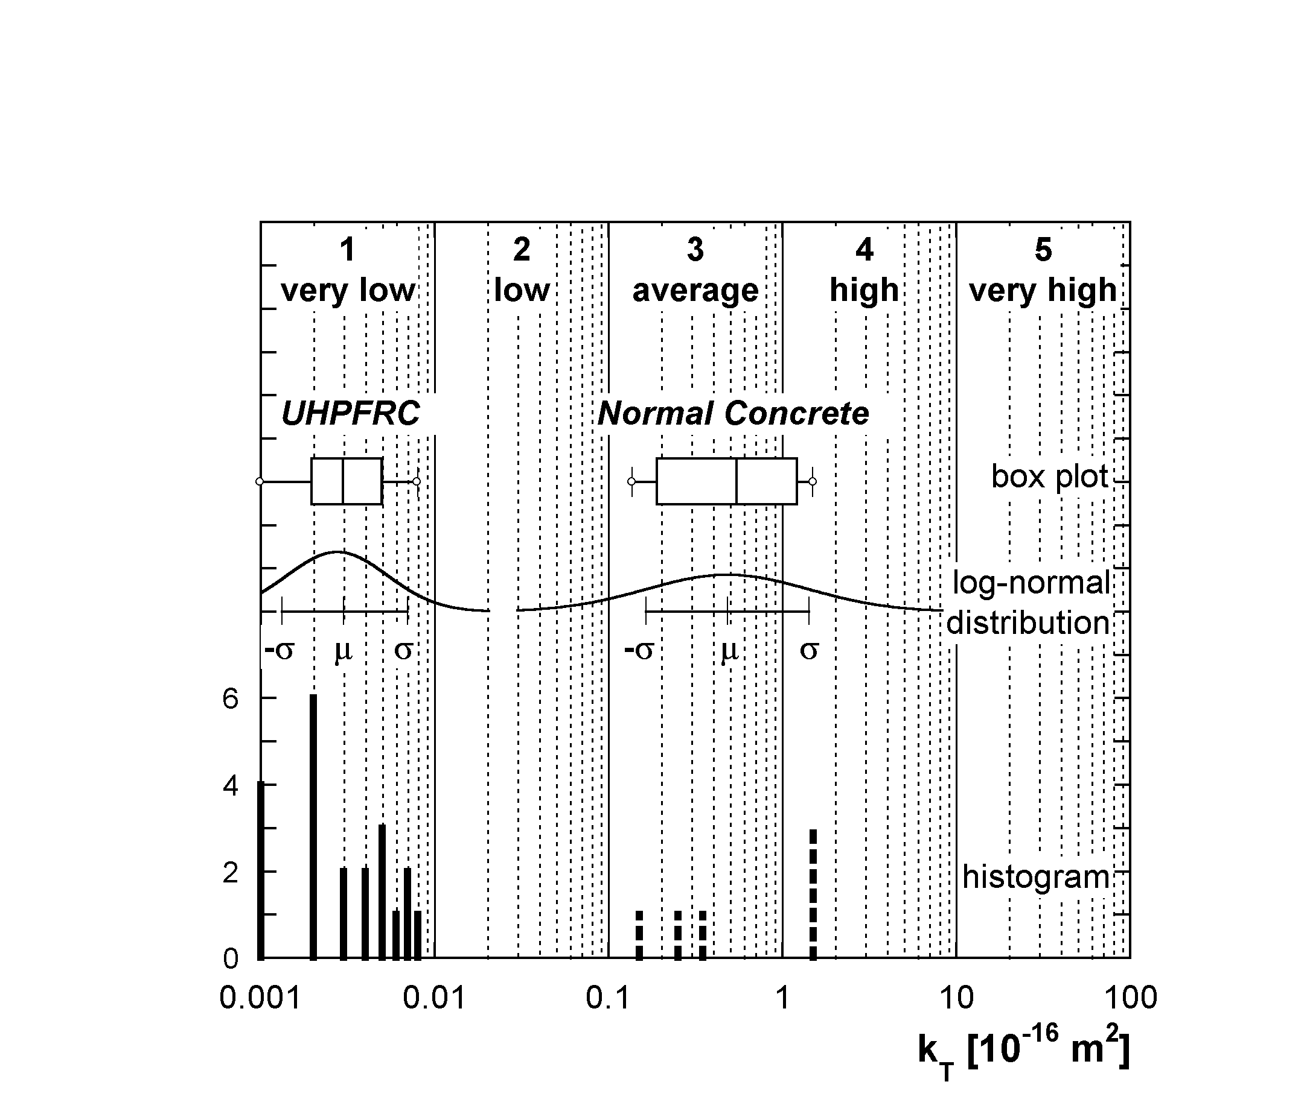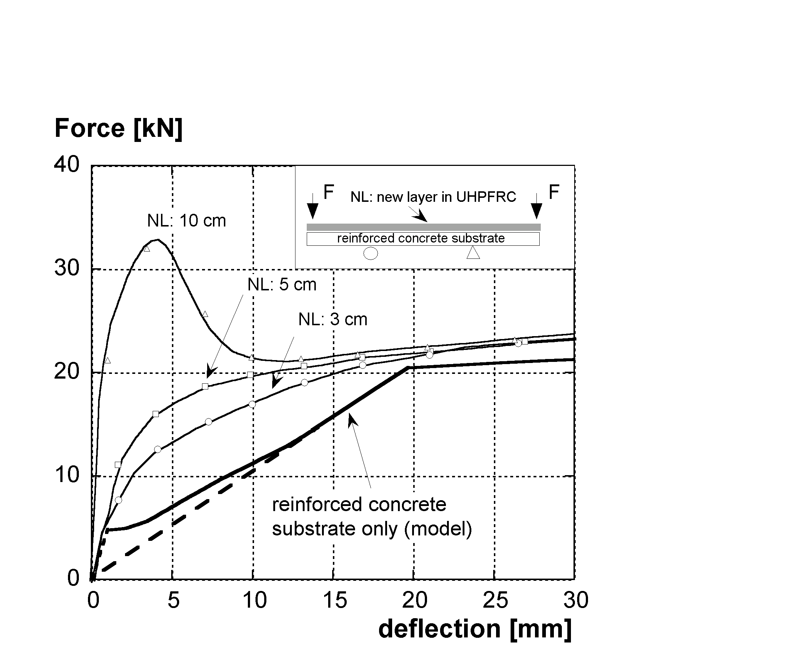
a) b)
Figure 2.1: a) Air permeability for UHPFRC and normal concrete, measured on new layers of hybrid beams, at early age, b) Force-deflection for hybrid beams as a function of the thickness of the new layer, after Habel (2003).

Publications issued during the reporting period
Denarié E., Habel K., Brühwiler E., (2003), "Structural behaviour of hybrid elements with Advanced Cementitious Materials (HPFRCC)", in Proceedings of fourth International RILEM Workshop on High Performance Fibre Reinforced Cement Composites, HPFRCC-4, Ann Arbor, Michigan, USA, Edited by A.E. Naaman and H.W. Reinhardt, RILEM PRO 30, pp 301-312.
Habel K., (2003), "Structural Behaviour of Hybrid Elements made of Advanced Cementitious Materials and Reinforced Concrete", test report, MCS-EPFL.
Habel K., Denarié E., Brühwiler E., (2003), "Comportement à la rupture d'éléments hybrides formés de BFUP et de béton armé", accepted for presentation at Quatrième édition des Journées scientifiques du Regroupement Francophone pour la Recherche et la Formation sur le Béton (RF)²B, Sherbrooke, Québec, Canada 25-26 août 2003.

Milestone M4 – Identification of most important phenomena
On the basis of works performed by MCS at an early stage and of the works performed since January 2003, the following aspects have to be considered in WP 14:
  - In fresh state, the composition of the fibrous mix largely influences the workability of the material. With a single type of fibres, a self compacting mix can be achieved. This mix has been tested for casting various kinds of hybrid structural elements. It showed very good performance.
  - In hardened state, the autogeneous shrinkage and the thermo-mechanical effects are the main sources of deformations. Drying shrinkage, although not negligible remains small with respect to the other deformations.
  - The viscoelastic behaviour will play a significant role on the evolution of eigenstresses and on the mechanical response at long term.
  - The effect of fatigue loading induced by traffic loads and cyclic thermal variations on the mechanical behaviour and risk of cracking and delamination of new layers of UHPFRC on hybrid elements with will have to be investigated.
  - The fibrous nature of UHPFRC induces a sensitivity of this material to the thickness and casting conditions (vertically, as a wall or horizontally as a plate). Possible heterogeneities and anisotropies due to the casting procedure and geometry of new layers will have to be investigated and taken into consideration for design.
  - The acute hydrophilic behaviour of UHPFRC, due to its extremely low water/binder ratio, and high quantity of unhydrated cement grains plays a very significant role in the water transport in permeability tests. Permeability tests with liquids inert towards cement hydration will have to be performed to have a sound overview of the transport properties of UHPFRC in damaged state.

Comparison of planned activities and actual work accomplished
The actual work accomplished during the reporting period fully corresponds to the planned activities.
Further, the WP 14 - HPFRCC benefits from all the works performed by MCS-EPFL on the application of HPFRCC for rehabilitation of reinforced concrete structures, in anticipation of the beginning of the SAMARIS project, on internal funding, from 2000 to 2002.

Planned activities for the next period
In the period from July 1, 2003 to December 31, 2003 (third and fourth quartals) following activities are planned:
- ordering of necessary equipments and beginning of preparation of TSTM testing machine (restrained shrinkage test at early age with temperature control) for main test series,
- ordering of materials for preliminary tests,
- preparation of substrate elements in ordinary reinforced concrete, for the tests on hybrid structural elements,
- preliminary tests on effect of fibrous mix on workability (batch 1),
- preliminary tests on effect of fibrous mix on mechanical properties (batch 1),
- preliminary tests on effect of direction of casting (vertically as a wall or horizontally, as a plate) and of the layer thickness on the mechanical properties (batch 1),
- selection of materials for the main test series – Milestone M12.

Technical overview for WP 15 – Survey
Work Package leader: Aleš Znidarič, ZAG, Slovenia

Summary of objectives
The overall objectives of this work package is to provide (a) an updated inventory and assessment of highway structures in selected EEA and CE countries, and (b) Guidelines for optimised assessment of highway structures.
WP 14 is divided into 5 tasks: WP 15.1 Data collection, WP 15.2 Condition assessment, WP 15.3 Loading, WP 15.4 Structural safety and WP 15.5 Survey.
According to the initial planning, only tasks 15.1 and 15.4 were addressed in the reported period with the following objectives:
- to collate information from existing questionnaires on highway infrastructures, prepared by COST 345, PIARC C11 committee and the BRIME project,
- to prepare draft questionnaire that will serve as the basic source of information for the tasks 15.2 to 15.5,
- to perform literature survey on procedures used for condition assessment of highway structures,
- to prepare state of the-art report on safety procedures available around the world,
- to prepare the detailed working plan and inception report.

Overview of results achieved in the period
Work done can be summarised as follows:
- Detailed work program for inception report has been prepared by all task leaders.
- All relevant questionnaires have been examined and based on them the draft SAMARIS WP 15 questionnaire was prepared for discussion at the subcontractors’ meeting in the first days of July.
- Literature survey for the task 15.2 on Condition assessment was done according to the plan.
- First draft of the state-of-the-art review on the safety assessment procedures has been delivered (Task 15.4).

Comparison of planned activities and actual work accomplished
The actual work accomplished during the reporting period fully corresponds to the planned activities.

Planned activities for the next period
In the period from July 1, 2003 to December 31, 2003 (third and fourth quartals) following activities are planned:
- Meeting with the subcontractors to define their obligations,
- Finalisation and submission of the questionnaire,
- Collection of responses to the questionnaire – Milestone M11,
- Weigh-in-motion and structural measurements on a bridge in Poland,
- Beginning of evaluation of measured data,
- Evaluation of condition assessment codes,
- Evaluation of existing dead load assessment procedures,
- Selection of countries for detailed safety assessment study.

Management and coordination aspects

Project commencement and kick-off
The official “project commencement date” was 1 January 2003 and the kick-off meeting was held at the Paris head office of Laboratoire Central des Ponts et Chaussées (LCPC) on the 21st and 22nd of January 2003. This meeting had been prepared by the leading partners at an ante-project meeting in Bruxelles on the 11th of December 2002 and was attended by all 23 contractors and most of the researchers who are involved in the first years’ project activities.
The Commission’s project officer gave a general introduction to the Commission’s priorities and policies under the active research programmes. The scientific coordinators for the two research streams (pavements and structures) presented the research plans, and the project coordinator highlighted the administrative routines and the reporting duties of the contractors.
Initial plans for the project web site and reporting templates and registration system were presented and discussed. Work package leaders and scientific coordinators had technical planning and coordination sessions, and the first meetings of the management committee and the extended management committee were held (see below).

Management Committee meetings
The Management Committee, which consists of the WP leaders, the two scientific coordinators (who are also WP-leaders) and the project coordinator, meets quarterly chaired by the project coordinator. It has held three meetings in the period.
The first meeting was held in conjunction with the kick-off meeting in Paris.
The second was held on the 11th of April at CEDEX in Madrid. Key items for the second meeting were the preparations for the meeting in Lausanne with the Reference Group of End Users in June (cf. 5.2) and the planning of the drafting of the inception report.
The third meeting was held on the 12th of June after the meeting in Lausanne with the Group of End Users. Key items at this meeting were the preparation of the first semi-annual management report (which at the time was expected to be a progress report) and the practicalities of the quality assurance procedure for primary deliverables.

Contractors’ committee meetings
The Contractors’ Committee (also known as the Extended Management Committee) consists of the Management Committee and one representative of all those contractors who do not have a seat in the Management Committee. It is chaired by the project coordinator and meets semi-annually or as deemed necessary by the project coordinator. It has held two short meetings in the period, one on the 22nd of January in conjunction with the kick-off meeting and one on the 12th of June in conjunction with the meeting with the reference group in Lausanne.
The committee has approved and individually signed a consortium agreement to protect LCPC’s property rights on a HPFRCC-type material, which is used in the structures research stream. The committee has also decided and approved a minor inter-contractor budget shuffle in order to provide travel funds to two contractors who by mistake had not been assigned such funds in their contracts with the Commission.
Committee members have been presented with the results of a test call for cost and manpower reports, which the project secretary conducted after the first quarter, and which was not very successfully answered. Subsequent consultations with individual contractors have solved most of these problems.

Preparation and submission of the inception report
The inception report was submitted to the Commission by hand on the 3rd of July at the project coordinator’s meeting in Bruxelles with the project officer, Mr. Frank Jost.

Change in key personnel
Aurelio Ruiz (CEDEX, Spain), who was the leader of WP6, has resigned from this task in the project following his promotion to director for the unit, and has been replaced by Francisco Sinis (CEDEX, Spain).

Planned management events
Management Comm. meeting no. 3: 13th October 2003 at LCPC, Paris, France.
Management Comm. meeting no. 4: 20th January 2004 at Ruhr-Universität Bochum, Germany.
Contractors’ Comm. meeting no. 3: 20th January 2004 at Ruhr-Universität Bochum, Germany

Dissemination issues

SAMARIS internet web site.
The SAMARIS internet web site on http://samaris.zag.si has been active since the 1st of March. It consists of an open section with unlimited access to selected information, and the private pages with password protected access, where all documents and events are posted. The private pages also give access to the updated Work Package plans and provide the way in which the Reference Group of End Users (cf. 5.2) can best keep themselves informed about the stream of events and results in SAMARIS. The private pages for the WPs of the pavement stream is not yet in operation (cf. 1.1.2)

Reference Group of End Users
At the time of planning for SAMARIS an invitation to European Road and Industry Associations to become members of a project reference group was very well received, but when this invitation was re-issued after project initiation, the interest was found to have faltered and replies even quite difficult to obtain. However, after repeated invitations and prompting a valid and interested group of 16 centrally placed individuals was finally formed and a meeting with them could take place as planned on the 11th of June 2003 at the École Polytechnique Fédérale de Lausanne (EPFL) in Switzerland.
The meeting was planned to present the aims and expected results of the project and have a dialogue with the reference group in order to clarify their priorities, so that the plans in the inception report could be adjusted if necessary. The meeting was successful in both respects, and it also resulted in offers from Reference Group members to participate in the QA procedure as validation reviewers of selected key reports. A summary of the meeting may be found in the inception report.
It is the intention of the management committee to offer “membership” of the reference group to a larger and more diverse target group of potential end users, and this is seen as a challenge to be met over the next 6 months period.

SAMARIS Brochure
Work on deliverable D3, which was due in month 6, was delayed by priority work on the inception report and then interrupted by the Summer period, but is now being finalised with 15 September as the ultimate target date.

Coordination with other projects
SAMARIS has identified the potential for synergies with project FORMAT (cf. 1.1.2) and has set up the process by which the need to exchange relevant results can be ascertained. Some opportunities for synergies and coordination were, however, lost by the separation in time of the work undertaken in the two projects.
It has been agreed that the two groups will mutually use their workshops and other major meetings to invite some from the other project to present work done and results obtained in their project. A member of the FORMAT project thus attended the meeting with the SAMARIS Reference Group of End Users in Lausanne (see 5.2 above) and was given a place on the programme to present FORMAT, which has aims and objectives that are seen as very relevant for that audience.

Planned dissemination activities
During the next 6 months period dissemination activities will focus on
- Expansion of the Reference Group of End Users
- Further improvements to the SAMARIS web site (delayed)
- Issue of the SAMARIS Brochure (delayed)
- Plan for production of articles and papers to journals and conferences
- Consideration of need for SAMARIS newsletter and possible production of it.

