Competitive and Sustainable Growth (GROWTH) Programme
Document number: | SAM_GE_DE02 | Date: | 30.6.2003

SAMARIS
Sustainable and Advanced MAterials for Road InfraStructure
INCEPTION REPORT

by
Aleš Žnidarič
Jean Michel Piau
Richard Woodward

TABLE OF CONTENTS
 | Name and signature | Date
Submitted: | Not applicable
Reviewed: | By the management group
Verified: | Not applicable
Validated: | Not applicable
Approved by SAMARIS Management Group: |  | 1 July 2003  Jørgen Christensen
Preface 1
1. INTRODUCTION 3
1.1 General background 3
1.2 Pavements 3
1.3 Structures 5
1.4 Management, exploitation and implementation 6
2. Overview 7
2.1 Organisation of work 7
2.1.1 Pavement stream of research work packages 8
2.1.2 Structures stream of research work packages 8
2.2 Deliverables 9
2.3 Milestones 10
2.4 Exploitation 12
3. Consortium and Resources 13
3.1 Contractors 13
3.2 Resources 14
3.2.1 Use of subcontractors 14
4. Plan of research, pavements 16
4.1 Introduction 16
4.2 Overview of pavement stream of research 17
4.3 WP 2: Elaboration, Integration and Review of the work programme 19
4.3.1 Objective 19
4.3.2 Tasks 19
Task 4.1 Refine the definition of the work programme of the pavement stream 19
4.4 WP 3: Assessment of alternative materials 20
4.4.1 Objective 20
4.4.2 Tasks 20
Task 3.1 Review of present approaches 21
Task 3.2 Definition of the assessment methodology 22
4.4.3 Schematic description and Gantt chart of WP 3 24
4.5 WP 4: Safety and Environmental Concerns in Material Specifications 24
4.5.1 Objective 24
4.5.2 Tasks 24
Task 4.1 Detection of Hazardous Components in Materials to be Recycled 24
Task 4.2 Reaction to Fire of Pavement Materials 27
Task 4.3 Environmental Annexes to Product Standards 29
4.5.3 Schematic description and Gantt chart of WP 4 30
4.6 WP 5: Performance based specifications 30
4.6.1 Tasks 30
Task 5.1 Data collection of fields experiments and accelerated loading tests 32
Task 5.2 Permanent deformation of unbound granular materials 33
Task 5.3 Rutting of bituminous mixtures 35
4.6.2 Schematic description and Gantt chart of WP 5 36
4.7 WP 6: Techniques for recycling 36
4.7.1 Objective 36
4.7.2 Tasks 36
Task 6.1 Elaboration of a technical guide on recycling techniques 36
Task 6.2 Review of the situation on Central European countries 38
4.7.3 Schematic description and Gantt chart of WP 6 39
5. Plan of research, structures 41
5.1 Overview of structure stream of research 41
5.2 WP 12: Strategies for rehabilitation of highway structures 42
5.2.1 Objectives 42
5.2.2 Justification 42
5.2.3 Tasks 43
Task 12.1 Description of problem 44
Task 12.2 Review of other work 45
Task 12.3 Development of guidelines 46
5.3 WP 13: Corrosion Inhibitors 47
5.3.1 Objectives 47
5.3.2 Tasks 47
Task 13.1 Basic mechanism study 48
Task 13.2 Chloride and inhibitor concentration 50
Task 13.3 Concrete permeability 51
Task 13.4 Influence on mechanical properties 54
Task 13.5 Field trials 55
Task 13.6 Specifications 56
5.4 WP 14: HPFRCC - High Performance Fibre Reinforced Cementitious Composites 57
5.4.1 Objectives 57
5.4.2 Tasks 58
Task 14.1 Preliminary study 59
Task 14.2 Testing 60
Task 14.3 Interpretation – modelling 62
Task 14.4 Numerical parameter study 63
Task 14.5 Specifications – documents for application 64
5.5 WP 15: Survey of highway structures 65
5.5.1 Objectives 65
5.5.2 Tasks 65
Task 15.1 Data collection 65
Task 15.2 Condition assessment 67
Task 15.3 Loading 69
Task 15.4 Structural safety 71
Task 15.5 Survey 73
6. Project Management and Administration 74
6.1 WP 1: Project management 74
6.1.1 Objectives 74
6.1.2 Tasks 74
Task 1.1 Organisation and documentation of Contractors’ Committee meetings 74
Task 1.2 Organisation and documentation of Management Committee meetings 75
Task 1.3 Scientific co-ordination of the project’s pavement stream 75
Task 1.4 Scientific co-ordination of the project’s structure stream 76
Task 1.5 Conduct of Midterm assessment 76
Task 1.6 Administrative and financial management of the project 76
Task 1.7 Maintaining a list of all project documents on project home page 76
6.2 Quality Assurance and Control 77
6.2.1 General 77
6.2.2 Milestones and deliverables 77
6.2.3 Review, verification and validation procedures 77
Project reviews 77
Deliverable reviews 77
Deliverable verifications 77
Deliverable validations 78
Control of project changes 78
6.2.4 Responsibilities 78
6.2.5 QA reports 78
6.2.6 Numbering of SAMARIS Documents 79
6.3 Project web site 80
7. Dissemination and exploitation of results 82
7.1 WP16: Dissemination and exploitation 82
7.1.1 Objectives 82
7.1.2 Tasks 82
Task 16.1: Maintenance of project internet web site 82
Task 16.2: Preparation and dissemination of information about and from the project 82
Task 16.3: Organisation and subsequent contact with reference group of end users 83
Task 16.4: Organisation and conduct of final seminar 84
Task 16.5: Final report 84
Task 16.6: Technological implementation plan 84
7.2 Reference Group of End Users 84
7.2.1 Role 84
7.2.2 Reference group members 85
8. OTHER 86
8.1 Coordination with other projects 86
8.1.1 FORMAT 86
8.1.2 REHABCON 86
8.1.3 BITSPEC and continuing activities 87
8.2 First meeting with Reference Group of End Users 87
8.2.1 Participation 87
8.2.2 Results 88

Appendix A Detailed overview of tasks to be completed in Work Packages i

Figures
Figure 2.1: Project SAMARIS organisation of work 7
Figure 5.1: Conceptual approach for the application of ultra compact HPFRCC for the maintenance of reinforced concrete structures. 59
Figure 5.2: Flow chart for the interrelation between modelling and testing 63
Figure 6.1: Opening pages of the public and private parts of SAMARIS web page 80
Figure 6.2: Main and detailed Partners page 81
Figure A.1: Detailed overview of tasks to be completed in WP 3 ii
Figure A.2: Detailed overview of tasks to be completed in WP 4 iii
Figure A.3: Detailed overview of tasks to be completed in WP 5 iv
Figure A.4: Detailed overview of tasks to be completed in WP 6 v
Figure A.5: Detailed overview of tasks to be completed in WP 12 vi
Figure A.6: Detailed overview of tasks to be completed in WP 13 vii
Figure A.7: Detailed overview of tasks to be completed in WP 14 viii
Figure A.8: Detailed overview of tasks to be completed in WP 15 ix
Tables
Table 2.1: Overview of the primary deliverables 9
Table 2.2: Overview of other deliverables and project outputs 10
Table 2.3: Overview of the Milestones 11
Table 3.1: List of contractors 13
Table 3.2: Distribution of project manpower and costs on consortium members 14
Table 3.3: List of subcontractors 15
Table 4.1: Description of Work Package 2 'Elaboration, integration and review' 20
Table 4.2: Description of Work Package 3 ‘Assessment of alternative materials’ 25
Table 4.3: Description of Work Package 4 ‘Safety and environmental concerns in material specifications’ 31
Table 4.4: Description of Work Package 5 ‘Performance-based specifications’ 37
Table 4.5: Description of Work Package 6 ‘Techniques for recycling’ 39
Table 5.1: Description of Work Package 12 ‘Strategies for rehabilitation of highway structures’ 43
Table 5.2: Description of Work Package 13 ‘Corrosion Inhibitors’ 48
Table 5.3: Description of Work Package 14 ‘HPFRCC materials’ 58
Table 5.4: Description of Work Package 15 ‘Survey of highway structures’ 66
Table 6.1: Description of Work Package 1 ‘Project management’ 75
Table 7.1: Description of Work Package 16 ‘Dissemination and exploitation’ 83

Preface
In this inception report are the original plans for project SAMARIS reviewed, reworked and specified so as to provide a complete and comprehensive activity guide for all 23 partners in the project consortium as well as for the European Commission, the national authorities who have provided the supplementary funding, and for the reference group of end users.
The report was part of the work of Work Packages 2 and 12, based on contributions from all Work Package leaders and from the two research co-ordinators for the pavement and structures parts respectively of the project. It was discussed as a first draft at a meeting with the Reference Group of End Users in Lausanne, Switzerland, on the 11th of June 2003 and subsequently modified to reflect the results of this discussion.
The final version was approved by the project’s management committee on the 30th of June 2003 for immediate delivery to the European Commission as deliverable D2.

INTRODUCTION

General background
The SAMARIS project was planned in response to the European Commission’s call for proposals addressing Task 2.2.1/18 ‘Road infrastructure materials’ of Key Action ‘Sustainable Mobility and Intermodality’ under the GROWTH part of the Fifth Framework Programme for Research and Technological Development. It merges two separate proposals, one (MAP) about materials used in highway pavements and another (STRIM) about innovative materials used for maintenance of highway concrete structures. The contract was signed by the Commission on the 25th of November 2002. Project commencement date was the 1st of January 2003 and the duration of the project is 36 months.
The societal needs that are specifically targeted in the project are to support the EU policy on sustainable development, waste management and energy efficiency and, as a specific issue under task 2.2.1/18, the challenge of finding optimal repair strategies for a large number of critical concrete structures on the main road networks in CE countries as well as in some EEA countries.
The project retains the aims and objectives of the two original projects and is structured with two project streams or sub-projects, one on pavements and the other on structures, but with common leadership and project co-ordination. It is seen as particularly important that both streams have the same target group of end users, i.e. those responsible for implementing new road maintenance and construction practices in road administrations at all levels in the European countries.
An important feature of the project is therefore the reference group of end users, comprising road administration officials as well as industry representatives. This reference group will follow the project from its start to its end. It will be kept informed about progress and results throughout the project and will form the core group of participants at the final seminar after project completion. It was convened for the first time to be informed about project plans and to discuss with the project management group this inception report in draft before it was finalised and submitted to the Commission.

Pavements
A key objective of this project stream is to encourage the use of recycled and secondary materials in pavements by detailing how such materials shall be selected and tested in order to secure satisfactory performance, environmentally as well as functionally. Attention is given to the situation in Central European countries for which the RETRA-EST programme has identified recycling and use of alternative materials in pavements as a first priority for co-operative actions.
Another key objective, also supporting the case for more and better use of recycling and alternative materials, is to prepare for the harmonisation of European approaches of material specification within the next generation of CEN standards. This will involve moving from a recipe approach, which puts much emphasis on the intrinsic characteristics of the constituents, to a performance-based approach, focussing on the in-place products that allows consideration to be made irrespective of the type of material.
Hence, this part of the project has the following technical and scientific objectives to:
- Produce a general methodology for the assessment of functional, safety and environmental aspects for the use and re-use of any kind of material taking into consideration the actual context of use. The originality is the consideration of the material interactivity with its environment in the assessment process.
- Draft an environmental annex to CEN products standards and to define testing protocols for investigation of hazardous components when considering the re-use of pavement materials.
- Develop mechanical models and test methods in order to derive performance-based specifications related to functional properties, using permanent deformation.
- Produce technical guides and recommendations for a proper use of recycling techniques in road construction.
The scientific and technical work plan is structured in four work packages which are closely inter-related to produce the expected results of call 2.2.1/18. The topics, subdivided into practical tasks, are:
- Assessment of materials to produce a methodology to assess the eco-compatibility of materials in road pavement design.
- Safety and environmental aspects in material specifications to incorporate these aspects in product standards and to develop the associated testing protocols.
- Performance-based specifications to address functional properties for a new generation of specifications for pavement materials with respect to permanent deformations.
- Techniques for recycling to draw recommendations from the many different approaches to recycling that have been tried, with various degrees of success, within Europe, with particular attention paid to the situation in CE countries.
Innovations introduced in this sub-project require combining expertise from a variety of disciplines: pavement, material and environmental engineering. From a scientific point of view, the different tasks require competence in physic-chemical analysis, mechanical testing, development of constitutive models and of numerical models of pavement behaviour, pollution transfer, etc. The very practical objectives of a better use of primary materials and by-products also necessitate that the technological aspects be correctly addressed with expertise in material processing and techniques of recycling. Participating in the four work packages are R&D institutes, engineering consultants, university laboratories, product manufacturers and road contractors, representing 17 partners from 11 European countries including 2 CE countries. This group is complemented by one research organisation from the U.S.A.
Outputs from this part of the project will permit a more efficient use of local aggregate and of by-products, which directly contribute to EU’s policy for sustainable development. Recommendations on recycling techniques will benefit both road authorities and the construction profession through fewer cases of failure due to inappropriate processing or construction methods and through more cost effective road works. They will help CE countries for a more efficient use of recycling in upgrading the existing networks. Moreover, work on specification will represent a direct input to CEN for the next generation of European pavement product standards.

Structures
Maintenance of concrete structures, whether it is pre-emptive or for repair or strengthening, is a heavy burden for society not only in financial terms but also by the associated risk of causing major and longer-term disturbance of traffic. A key objective of this part of the project is therefore to support the EU policy to improve the maintenance of highway structures through radically improved efficiency and durability of repair methods, resulting in reduced number of necessary road closures. This will lead to considerable reduction of associated costs and increase users’ and workers’ safety. Special attention will be given to the Central European countries where condition of the highway structures may differ from the situation in the current EU member countries.
This part of the project has therefore the following technical and scientific objectives to:
- Draw together the requirements for a sustainable maintenance strategy which satisfies the functional, safety, economic and environmental requirements for highway structures.
- Investigate the applicability of two innovative techniques, 1) the corrosion inhibitors and 2) the high performance fibre reinforced cementitious composites, which can be used for maintenance of bridges, tunnels, embankment, culverts and retaining walls, at different levels of corrosion attack of the reinforcement.
- Update and analyse the inventory of highway structures in the selected EEA and CE countries.
- Propose methods and procedures for improved maintenance of highway structures.
The scientific and technical work plan is structured to give clear answers about the applicability of innovative materials and to clarify the state of the highway structures in EEA and CE countries. To produce the results expected by the task description, the project work plan is structured in four technical work packages. The topics, subdivided into practical tasks, are:
- Strategies for rehabilitation of highway structures, to draw together the requirements for a sustainable maintenance strategy for highway structures including guidelines for the use of innovative materials and techniques within this strategy
- Corrosion inhibitors, to investigate the effects and effectiveness of these materials and produce specifications for their characterisation, use and methods of applications.
- HPFRCC (High Performance Fibre Reinforced Cementitious Composites) materials, to demonstrate the applicability and advantages of these materials, optimise them for maintenance and provide guidelines for their use.
- Survey, to provide an up-to-date inventory and assessment of highway structures in selected countries in CE and EEA including a review of current procedures for determining condition, loading and structural safety.
The innovative materials investigated here require expertise from a variety of disciplines: structures, materials and environmental engineering, as well as interdisciplinary fields such as maintenance engineering. The different tasks require a high level of competence in fundamental as well as applied sciences and engineering, both experimentally and numerically, for materials and for structures. These needs are met by a group of participants from R&D institutes, engineering consulting firms, university laboratories, product manufacturers and road administrations from thirteen European countries. Five principal contractors, each having overall responsibility for one or two of the work packages, form the core management of this part of the project. They will be assisted by five assistant contractors, including two from the industry, and ten sub-contractors. One principal and one assistant contractor are from the CE countries.
The expected results will have economic impacts far beyond costs of construction and maintenance. They will contribute to a safer and more efficient road network by reducing the need and duration of rehabilitation work on highway structures and thus curbing the unsafe and congestive effects of this activity on road traffic. Thus, societal value of the project is seen as being orders of magnitude greater than project costs. The ‘highway structures’ engineering profession will benefit directly from the project by being given a basis for the practical use of new materials and techniques for maintaining and constructing structures which aim at reducing dramatically future durability problems. Highway infrastructure managers will benefit from the verified assessment tools and guidelines for the new maintenance strategies.
The results of the project will contribute substantially to European technological progress. The dissemination plan will promote wide distribution of the results, both at the European and national level.

Management, exploitation and implementation
The decision-making structure of the project will consist of the Contractors’ Committee, with a representative for each principal or assistant contractor, the Management Group, consisting of all work-package leaders, and the Work Package Teams.
The Contractors’ Committee has the ultimate responsibility for the project and makes all decisions that influence the overall project plan, total project economy or the internal distribution of costs. It approves deliverables and makes milestone decisions. Chaired by the project co-ordinator, it will meet as necessary, normally 2 times per year. The Management Group monitors the progress of the project and makes all decisions necessary to stay within the project plan and budget. Chaired by the project co-ordinator and co-chaired by the two scientific co-ordinators, one for the pavement part and one for the structures part, it meets four times per year.
A Reference Group of end-users, involving partner country road authorities and European professional associations, will provide guidance at important project milestones and will be kept informed about the results so at to be able to prepare for their implementation. The Reference Group of end-users will provide feedback, support dissemination and secure commitment to implement project results.
In addition, in order to obtain a reliable and comprehensive survey of highway structures in selected EEA and CE countries, a subcommittee has been set up comprising technical experts and end-users from these countries.

Overview

Organisation of work
The figure below shows the overall organisation of the work in the project. The two streams of research work packages in pavements and structures respectively are sandwiched between the management activities of work in work package 1 and the dissemination and employment activities in work package 16.
Management (WP1)

Pavement
stream of research work packages
WP2
WP3
WP4
WP5
WP6

Structures
stream of research work packages
WP12
WP13
WP14
WP15
Dissemination and Exploitation of Results (WP16)
Figure 2.1: Project SAMARIS organisation of work
The tasks and activities of the ‘Management’ work package are described in chapter 6, and the ‘Dissemination and exploitation’ work package is described in chapter 7. Plans and organisation of the research streams for pavement and structures parts of the project may be found in chapters 4 and 5 respectively. Sections 2.1.1 and 2.1.2 below lists the headings and tasks of the research work packages.

Pavement stream of research work packages
- WP 2 Review, development of pavement programme (see chapter 4.3)
2.1 Refine the definition of the work programme of the pavement stream
- WP 3 Assessment of materials (see chapter 4.4)
3.1 Review of present approaches
3.2 Definition of the assessment methodology
- WP 4 Safety and environment(see chapter 4.5)
4.1 Detection of Hazardous Components in Materials to be Recycled
4.2 Reaction to Fire of Pavement Materials
4.3 Environmental Annexes to Product Standards
- WP 5 Performance-based specifications (see chapter 4.6)
5.1 Data collection of fields experiments and accelerated loading tests
5.2 Permanent deformation of unbound granular materials
5.3 Rutting of bituminous mixtures
- WP 6 Techniques for recycling (see chapter 4.7)
6.1 Elaboration of a technical guide on recycling techniques
6.2 Review of the situation on Central European countries

Structures stream of research work packages
- WP 12 Strategies for rehabilitation (see chapter 5.2)
12.1 Description of the problem
12.2 Review of other work
12.3 Development of guidelines
- WP 13 Corrosion Inhibitors (see chapter 5.3)
13.1 Basic mechanism study
13.2 Chloride and inhibitor concentrations
13.3 Concrete permeability
13.4 Influence on mechanical properties
13.5 Field trials
13.6 Specifications
- WP 14 High Performance Fibre Reinforced Cementitious Composite materials (see chapter 5.4)
14.1 Preliminary study
14.2 Testing
14.3 Interpretation - modelling
14.4 Numerical parameter study
14.5 Specifications – documents for application
- WP 15 Survey of highway structures (see chapter 5.5)
15.1 Data collection
15.2 Condition assessment
15.3 Loading
15.4 Structural safety
15.5 Survey

Deliverables
The project is contracted to produce 34 deliverables, i.e. formally approved written documentation reports presenting completed output from the project. Some are intermediary, meaning that they represent a step in the link of activities necessary to arrive at an end result. Others are such end results, and may be scientific papers or practical guidelines derived from the findings in these, presented in a form intended for practical use by end users.
The Commission has required the many deliverables to be grouped into two categories: primary deliverables and other mandatory deliverables and outputs. The tables below present the two sets of deliverables with the pavements stream ones being lightly shaded and the structures stream ones being more heavily shaded.
Table 2.1: Overview of the primary deliverables
Deliverable No. | Delivery date (month) | Output from WP | Nature of deliverable and brief description
D4 | 12 | 3 | State of the art report “Existing specific national regulations applied to material recycling”
D7 | 10 | 4 | State of the art report on test methods for the detection of hazardous components in road materials to be recycled
D15 | 20 | 6 | Situation in the CE countries as regard recycling
D16 | 24 | 3 | Report on methodology for assessing the possibility to re-use materials for road construction
D17 | 24 | 13 | Report on test of effectiveness of corrosion inhibitors in laboratory trials
D22 | 30 | 14 | Report on tests of HPFRCC in the field
D24 | 31 | 4 | Environmental annexes to road products standards
D25 | 33 | 13 | Specifications for the use of corrosion inhibitors for maintenance of highway structures
D27/D28 | 33 | 5 | Calibration and validation report for modelling of permanent deformation of unbound and bituminous layers in flexible pavements and recommendations for the definition of performance-based specifications
D29 | 33 | 6 | Technical guide for recycling techniques in road construction
D30 | 33 | 15 | Guidelines for optimised assessment of highway structures
D31 | 36 | 12 | Guidelines on selection and use of innovative materials for the rehabilitation of highway structures
Table 2.2: Overview of other deliverables and project outputs
Deliverable No. | Delivery date (month) | Output from WP | Nature of deliverable and brief description
D1 | 3 | 16 | Project web-site
D2 | 6 | 2 and 12 | Developed work programme/Inception report
D3 | 7 | 16 | Brochure presenting the project
D5 | 15 | 6 | Literature survey of recycling of by-products in road construction in Europe
D6 | 15 | 5 | Data base and report on reference full-scale tests results on pavements
D8 | 14 | 4 | Review of road authorities’ positions on reaction to fire of pavement materials
D9 | 15 | 3 | Critical analysis of European documents
D10 | 15 | 5 | Report on models for prediction of permanent deformation of unbound materials in flexible pavements
D11 | 15 | 5 | Report on models for prediction of rutting of bituminous surface layers
D12 | 18 | 6 | Recommendations for mixing plants for recycling works
D13 | 18 | 14 | Report on preliminary studies for the use of HPFRCC for rehabilitation of road infrastructure components
D14 | 18 | 1 | Mid-term assessment report
D18 | 24 | 14 | Report on tests of HPFRCC in the laboratory
D19 | 24 | 15 | Report on state-of-the-art of the assessment of structures in selected EEA and CE countries
D20 | 30 | 4 | Report on test procedure for reaction to fire of pavement materials
D21 | 30 | 13 | Report on test of effectiveness of corrosion inhibitors in field trials
D23 | 32 | 4 | Report on test methods for the detection of hazardous components in road by-products
D26 | 33 | 14 | Modelling of HPFRCC in hybrid structures
D32 | 36 | 16 | Final executive summary report
D33 | 36 | 16 | Briefing material for national promotion of project results
D34 | 38 | 1 | Summary technological implementation plan

Milestones
Milestones are another important feature of the project, indicating points in the progress of work at which important decisions must be taken with respect to the course of research. A special milestone is the mid-term assessment, at which the project together with the Commission evaluate the progress and direction of the project before embarking on the second half of the project. The project has 19 such milestones, which are listed in the table below using the same shadings as for the deliverables.
Table 2.3: Overview of the Milestones
Milestone No. | Delivery date (month) | Output from WP No. | Brief description of Milestone objectives | Criteria for assessment
M1 | 3 | 16 | Project web-site | Fully operational home page with basic project information
M2 | 6 | 12 | Complete review of repair methods for structures | Inception report for structure WPs available
M3 | 6 | 13 | Decisions on properties of concretes to be used in laboratory and field test trials of CI. | Selection of materials
M4 | 6 | 14 | Identification of most important phenomena for defining HPFRCC main test programme | Results of numerical simulations and preliminary tests available
M5 | 6 | 2 | Approval of scientific methodology and work programme for pavement WPs | Consistency with objectives of project
M6 | 9 | 12 | Complete critical review of relevant R&D work | Internal draft report available
M7 | 12 | 3 | Determine the influent parameters and their range of variation before developing the methodology for assessing the possibility to use by-products | Suitability of the information collected
M8 | 12 | 4 | Evaluation of existing test methods for detection of hazardous components and decision for the development of new tests | Applicability of existing methods to the context of recycling
M9 | 16 | 5 | Evaluation of full-scale pavement tests results data base and need for additional specific data to be collected | Quality and completeness of data sets
M10 | 15 | 6 | Approval of the draft of the structure and table of content of the technical guide on recycling techniques | Comparison with information collected from literature survey and enquiry.
M11 | 12 | 15 | Collection of structural data completed | All questionnaires completed and returned
´M12 | 12 | 14 | Selection of materials for main test series of HPFRCC | Preliminary test results and conclusions concerning materials for main tests available
M13 | 15 | 4 | Determine the necessity to develop test methods for assessing the reaction to fire of pavement materials. | From road authorities answers.
M14 | 16 | 5 | Evaluation of the need for additional tests for validation of models for permanent deformation of unbound materials in flexible pavements | Comparison of existing data with model requirements
M15 | 16 | 5 | Evaluation of the need for additional laboratory tests for validation of models for rutting of bituminous layers | Comparison of existing data with model requirements
M16 | 18 | 15 | Collection of traffic data completed | Database on traffic data base and WIM measurements available
M17 | 19 | 1 | Mid-term assessment passed | Consistency with work-programme and objectives of the project
M18 | 21 | 14 | Choice of on-site applications for pilot tests of HPFRCC | Results and interpretations of main test series available
M19 | 33 | 16 | Final symposium organised | Preparations completed

Exploitation
The project has been structured so as to produce results that can be applicable and implemented into practice in the near future. The following deliverables are seen as particularly user oriented:
- technical guides for assessing the possibility to re-use materials in road construction,
- guides on techniques of recycling,
- analysis and recommendations for CE countries as regard recycling,
- models and test methods to support performance-based specification with regard to permanent deformation of pavements, tests protocols, etc.,
- state-of-the-art report on condition and needs of structures in selected EEA and CE countries,
- specifications for the use of CI and HPFRCC in the maintenance of highway structures,
- guidelines for use of innovative materials and techniques for the rehabilitation of highway structures,
- guidelines for optimised assessment of highway structures.
The implementation of the results is a very significant aspect of the proposed project. Special attention will be given to facilitating the implementation of the results in Central and Eastern European countries
Effective implementation of the findings of the project is expected to result in more efficient, safer, environmentally sustainable and durable maintenance of highway pavements and structures and increased traffic comfort due to fewer delays and detours caused by maintenance work.
The project will also strengthen networking between researchers and practitioners.
The dissemination and exploitation plan that will be implemented by WP 16 will refine the present ideas and seek feedback from the reference end-users group. A Technology Implementation Plan will be submitted to the Commission at project termination.
A seminar will be organised at the end of the project to explain the findings to a large audience. Special sessions of this seminar will be devoted to the situation in CE countries and to the impact of project results on pavements standards.
Given the three-year duration of the project, the seminar should follow soon after the current harmonised European specifications for road materials are being implemented, and the timing will be suitable for developing strategies that could improve these standards in the near future.
The primary route to full implementation is through the European standards, but it is intended that the members of the Consortium will keep their national standardisation bodies informed of the developments so that they can also be implemented in any national standards for associated aspects not covered by the European Standards.

Consortium and Resources

Contractors
Table 3.4 lists all the contractors in the SAMARIS project.
Table 3.4: List of contractors
Contractor name | Short name | Nationality
Danish Road Institute | DRI | Danish
Laboratoire Central des Ponts et Chaussées | LCPC | French
Slovenian National Building and Civil Engineering Institute | ZAG | Slovenian
Transport Research Laboratory | TRL | English
National University of Ireland Dublin | UCD | Irish
Centro de Estudios y Experimentacion de Obras Publicas | CEDEX | Spanish
Swiss Federal Institute of Technology, Lausanne | EPFL | Swiss
Vienna Univ. of Techn., Inst. of Road Constr. and Mainten. | VUT/ISTU | Austrian
Shell Global Solutions S.A. | SHELL | French
Trinity College Dublin | TCD | Irish
Universitat Politécnica de Catalunya | UPC | Spanish
Instituto Superior Tècnico | IST | Portuguese
Swedish National Road and Transport Research Institute | VTI | Swedish
SIKA Ireland Ltd. | SIKA | Irish
DHI Water and Environment | DHI | Danish
Netherlands Energy Research Foundation | ECN | Dutch
Forméquip. École Nationale des Travaux Publics de l'État | ENTPE | French
University of New Hampshire | UNH | American
Ruhr University Bochum | RUB | German
Raastof og Genanvendelse Selskabet af 1990 A/S | RSG90 | Danish
Vysoké Uceni Technicke v Brne | TU Brno | Czech
Road and Bridge Research Institute | IBDIM | Polish
Eurovia Management | EUROVIA | French

Resources
Table 3.5: Distribution of project manpower and costs on consortium members
Contractor’s short name | Man months |  |  |  | Budget (€)
Contractor’s short name | Pavements | Structures | Other | Total | Budget (€)
DRI | 20 | 0 | 19 | 36 | 561.680
LCPC | 29 | 6 | 11 | 46 | 541.252
ZAG | 0 | 43 | 12 | 55 | 489.833
TRL | 18 | 44 | 6 | 68 | 887.261
UCD | 0 | 88 | 2 | 90 | 267.103
CEDEX | 14 | 0 | 2 | 16 | 160.587
EPFL | 0 | 80 | 4 | 84 | 452.108
VUT/ISTU | 11 | 0 | 0 | 11 | 68.201
SHELL | 6 | 0 | 0 | 6 | 122.436
TCD | 0 | 10 | 0 | 10 | 56.070
UPC | 0 | 5 | 0 | 5 | 55.707
IST | 6 | 0 | 0 | 6 | 53.431
VTI | 6 | 0 | 0 | 6 | 93.784
SIKA | 0 | 4 | 0 | 4 | 46.505
DHI | 5 | 0 | 0 | 5 | 84.329
ECN | 9 | 0 | 0 | 9 | 121.177
ENTP | 7 | 0 | 0 | 7 | 47.430
UNH | 16 | 0 | 0 | 16 | 111.100
RUB | 16 | 0 | 0 | 16 | 62.403
RSG90 | 6 | 0 | 0 | 6 | 93.139
TU Brno | 12 | 0 | 0 | 12 | 65.808
IBDIM | 9 | 18 | 0 | 27 | 111.325
EUROVIA | 6 | 0 | 0 | 6 | 119.882
Total | 196 | 298 | 56 | 547 | 4.672.551

Use of subcontractors
Subcontractors have important roles in the project, but are not members of the consortium, which holds the contract(s) with the Commission, and they may change in the course of the project. Table 3.6 shows current subcontractors and their respective employing consortium member.
Table 3.6: List of subcontractors
Contractor short name | Subcontractor | Nationality
TRL | Fire Research Station (UK Building Research Establishment) | British
TRL | University of Cardiff | British
TRL | FEMMASSE bv | Dutch
EPFL | PSI-Würenlingen (Swiss Nuclear Research Centre) | Swiss
EPFL | LMC-EPFL (Laboratory for Building Materials) | Swiss
ZAG | KTI, Institute for Transport Sciences | Hungarian
ZAG | Bundes Ministerium für Verkehr, Innovation and Technologie | Austrian
ZAG | Road and Motorway Directorate of the Czech Republic (ŘSD ČR) | Czech
ZAG | Norwegian Public Roads Administration | Norwegian
ZAG | Directorate of the Republic of Slovenia for Roads | Slovenian
IBDiM | General Directorate for Public Roads | Polish
DRI | Association of Danish Asphalt Industries | Danish

Plan of research, pavements

Introduction
In a 1977 report, OECD was already calling attention to the fact that increasing needs of materials for construction were creating a shortage of local resources traditionally used for construction (annual aggregate consumption per inhabitant is between 6 and 8 tons) in many places. In this context, recycling (considered here irrespective of whether the material is reused for the same or a different application) of road construction and industrial by-products in road pavements has evident benefits for sustainable development, provided that their use does not alter the performance of the road infrastructure (durability, functional, safety and environmental requirements).
Since then, several European countries have started to implement different policies in line with the 1993 European Council resolution in favour of the concept of management and treatment of products over their life cycle. However, the stages of implementation and the approaches often differ. Research programmes such as ALTMAT, COURAGE, POLMIT and COST 337 have permitted progress to be made in the identification of the hazards associated with the use in road construction of the main by-products found in the European Union. Within this context, they also have highlighted the shortcomings of traditional approaches for the specification of road material characteristics.
Groups of experts in CEN technical committees (in particular TC 227, 19/336 and 154) have been working over the past 10 years to produce a set of harmonised standards in response to Mandate 124 on road construction products. However, due to the large differences in approaches and experiences that exist between the different European countries, this first generation of product standards will be largely based on a recipe type of approach and empirical tests instead of being performance-related.
From this situation and in order to achieve the best use of the different kinds of materials for pavement construction, the following actions need to be undertaken:
- A general methodology has to be defined for the assessment of functional, safety and environmental aspects, in particular long-term performance, taking into consideration the actual use of the materials.
- Safety and environmental aspects have to be considered when defining pavement products. This idea has been put forward by CEN with an environmental annex to the products standards but, as yet, it has not been implemented. In addition, practical test methods have to be developed in order to allow a proper assessment of the hazards and possibilities for the re-use of by-products and recycled materials.
- Real harmonisation, which should help facilitate the development of the European road industry, requires changes to the functional specification system. It requires moving from a recipe approach, which puts much emphasis on the intrinsic characteristics of the constituents, to a performance-based approach of the in-place products, which allows consideration to be made irrespective of the type of material.
Conclusions should be drawn from studying the varied applications of recycling made throughout Europe, paying particular attention to the techniques of recycling. Technical recommendations should be very useful to prevent reproduction of failures and to make road authorities more confident in the use of appropriate recycling solutions. As pointed out in the transport research programme RETRA-EST, launched in 1998 by the Commission, recycling, life cycle and environmental considerations in use and re-use of materials in road construction are ranked among the first priorities for Central and Eastern European countries which are now facing the challenge of upgrading their road network to face the large increase in heavy traffic.
The decision about whether to recycle will depend on a number of economic factors including aggregate taxes, waste disposal policy, need for transport and the effect on the durability of using the alternative materials. The main recommendations from this work will cover the technical aspects of recycling rather than these economical and political aspects associated with such choices.
These are the main considerations that were organised into the work packages of the Pavement stream of SAMARIS that make up the research programme.

Overview of pavement stream of research
The pavement stream of the SAMARIS project deals with four main topics that are closely inter-related and directed towards a better use of the various sources of pavement materials. These aspects are the assessment of materials, an improved consideration of safety and environment concerns in material specifications, performance-based specifications and recommendations about techniques for recycling.
A multi-disciplinary team of experts will ensure that the various components of the project are drawn together in a single integrated approach.
The project is organised into 4 technical work packages (WP 3 to WP 6) and one work package for the stream co-ordination (WP 2), the role of which is to elaborate, integrate and review the general approach of the research programme.
Work Package 3, “Assessment of materials”, introduces a comprehensive approach to the recycling of materials, covering the different aspects (technical, environmental and economical implications) to be developed. Former projects like ALT-MAT made initial proposals for a methodology to assess environmental impact (leaching potential and long-term stability) in order to judge the suitability of alternative materials for use in road pavement. However, further development is required in order to make the approach generally applicable by applying the concept to a series of known scenarios and by refinement of the models for the interaction between the material, the pavement structure and the given environmental conditions. The project will concentrate on the main by-products that were identified from the surveys made both within ALT-MAT and the OECD’s 1997 report “Strategies of recycling in road works”, supplemented by the planned survey to be carried out within Work Package “Techniques for recycling”.
Work Package 4, “Safety and environmental aspects in material specifications”, addresses the important issue of incorporating environmental aspects in products standards, in particular in order to assess the environmental impacts during all phases of the product life, from manufacture to the end of its useful life. Some guidelines have been issued by CEN about how to perform the analysis from which the result could be documented in an environmental annex in product standards. However, at present this approach is voluntary and has not been applied to pavement materials. It is proposed to make pilot studies on this topic by considering various types of pavement materials in order to derive proposals and recommendations for further applications. This part will be developed from the analysis made within WP 3 “Assessment of materials”. It will also serve to orientate the production of test methods for making a proper identification of the constituents that are to be recycled for detection of potentially hazardous products. These are products which could be detrimental to the final pavement or hazardous for the environment or for the health and safety of operatives working with pavement materials. Special attention will be paid to the behaviour of asphalt materials in fires, more particularly in confined areas such as tunnels.
Work Package 5, “Performance-based specifications”, aims at preparing the production of a new set of performance-based specifications for pavement materials, which can be applied whatever the origin of the products (traditional or innovative). With regard to mechanical properties, important work has already been done within RILEM in the Technical Committee for testing on bituminous materials. In particular, recommendations have been produced for the determination of materials moduli and research is presently being carried out on the interpretation of fatigue cracking tests. Therefore, in order to avoid duplication, the project will concentrate on the topic of permanent deformation and address the cases of both unbound granular materials and asphalt materials. Laboratory tests and interpretation of field results of pavement performance from selected test-tracks experiments and road test trials will complement theoretical modelling. As suggested during the meeting of the reference group in Lausanne, information about the research undertaken on bituminous materials in this SAMARIS task will be made available to the on-going European project “BitSpec”, aiming at the development of a second generation of standards for bituminous binders of all sorts, classical or modified ones (see chapter 8).
Work package 6, “Techniques for recycling”, will concentrate on road works. In former studies, such as ALTMAT and the 1997 OECD report on Strategies of recycling in road works, investigations were made to determine what were the main types of by-products and their potential for use in road construction. More attention was paid to the suitability of the materials than to the assessment of the techniques of recycling. In order to promote a wider and more efficient use of recycling, it is time to draw conclusions from the many different approaches that have been tried with various degrees of success within the different European countries. From a review of available recycling techniques and from the experience gained in different countries, recommendations will be drawn for a proper selection of the ways of recycling. They will include recommendations for a correct protection of the environment depending on the toxicity of the by-products and their context of use.
A more detailed description of the programme and subtasks envisaged in each WP, as well as the contribution of partners, is given below.

WP 2: Elaboration, Integration and Review of the work programme

Objective
The aim of WP 2 is to elaborate the detailed work programme from the work plan of the proposal.

Tasks

Task 4.1 Refine the definition of the work programme of the pavement stream

Description
The task must ensure that the different aspects covered by the other work packages of the Pavement stream are considered within an integrated approach. In particular, the definitions and end dates of the surveys needed for the different WPs must be co-ordinated for efficiency and to minimise discontinuities.
The Lausanne meeting (June 2003) with the end-users reference group was held to ensure that the needs are correctly considered.
Beside WP2 had also to define the useful contacts to be undertaken between FORMAT (Fully Optimised Road Maintenance) and SAMARIS European projects and to settle the practical terms of this cooperation (see chapter 8).

Timetable
The task started at the kick-off meeting in January 2003. It will end at Month 7 (July 2003) with the final version of the inception report, which will take into account the advice from the end-users group expressed during the Lausanne meeting (June 2003).

Participants
This task is under the responsibility of the scientific co-ordinator, Jean-Michel Piau from LCPC, and that of the leaders of the four technical Work Package of the Pavement Stream, Denis François from LCPC for WP 3, Cliff Nicholls from TRL for WP 4, Erik Nielsen from DRI for WP 5 and Francisco Sinis from CEDEX for WP 6.

Milestone
This part of the inception report, with its proposed methodology and detailed planning, will have to be approved by the CE as a milestone for the project. The criterion of acceptance will mainly consist of checking the consistency of the present project with the objectives of the initial proposal.
Table 4.7: Description of Work Package 2 'Elaboration, integration and review'
Work Package Title: Elaboration, integration and review for pavement stream |  |  | WP No. 2
Starting date: Month No. 0 |  | Duration: 7 months | Total Effort: 9
Partners involved | R&D Task / Activity of partner |  | Effort:
LCPC | Scientific co-ordinator and leader of WP 3 |  | 2
TRL | Leader of WP 4 |  | 3
DRI | Leader of WP 5 |  | 2
CEDEX | Leader of WP 6 |  | 2
Objectives
Description of Work/tasks
Task 1: To refine the definition of the work-programme of the pavement stream where necessary in particular for the interrelation between the WPs. To take advice from the end-users reference group and from there to produce the detailed project planning. To co-ordinate the definition and organisation of the different surveys necessary for the different pavement WPs. To ensure contacts with FORMAT project.
Deliverable
Deliverable D2: Developed work-programme for the pavement stream. |  |  | Date due: Month 7
Milestones and criteria
Interrelation with other work packages
WP 2 will set the detailed work programme for all other WPs.
Development of the detailed work-programme for pavement stream
Co-ordination of the surveys for the different WPs in the pavement stream

WP 3: Assessment of alternative materials

Objective
The objective of this Work Package is to develop a general frame for optimising the use of alternative materials in road construction. Optimised use means making alternative materials used as widely as possible (in order to economise on the use of natural materials and to reduce the dumping of waste) with reasonable assurance about the environmental harmlessness and the physical integrity of the road structure throughout its life.

Tasks
The WP is organised in two tasks to:
Task 3.1: Review the present approaches to the assessment of alternative material for recycling across a number of European countries and USA states, and to analyse the present European Union documents (legislative, standards), developed or under development, in respect to the issues of handling recycled material and assessment of materials for subsequent recycling.
Task 3.2: Built a methodology for alternative material assessment for road construction based on the definition of a set of use scenarios which take into account the main characteristics of the local environment, the material and the road structure.
These separate tasks are described below.

Task 3.1 Review of present approaches

Description
The objectives for Task 3.1 are firstly to allow a better knowledge of the state of the art for alternative material specific assessment in respect to recycling in a number of European countries with the possibility of making comparisons with the situation in the USA. A second objective is to analyse the recycling issue handling and the material assessment handling in current European Union documents (legislation, standardisation), developed or under development.

Justification
Alternative materials are already used in road construction in various countries across Europe or abroad. Re-used materials can vary from one country to another. The amounts of re-used material can vary also, depending on local situation (natural material preservation policy, waste management policy, technical and legal context for alternative material assessment and use). Before starting to develop a general methodology for alternative material re-use in road construction, it is necessary to have the clearest view as possible of the existing situation, country per country. Understanding the specific situation of each country can provide interesting elements for the general methodology development. This review can highlight contrasts and/or common points across Europe. Because the general methodology is developed in a European context, it is also important to have a clear view of the degree of handling of recycling issues and material assessment (functional and environmental aspects, requirements, methodologies) in European Union documents (legislative, regulations, standards).

Programme
The review, as the rest of the methodology, will concentrate on a limited number of alternative materials which are among the most important: Municipal Solid Waste Incinerator bottom ash, coal fly ash, crushed concrete (from building demolition, and from road), blast oxygen furnace slag, electric arc furnace slag, air cooled blast furnace slag, granulated (vitrified) blast furnace slag, decontaminated soils. Specific documents applied to the recycling of these materials will be investigated thanks to a questionnaire sent to SAMARIS members in order to cover all the SAMARIS countries. Figures relative to the annual production of these materials and stocks will be asked also. Previous studies in that field in Europe and in the USA will be used for this review too. Lastly, any remarkable situation related to another material than the ones listed above will be compiled also. The first output of this Task 3.1 will be Deliverable D4 – Existing specific national regulation applied to material re-use. It will be submitted to the EU Commission by December 2003.
The second output from this Task 3.1 will be Deliverable D9 – Analysis of European texts. It will be submitted to the EU Commission by March 2004. Thanks to WP3 members, links already exist with CEN technical committees 154 (aggregates) and 292 (characterisation of wastes). For other CEN technical committees of potential interest (104 – Concrete and related products; 178 – Paving units and kerbs; 227 – Road materials; 256 – Railway applications; 288 – Execution of special geotechnical works; 336 – Bituminous binders), links will have to be established. This document will provide an analysis of the degree of handling of environmental assessment (methods, thresholds, specifications, requirements, for materials and applications), the degree of handling of functional assessment (methods, thresholds, specifications, requirements, for materials and applications), the handling of the concept of sustainability. For legislation related to the environment and to construction, the analysis will apply respectively on the handling of re-use and recycling on one hand, and on the handling of environmental assessment on the other hand. For possible documents related to recycling in construction, the risk assessment approach will be analysed.

Timetable
The task is due to start in Month 3 (March 2003) and be completed by Month 15 (March 2004).

Participants
The task will be undertaken by teams from ENTPE from France under Cécile Delolme, DRI from Denmark under Knud Pihl, DHI from Denmark under Ole Hjelmar, ECN from the Netherlands under Hans van der Sloot, VTI from Sweden under Karl-Johan Loorents, UNH from the USA under Taylor Eighmy and LCPC from France under Denis François. Knud Pihl will act as Task 3.1 leader.

Task 3.2 Definition of the assessment methodology

Description
The objective for Task 3.2 is to build a methodology for alternative material assessment with respect to road construction based on the definition of a set of use scenarios which take into account the main characteristics of the local environment, the material and the road structure.

Justification
Difficulties in natural material supply, waste management problems, environment protection issue, lead all together to an increasing request for a safe re-use of alternative materials in road construction. Compared to traditional natural materials, the assessment of alternative materials has to take into account their possible interactivity with the environment. Alternative materials may have an effect on their environment, but their environment is also likely to have an effect on their physical and chemical state. Most of the regulations and technical recommendations today in force were built on few data specific to alternative materials. The knowledge on a range of alternative materials has greatly progressed since then and it is therefore possible to envisage to build a more rational methodology for alternative material assessment and re-use. Orientated toward end-users - ie as simple as possible to be implemented – this methodology should be built on the definition of a limited set of use-scenarios which take into account the main characteristics of the local environment, the material and the road structure. The assessment of the material should be made through a limited number of tests. These tests must apply to determinant properties for a given material. Lastly, some recently frameworks proposed in the field of alternative materials assessment can serve as basis for this initiative.

Programme
The proposal of scenarios for a rational use of alternative materials in road construction must be the result of a comprehensive analysis of the possible evolution of the material implemented in a given situation. Another crucial point for using an alternative material is that the road functional properties have to be guaranteed to the same extent as is assumed with natural materials.
Based on these two principles, the first stage of this Task is to list the functional properties that each part of the road structure is expected to fulfil (in that perspective, a typical road structure will be defined), the external factors that it is supposed to undergo (traffic load, climatic factors, ...) and the range of magnitude of these factors. To summarise, the first step to build the methodology is to understand the road structure: which functions, which stresses, what magnitude? The data collection will be done through a questionnaire sent to SAMARIS members in order to cover all the SAMARIS countries. The result will constitute Milestone M7 – Influent factors and their range of variation in applications. It will be submitted to the EU Commission by December 2003.
For the WP 3 selected materials, and for each part of the typical road structure, the usual design parameters and the specific results of these materials to the inherent tests will be investigated. Lastly, available values for some in-situ determinant characteristics (porosity, density ...) will also be investigated.
Existing reviews on the evaluation of materials for road construction (like COST actions 333 and 337 and the Amadeus project) will be investigated concurrently, as well as existing frameworks for the evaluation of wastes’ leaching, or for the evaluation of recycled materials in the highway environment (USA-FHWA framework). The review carried out during this Task and the data collected will complement and improve existing reviews.
Based on the existing methodologies assessment (and the selection of their relevant elements for the topic), based also on the WP 3 review for improvements, a draft for the new general methodology will be built. The WP 3 materials will be assessed using this draft. The assessment, on engineering and environmental grounds, will require a definition of the engineering acceptability and of the environmental acceptability (for soil, water and biocenosis). Thresholds for such an assessment will be researched and selected from amongst existing methodologies (technical references, target values and possibly modelling).
Then, on one hand the suitability of the general methodology will be discussed, and on the other hand, the potential of WP3 alternative materials for re-use in road construction will be clarified, and will then lead to the definition of a set of use-scenarios for each material selected in WP3. The framework for evaluating each material will be provided also. It will be built with selected existing tests and/or proposals of new tests (principles of these tests only at that stage).
The output of this Task 3.2 will be Deliverable D16 – Methodology for assessing the possibility to re-use alternative materials for road construction. It will be submitted to the EU Commission by December 2004.

Timetable
The task is due to start in Month 3 (March 2003) and be completed by Month 24 (December 2004).

Participants
The task will be undertaken by teams from ENTPE from France under Cécile Delolme, DRI from Denmark under Knud Pihl, DHI from Denmark under Ole Hjelmar, ECN from the Netherlands under Hans van der Sloot, VTI from Sweden under Karl-Johan Loorents, UNH from the USA under Taylor Eighmy and LCPC from France under Denis François. Denis François will act as Task 3.2 leader.

Schematic description and Gantt chart of WP 3
The revised description of the activities, deliverables and milestones of Work Package 3, incorporating the proposed changes in schedule (Deliverable D4 and time allocated by WP 3 members to Work Package 4 – Task 4.3) is given in Table 4.8. Appendix A contains a Gantt chart of the project planning for Work Package 3 with its expected tasks and subtasks.

WP 4: Safety and Environmental Concerns in Material Specifications

Objective
The objective of this Work Package is to address safety and environmental aspects in product standards.

Tasks
The WP is organised in three tasks:
Task 4.1: To identify practical means of identifying hazardous components in existing pavements prior to them being recycled.
Task 4.2: To investigate the necessity for an appropriate way to assess the reaction to fire of materials used in pavements.
Task 4.3: To prepare informative annexes on environmental aspects for CEN products standards in this area.
These separate tasks are described below.

Task 4.1 Detection of Hazardous Components in Materials to be Recycled

Description
The objective for this task is to produce an overall procedure for the identification of hazardous components in road materials to be recycled together with a set of test procedures, duly formatted so as to be suitable for future standardisation. The intention is to cover both concrete and asphalt pavements but, at least initially, the emphasis will be on asphalt.

Justification
When recycling by-products in road structures, there should be nothing either detrimental to the performance of the finished pavement and the environment or hazardous to those constructing or using the pavement. Therefore, practical tests need to be readily available for identification of components with environmental implications. Examples of such materials are:
Table 4.8: Description of Work Package 3 ‘Assessment of alternative materials’
Work package Title: Assessment of alternative materials |  |  | WP No. 3
Starting date: March 2003 |  | Duration: 21 months | Total Effort: 48
Partners involved | R&D Task / Activity of partner |  | Effort
LCPC | WP leader and task 2 leader |  | 9,5
DRI | Pavement engineering aspects |  | 7
VTI | Pavement engineering aspects |  | 5
DHI | Water pollution and protection aspects |  | 4,5
ECN | Water and soil pollution and protection aspects |  | 7,5
ENTPE | Environmental engineering |  | 7
UNH | Environmental engineering (US experience and input) |  | 7,5
Objectives: To define a general methodology to assess the suitability of use and re-use of materials in road pavements and the conditions that would guarantee the durability of the road structure and the eco-compatibility of the materials.
Description of Work / tasks:
Task 1: To review the present approaches of material assessment for re-use at national level across Europe with comparison with the USA. To analyse the handling of sustainability and material recycling in civil engineering at the European Union level.
Task 2: To build a general methodology for material assessment in the field of alternative material for re-use in road construction, developing a set of use scenarios and a testing procedure.
Deliverables:
Deliverable D4 Report on existing specific national regulations applied to material recycling. Due December 2003
Deliverable D9 Report on the critical analysis of European documents. Due March 2004
Deliverable D16 Report on a methodology for assessing the possibility to re-use alternative materials in road construction. Due December 2004
Milestones and criteria:
Milestone M7 Influent factors and their range of variation in road applications. Due March 2004.
Criteria Suitability of information collected
Interrelation with other work packages:
WP 3 will serve as an input to tasks 1 and 3 of WP 4 for detection of hazardous components and for the environmental annex. An extra effort of 2 man-months will be allocated by WP 3 members to Task 4.3.
WP 3 will exchange with WP 5 for performance-based specifications.
WP 3 will exchange with WP 6 for alternative materials stocks and production data collection.
- Tar (used in early asphalt products but is now known to be carcinogenic).
- Sulphur (use as binder additive, but requiring close temperature limits to avoid production of H₂S).
- Polymer binder modifiers (because of their possible effect on the properties of the binder in the recycled mixture, particularly if other polymers are to be included in the mixture).
- Asbestos fibres (possibly used in early asphalt mixtures requiring fibres to minimise binder drainage).
The aim is to produce an overall procedure devised for the identification of such component materials together with a set of test methods, if available, duly formatted so as to be suitable for future standardisation. The procedure and/or tests will be intended to identify the presence of the materials and not necessarily to determine their health and safety implications nor any influence that they may have on performance of the finished product.

Programme
A questionnaire will be sent to national standard institutions within Europe about any investigation procedures and/or specific test methods for identifying hazardous materials. The questionnaire will be biased towards, but not exclusively on, investigation procedures and test methods for pavement materials. In addition, a more general literature search will be undertaken on procedures from outside Europe, on non-standardised procedures and test methods and on informal investigations into hazardous component materials in asphalt products. Further input should be provided by WP 3 and other work packages of SAMARIS.
The information gathered will be reviewed categorised based on the type of hazard, where hazardous materials are defined by how they can affect workers and/or travelling public. The categories initially envisaged are:
- Materials that produce fine particles when pulverised during milling off and/or crushing that are hazardous when ingested.
- Materials for asphalt that produce hazardous fumes when heated during mixing.
- Materials for asphalt that near or exceed their flash point during heating.
- Materials that could be leached out of the recycled asphalt or concrete once installed.
The review will identify currently known potentially hazardous materials and tests to identify them in asphalt, concrete or other materials intended to be recycled. If a large number of such products are found, they will be ranked in terms of a combination of the likelihood of them being present in asphalt, the likelihood that they will present a hazard to workers and/or the public and the extend of the hazard posed.
The initial output from this task, “Report on existing test methods for detection of hazardous components”, will be submitted to the EU Commission by December 2003. There will then be a decision milestone for the EU Commission to agree the topics for which test protocols need to be developed, refined or adjusted to the context of pavement works.
Based on the information gain, an overall procedure to assess materials for their hazardous components will be developed. This procedure will, as far as possible, be based on the categories of hazard described above rather than on just the presence of particular chemicals or polymers. Therefore, separate parts of the procedure may be needed for each category. The procedure will be designed to be as general as possible so that it can identify hazard materials yet to be used in asphalt. The procedure will indicate whether the hazard can be controlled (by, say, not letting the temperature rise above a specific temperature).
Tar is a carcinogenic that is known to be present in many older roads and for which there are regulations in many member states. Therefore, the available tests for the detection of tar identified in the literature will be reviewed and ranked in terms of accuracy, precision and cost. If appropriate, combinations of, or modifications to, the tests will be devised to produce a preferred test method for the identification of tar. The preferred method will be drafted in a format suitable for adoption as a CEN Standard.
The final output from this task, “Report on test methods for the detection of hazardous components”, will be submitted to the EU Commission by August 2005.

Timetable
The task is due to start in Month 6 (June 2003) and be completed by Month 32 (August 2005).

Participants
The task will be undertaken by teams from LCPC from France under Virginie Mouillet, Shell from France under François Deygout and TRL from the UK under Cliff Nicholls. Cliff Nicholls will act as Task leader.

Task 4.2 Reaction to Fire of Pavement Materials

Description
Clarification of the need to investigate the reaction to fire of pavement materials and to define the appropriate testing procedures.

Justification
The reaction of pavement materials to fire is an issue raised in the EU Mandate 124 for Road Construction Products. However, there is considerable debate about this topic and opposite attitudes in national regulations. The objective is to clarify the situation, to identify the situations and the aspects of fire-damage, which could be of concern. Pavement materials imply asphalt, surface dressing, slurry surfacing, concrete and road marking materials but, for this task. This task rather aims to focus on the case of asphalt materials, but the comparison with the case of concrete submitted to fire will be envisaged, from available knowledge.

Programme
The first stage of this task will be a survey carried out among road authorities and regulatory institutions across Europe to assess their views on the relevance of requirements about reaction to fire of pavement materials and, more particularly, the pertinence of the question raised in the Mandate. Particular note will be taken of the views from the Netherlands, as the only country currently requiring resistance to fire, and from Alpine countries, following recent major incidents in tunnels. In addition, a limited literature review will be undertaken of the regulations on the reaction to fire of pavement materials that are in force elsewhere in the world.
Concurrently, literature reviews will be carried out on:
- Fires on roads, particularly those in tunnels, to ascertain the influence that pavement materials have on their incidence and on the damage they cause to the travelling public and also to the infrastructure.
- The basic thermodynamic phenomena involved in fires, especially in confined areas such as tunnels. Such phenomena include chemical reaction, energy balance, heat and fume production, heat and fumes spread by convection, diffusion, etc.
- Existing tests for the reaction to fire of pavement materials and on the reaction to fire of other materials (in particular building and roofing materials) that could be adopted for use with pavement materials. In particular, any specification or pas/fail limits associated with each test method will be noted. The potential to modify the test use on pavement materials, and the resulting relevance of the results, will be assessed.
From the results of these reviews, a report will be prepared on the current situation with regard to the assessment and suitability of pavement materials concerning their reaction to fire. The report should identify current gaps in knowledge, if any, and possible ways forward. The initial output from this task, “Report on the survey of road authorities’ positions with regards to reaction of pavement materials to fire”, will be submitted to the Commission by February 2004. There will then be a decision milestone for the EU Commission to decide if the remaining work is to go ahead.
If there is a positive confirmation of the need for an assessment of the reaction of pavement materials to fire and/or Road Authorities are not satisfied with the current position, work on the second stage of this task will proceed. If no need for assessment procedure is identified, work on this task will cease.
The second stage of this task will aim at defining the means, and possibly developing them in order to fill the knowledge gap identified in the initial report. This goal may concern the development of new tests, at laboratory scale or on site at full scale, but may also be reached by using the existing means (tests but possibly also models) under the condition of using appropriate data for asphalt mixtures.
In which case, missing data will be looked for by performing the relevant tests on different types of materials, such as a porous asphalt mixture with not less than 20 % interconnecting air voids, a mastic asphalt mixture and at least one polymer-modified thin surfacing mixture. All mixtures will have binder contents near the top of the range appropriate to the mixture type. If possible, the mixtures selected will include ones similar to any identified in the literature review for which associated actual performance is known.
If the selected test method(s) have supporting specification limits for the materials they were originally developed for, the relevance of those limits to asphalt mixtures will be assessed. Possible recommendations will be developed for the use of asphalt materials with regard to fire hazards depending on the site context. The recommendations will be validated by comparison with literature review on actual incidents, if found.
The test procedure(s) for asphalt materials will be reviewed to identify modifications, if any, that would be required for the test to also be relevant for use with surface dressing, slurry surfacing and/or road marking materials. Ideally, the same test regime would be developed for all pavement materials but, if necessary, separate procedure for each type may be necessary or for particular secondary materials such as sulphur.
The final output from this task, “Report on testing procedure for reaction to fire of pavement materials”, will be submitted to the EU Commission by June 2005.

Timetable
The task is due to start in Month 3 (March 2003) and be completed by Month 30 (June 2005).

Participants
The task will be undertaken by a team from the Fire Research Station in the UK under Debbie Smith. FRS is a specialist subcontractor to TRL with Cliff Nicholls as Task 4.2 leader.

Task 4.3 Environmental Annexes to Product Standards

Description
The objective is to make pilot studies by considering various types of pavement materials for drafting an environmental annex to European Product Standards.

Justification
The analysis contemplated in this task has to assess the environmental impacts during all phases of the product life, from production to end of life. This part will be developed from the methodology produced within WP 3 “Assessment of materials”.

Programme
The start of this task is deferred in order to receive any relevant input from WP 3. This delay will also allow the draft European Standards, scheduled for publication in March 2005, to be nearer their finalised format. The information from other work packages within SAMARIS will also be checked for relevant information that could be advantageous if included in an environmental annex. A literature review will also be carried out for other potentially useful sources of information that can be included in environmental annexes as well as any advice then available on the contents and/or format of such documents.
The available information will be reviewed for its usefulness to potential readers of environmental annexes. That information which is considered to be of benefit will be assembled into a logical layout in accordance with any guidance then available. A suitable example of an environmental annex will be prepared, probably based on the European Standard for asphalt concrete, together with guidelines for preparing similar documents for other material specifications.
The draft annex and associated guidance document will be reviewed by others, in particular by some of those who provided input from WP 3. Any comments made by the reviewers will be taken considered and, if necessary, changes made to the documents. When considered ready, at least one further annex would be prepared on either surface dressing or slurry surfacing. A report incorporating the guidelines and example annexes would then be prepared. When accepted by the EU Commission, the guidelines and annexes would be offered to the relevant Working Groups and Task Groups of CEN TC227.
The sole output from this task, “Report on environmental annex to road product standards”, will be submitted to the EU Commission by December 2005.

Timetable
The task is due to start in Month 21 (September 2004) and be completed by Month 36 (December 2005).

Participants
The task will be undertaken by a team at Ruhr-Universtät Bochum in Germany under Klaus Krass as Task 3 leader. Prof Krass, as chairman of CEN TC227, Road materials, has access to all current drafts of the material European Standards being prepared. Klaus Krass has also been a member of CEN TC 154, Aggregates, and keeps in touch with its progress, which could be relevant when considering by-products and recycling materials.

Schematic description and Gantt chart of WP 4
The revised activities, deliverables and milestones of Work Package 4 are given in Table 4.9. Appendix A contains a Gantt chart of the project planning for Work Package 4 with its expected tasks and subtasks.

WP 5: Performance based specifications
Pavements are at present and, will increasingly be in the future, subjected to high traffic loads which will contribute to deterioration of the pavement structure, both granular and bituminous bound parts, and one of the mechanisms will be permanent deformation. The presence of excessive deformation will lead to accelerated deterioration and reduction in safety for the drivers as they are exposed to increased risk of aquaplaning. Premature failure of this kind burdens the society directly by increased maintenance costs and indirectly by expenditure for traffic delay due to repair works.
At present this problem of permanent deformation is avoided by careful selection of materials and placement techniques, but it is often based on a recipe approach. The society would benefit from having the knowledge to evaluate the materials through a performance-based system, which would be blind to the origin of the material providing the materials could fulfil the overall performance criteria. The introduction of alternative or secondary materials to road construction can be a result of such a performance-based system from which the society in the long run could benefit.
The overall objective of this Work Package is to prepare and facilitate the future production of a new set of performance-based specifications for pavement materials irrespective of their kind. It will concentrate on the important topic of permanent deformation of standard or not standard materials and will include both parts of the pavement structure e.g. the unbound granular base layers and the bituminous bound materials.
The focused objective of Work Package 5 is to produce models and laboratory protocols to assess permanent deformation of pavement materials in view of the definition of performance-based specifications.

Tasks
The objective is achieved through three main tasks, which are described below:
Task 5.1: To collect data from well-documented field experiments and accelerated loading tests on test-tracks for calibration and validation of models.
Task 5.2: Modelling and validation of permanent deformation of unbound materials.
Task 5.3: Modelling and validations of rutting of bituminous pavements.
Table 4.9: Description of Work Package 4 ‘Safety and environmental concerns in material specifications’
Work package Title: Safety and environmental concerns in material specifications |  |  | WP No. 4
Starting date: March 2003 |  | Duration: 30 months | Total Effort: 34
Partners involved | R&D Task / Activity of partner |  | Effort
TRL | WP leader and task 2 leader |  | 8
LCPC | Physico-chemical analysis on bituminous binders  Assessment of environmental impact in relation with WP 3 |  | 6
Shell | Tests for detection of hazardous components in recycling road materials |  | 4
RUB | Task 3 leader |  | 16
Objectives: To address safety and environmental aspects in products standards and for decisions of recycling materials in road pavements
Description of Work / tasks:
Task 1: To produce an overall procedure for the identification of hazardous component in road materials to be recycled together with a set of test procedures, duly formatted so as to be suitable for future standardisation.
Task 2: Clarification of the need for investigation reaction to fire of pavement materials. Definition of testing procedures.
Task 3: Draft an environmental annex to CEN product standards for different types of road materials.
Deliverables:
Deliverable D7 State of the art report on test methods for the detection of hazardous components in road materials to be recycled. Due October 2003
Deliverable D8 Review of road authorities’ positions on reaction to fire of pavement materials. Due February 2004
Deliverable D20 Report on testing procedure for reaction to fire of pavement materials. Due June 2005
Deliverable D23 Report on the test methods for the detection of hazardous components. Due August 2005
Deliverable D24 Report on the environmental annex to road product standards. Due September 2005.
Milestones and criteria:
Milestone M8 Literature review on test methods for detection of hazardous components. Due December 2003.
Criteria Collected information will determine the topics for which tests protocols need to be developed, refined or adjusted to the context of pavement works.
Milestone M13 Survey of road authorities' positions as regard reaction of pavement materials to fire. Due March 2004.
Criteria The answers will determine if and under which situations reaction of pavement materials need to be assessed. In case of positive answers, testing methods will be developed; otherwise task 2 is stopped.
Interrelation with other work packages:
WP 3 will serve as an input to tasks 1 and 3 of this WP for detection of hazardous components and for the environmental annex.

To facilitate the work, the tasks will be broken down into subtasks, which will be given in more details under each main task.

Task 5.1 Data collection of fields experiments and accelerated loading tests

Description
Task 5.1 consists of data collection from well-documented field experiments and accelerated loading tests on test-tracks for calibration and validation of models.

Justification
Modelling of pavement performance can be based on data of various kinds, of which the validity of some of them often is questionable either due to lack of the quality of the documentation from laboratory to real life or due to the range of material properties being too highly focused for general purposes. In order to have the best available data to link the material performance in the laboratory to performance in real life and, for this purpose, modelling based on well-documented field experiment trials and accelerated loading tests will be very valuable. This linkage is important not only for the modelling but also for the calibration and validation of the models.

Programme
From the experiments already performed by the partners of the project, a common database of well-documented cases will be organised. It will contain the information on the pavements structures, traffic and climatic data including laboratory tests results describing the composition and performance of the pavement materials.
If additional, well-documented cases can be found outside the partners of WP 5 which may be included in the database in order for the database to have documented cases with both standard and non-standard materials in both granular and bituminous bound layers.
The database should provide sufficient data to give the possibility for calibration and validation of predictive models for permanent deformation. If this data is not already available, additional laboratory tests will have to be performed on the bituminous and unbound granular materials, in order to obtain the permanent deformation parameters.
One experiment has already been selected for the study. This experiment, dealing with low traffic pavements with unbound granular bases, is being performed on the LCPC test track, having started on May 19^{th,} 2003. It should be completed in September 2003. Five different pavement structures are being tested:
- two structures with a 50 mm thick bituminous wearing course and different granular bases,
- two structures with an 80 mm thick bituminous wearing course and different granular bases,
- one structure with a 60 mm thick bituminous wearing course, an 80 mm thick bituminous base course and a granular sub-base.
This experiment will be mainly used for the validation of models for granular materials, but the thickest structure, with a bituminous base, will also be used for modelling of pavement deformations.
Permanent deformation tests on the materials are planned, as part of the work of tasks 5.2 and 5.3
The database of pavement experiments will evolve alongside the two other tasks to develop predictive models. As their need for data and documentation may change with time, it is vital that the well-documented cases in the database try to adjust to these needs. Because of the synergy between the models and the data in the database, it is advantageous to the project if the database and the report on reference full-scale tests (Deliverable D6) coincide with the deliverables D10 and D11 which are due in Month 15 (March 2004). This is only a change in an intermediate step in Work Package 5 and will not involve a change in the total duration of the work package in the project.
For this reason, WP 5 asks for a change in deliverable from Month 12 (December 2003) to Month 15 (March 2004).

Timetable
The task has started in Month 3 (March 2003) and was originally due to be completed in Month 12 (December 2003) with Deliverable 6, but it is proposed to move the date of deliverable to Month 15 (March 2004).

Participants
The task will be undertaken by a team from Danish Road Institute, DRI (Denmark) under Erik Nielsen with contributions from teams from Laboratoire Central des Ponts et Chaussées, LCPC (France) under Pierre Hornych and from Transport Research Laboratory, TRL (United Kingdom) under Cliff Nicholls.

Task 5.2 Permanent deformation of unbound granular materials

Description
Task 5.2: Modelling and validation of permanent deformation of unbound materials.

Justification
Permanent deformation can evolve from both granular and bituminous layers. The phenomenon is normally identified by the drivers as permanent deformation or rutting in the surface profile, but this is just the visible result of the behaviour of the whole pavement structure. For low traffic pavements with a thin bituminous wearing course, the permanent deformations come predominantly from the unbound granular base. Therefore, it is important that predictive models for permanent deformation in the total pavement structure should also address the contribution from the base.
Study of permanent deformation behaviour is especially important for alternative materials, because there is little experience with the behaviour of these materials in pavement structures, and some of them may have a reduced capacity to withstand high traffic loads. It is expected that the development of performance based predictive models and performance-based specifications for permanent deformations will, in particular, allow a better use of these alternative materials in pavements.

Programme
A literature search as well as developments within SAMARIS will provide the team with a population of different models to be investigated further. All these predictive models will be divided into three categories with respect to their operational level and complexity towards future users of the models:
- Routine level
- Advanced level
- Research level
For unbound granular materials, routine level models mean models which can be used routinely for pavement design. Typically, such methods consist of calculating the stresses in the pavement (using linear elastic or finite element methods) and then using empirical relationships that relate the permanent deformations to the applied stresses and the number of load cycles. Generally in these approaches, only the vertical permanent strains are evaluated.
Advanced models mean approaches based on more elaborate models of material behaviour (empirical or possibly elasto-plastic models) that are fully operational (i.e. they have already been validated). Such approaches can be used for modelling or designing special pavement structures but require more experienced users.
Research level models mean approaches based on elaborate incremental constitutive laws, describing accurately the behaviour of unbound materials (elasto-plastic or visco-elasto-plastic models), implemented in 3D finite element codes, to be used by specialists. Such models may still require further developments and/or validation.
In Deliverable 10 for granular materials (and Deliverable 11 for bituminous materials) each identified model will together with the documentation provide a link to the laboratory protocols for tests available which are used to deliver input parameters for each individual model.
In SAMARIS, it is planned to work mainly with routine and advanced level models because these models are within the scope, timeframe and contract of SAMARIS, which research level models are clearly outside. Models found in this category will also be reviewed, but it is not planned to use them for pavement structure calculations
In each deliverable (either D10 or D11), one routine level model and one advanced model will be selected as the most promising candidate for further work.
With acceptance of the candidate models, the team will proceed to laboratory studies on the selected materials (standard or non-standard selected in WP 3), using repeated load triaxial tests, to determine the model parameters, followed by calibration and validation with results of full scale experiments from the database. This process will be documented for each model level and result in validated, predictive models that, in the future, can address the problems of permanent deformation and facilitate the construction of performance-based specifications covering this topic.

Timetable
The task is already started and is due to be completed in Month 30 (September 2005) with a deliverable D10 in Month 15 (March 2004) and D27 in Month 30 (September 2005).

Participants
The task will be undertaken by a team from Laboratoire Central des Ponts et Chaussées, LCPC (France) under Pierre Hornych with contributions from teams from Instituto Superior Téchnico, IST (Portugal) under António Gomes Correia and from LCPC itself, in particular with respect to material testing by the mean of repeated tri-axial testing.

Task 5.3 Rutting of bituminous mixtures

Description
Task 5.3: Modelling and validation of rutting of bituminous mixtures.

Justification
Permanent deformation can as already mentioned evolve from both granular and bituminous layers. A model for the prediction of permanent deformation (or rutting as it is often called when the phenomenon occurs in the bituminous layers) is of great importance. Rut-resistance can be achieved by leaner mixtures, but this can also endanger the durability of the bituminous layers due to oxidation of the binder and/or water sensitivity. The influence of temperature is a very important parameter in the predictive models for permanent deformations on bituminous materials – especially the combination of high traffic loads at elevated service temperature – that emphasises the desire to model the stress distribution in the immediate vicinity of the tyre. In the future, this model could also provide information about the pavement-tyre-interaction, which is of utmost importance for specifying authorities with high traffic road networks. For long-term performance, it is vital to have a predictive capability to evaluate the performance of the surface layers in order to minimise the direct or indirect cost to society due to premature maintenance, traffic delay, etc.

Programme
Apart from the general programme which run parallel to the granular materials (see above), significant progress has been made recently in the capability to model visco-elastic behaviour of bituminous mixtures under different temperature conditions. Special attention will be paid as well to the modelling of asphalt materials in rutting machines and to compare that behaviour with the behaviour of asphalt layers in real pavements because such apparatus are currently the most common means to assess the performance of asphalt materials against rutting in the laboratory.

Timetable
The task is already started and is due to be completed in Month 30 (September 2005) with a deliverable D11 in Month 15 (March 2004) and D28 in Month 30 (September 2005).

Participants
The task will be undertaken by a team from Institut für Strassenbau und Strassenunterhaltung, ISTU (Austria) under Ronald Blab with contributions from several teams. Laboratoire Central des Ponts et Chaussées, LCPC (France) under Jean-Michel Piau will assist with modelling of the pavement performance. Danish Road Institute, DRI (Denmark) under Erik Nielsen will perform large scale wheel tracking tests. Shell Global Solutions, SHELL (France) under Richard C. Koole will perform advanced mechanical tests on bituminous materials in the laboratory. Transport Research Laboratory, TRL (United Kingdom) under Cliff Nicholls will also perform mechanical tests for bituminous mixture characterisation.

Schematic description and Gantt chart of WP 5
The activities, deliverables and milestones of Work Package 5. are given in Table 4.10. The changes are highlighted in red. Appendix A contains a Gantt chart of the project planning for Work Package 5 with its expected tasks and subtasks.

WP 6: Techniques for recycling

Objective
The objective of this Work Package is to provide up-dated information and recommendations about the techniques and applications of recycling.

Tasks
The WP is organised in two tasks:
- Task 6.1: To elaborate a technical guide on recycling techniques.
- Task 6.2: To review the situation on recycling in Central European countries.
These separate tasks are described below.

Task 6.1 Elaboration of a technical guide on recycling techniques

Description
The objective for this task is to produce a technical guide on recycling techniques.

Justification
In the past decades, much effort has been put in European countries on the management of wastes and by-products that the industry no longer needs. One of the main locations for these materials has been the road. As a result of this, many unco-ordinated experiments have been carried out and techniques for conversion of these materials into roads have been developed throughout Europe. The purpose of this task is to assist road authorities in using or increasing their understanding of the possible applications of by-products and highlighting the issues that need to be evaluated when considering their use as identified from the analysis made.
Table 4.10: Description of Work Package 5 ‘Performance-based specifications’
Work package Title: Performance-based specifications |  |  |  |  | WP No. 5
Starting date: Month No. 3 Duration: 30 months |  |  |  |  | Total effort: 43
Partners involved |  | R&D Task / Activity of partner |  |  | Effort:
DRI |  | Manage WP and task 1, Organise the data base, Contribute to data base of test-track experiments, Perform large wheel-tracking tests |  |  | 8
LCPC |  | Contribute to database with test-track experiments, Manage task 2, Perform lab tests and develop numerical models for unbound granular materials, Develop numerical models for pavement behaviour |  |  | 11
ISTU |  | Manage task 3, Develop numerical models of permanent deformation of bituminous mixtures |  |  | 11
SHELL |  | Perform advanced laboratory mechanical tests on bituminous mixtures |  |  | 3
TRL |  | Contribute to data base, Perform mechanical tests for bituminous mixtures characterisation |  |  | 4
IST |  | Perform cyclic tri-axial tests on unbound materials |  |  | 6
Objectives
To produce models and laboratory protocols to assess permanent deformation of pavement materials in view of the definition of performance-based specifications.
Description of Works/tasks
Task 1: | Data collection of well-documented field experiments trials and accelerated loading tests on test-tracks for calibration and validation of models.
Task 2: | Modelling and validation of permanent deformation of unbound granular materials
Task 3: | Modelling and validation of rutting of bituminous mixtures.
Deliverables
Deliverable D6 |  |  |  | Data base and report on reference full scale tests | Date due: Month 15
Deliverable D10 |  |  |  | Report on models for prediction of permanent deformation of unbound granular materials in flexible pavements | Date due: Month 15
Deliverable D11 |  |  |  | Report on models for prediction of rutting in bituminous surface layers | Date due: Month 15
Deliverable D27/28 |  |  |  | Calibration and validation report for modelling of permanent deformation of unbound and bituminous materials in flexible pavements and recommendations for the definition of performance-based specifications. | Date due: Month 33
Milestones
Milestone M9 |  |  | Assessment of full-scale pavement results and need for additional specific data to be collected. |  | Date due: Month 16
Milestone M14 |  |  | Assessment of the need for additional laboratory tests for validation of models for permanent deformation of unbound materials in flexible pavements. |  | Date due: Month 16
Milestone M15 |  |  | Assessment of the need for additional laboratory tests for validation of models for rutting of bituminous layers.  Criteria: Quality and completeness of data sets. |  | Date due: Month 16
Interrelation with other work packages
WP 3 will provide recommendations for the assessment of mechanical stability of unbound by-products.

Programme
Updated information will be gather-up about techniques and applications of recycling. It will be collected from the partners, international literature and representatives of other countries involved in other WPs, in co-ordination with a questionnaire from WP 3. The information will be analysed and the result will be collected in the first report. A format for the technical guide will then be proposed.
In the second phase, a technical guide will be developed. This guide will give guidance, for each type of material, on the relevant parameters to be considered, the environmental implications and the handling hazards. Specific operations needed for an adequate reuse of some materials (such as storage and processing, construction, mitigation measures for protection from the environment or leachate prevention during the service life) will be considered and described. The main applications for the different materials will be identified and the main technical characteristics of these applications described. Some pavement recycling techniques will not be covered because of the on-going work on the subject in PIARC.
A special appendix will provide information and recommendations about the plants for the production of road materials from recycled constituents.
The work will be addressed to the following by-products:
- Steel slag (basic oxygen furnace slag and electric arc furnace slag)
- Blast furnace slag, air cooled
- Coal fly ash
- Mining waste rock (colliery spoil)
- Blast furnace slag, ground granulated
- Scrap tyres
- Coal bottom ash
- Building demolished by-products (separated into waste concrete, tile/bricks and tile/concrete)
- Municipal solid waste incinerator bottom ash
- Waste glass
- Foundry sand

Timetable
The task is due to start in Month 3 (March 2003) and be completed by Month 33 (September 2005)

Participants
The task will be undertaken by the following teams: CEDEX from Spain under Francisco Sinis, RGS 90 A/S from Denmark under Karsten Ludvigsen and EUROVIA from France under Samir Soliman. Francisco Sinis will act as Task leader.

Task 6.2 Review of the situation on Central European countries

Description
Review of the situation regarding techniques for recycling in Central European countries.

Justification
This specific review is in line with the priorities of actions of the RETRA-EST programme.

Programme
Task 2 will start from a questionnaire based on the one included in the OCDE (1997) report to collect information about the situation on recycling in Central European countries. It will be necessary to elaborate a list of institutions and contact people to whom the questionnaire will be sent. The list of by-products will be the same as for Task 1.
All this information will be analysed and conclusions will be drawn up.

Timetable
The task is due to start in Month 3 (March 2003) and be completed by Month 20 (August 2004).

Participants
The task will be undertaken by teams from TUBrno from the Czech Republic under Jan Kudrna and IBDiM from Poland under Dariusz Sybilski. Jan Kudrna will act as Task leader.

Schematic description and Gantt chart of WP 6
The activities, deliverables and milestones of Work Package 6. are given in Table 4.11. Appendix A contains a Gantt diagram of the project planning for Work Package 6 with its expected tasks and subtasks.
Table 4.11: Description of Work Package 6 ‘Techniques for recycling’
Work package Title: Techniques for recycling |  |  | WP No. 6
Starting date: March 2003 Duration: 30 months |  |  | Total Effort: 45
Partners involved | R&D Task / activity of partner |  | Effort:
CEDEX | WP leader. Leader task 1 |  | 12
RSG90 | Material processing and plants technology |  | 6
TUBrno | Leader task 2. Review situation in CE countries |  | 12
IBDIM | Review situation in CE countries |  | 9
EUROVIA | Techniques of recycling and input to the analysis of the situation in CE countries |  | 6
Objectives
Produce a technical guide on recycling techniques. Evaluate the situation in CE countries.
Description of Work/tasks
Task 1: Production of a technical guide on techniques of recycling, including recommendations for the plants.
Task 2: Review of the situation in CE countries about recycling.
Deliverables
Deliverable D5: | Report on literature review on recycling of by-products in road construction in Europe. | Date due: March 2004
Deliverable D12: | Report recommendations for mixing plants for recycling works | Date due: June 2004
Deliverable D15: | Report on the situation on recycling in Central European countries. | Date due: August 2004
Deliverable D29: | Technical guide on techniques of recycling (will include D12 as an appendix) | Date due: September 2005
Milestones and criteria
Milestones 10 | Approval of the structure and table of content of the technical guide on recycling techniques | Date due: March 2004
 | Criteria: Comparison with information collected from literature survey and enquiry.
Interrelation with other work packages
WP 3 will provide input about recommendations for protection of the environment

Plan of research, structures

Overview of structure stream of research
The aim of the structures stream of research is to evaluate the applicability of advanced materials and techniques for the rehabilitation of highway structures, to provide guidelines for their use and to provide an updated inventory and analysis of highway structures in selected EEA and CE countries.
Highway structures, such as bridges, buried structures (e.g. tunnels and culverts) and earth retaining walls make up a substantial proportion of the fixed assets of the land based transportation network of Europe. The stock of such structures has been accumulating over the years: some in-service structures predate the 20th century with some masonry arch bridges dating back to Roman times.
Such structures are vital elements in the road network and the imposition of restrictions on their use such as lane closures or weight restrictions or even complete closure may have severe economic and political consequences. The most common reason for restricting the use of a structure is deterioration of the structural elements and the repercussions are greatest on national roads and least on local roads where, being less dramatic, their impact on the general public is reduced, as is their political impact. However the economic consequences can still be serious with heavier goods vehicles often being forced to make considerable detours and in some cases being completely excluded from some areas.
Over the last few decades there has been a rapid growth in the national road networks in most European countries. The majority of structures comprise reinforced or prestressed concrete and the most common form of deterioration is corrosion of the steel reinforcement caused by the ingress of de-icing salts that are applied during winter. For this reason, the techniques to be researched in this project will focus on the rehabilitation of structures that have deteriorated or are at risk of deterioration as a result of the application of de-icing salts.
To achieve the specified objectives, the project is built around four work packages, three deal with two specific techniques (corrosion inhibitors and high performance fibre reinforced cementitious composites (HPFRCC)) and the fourth deals with the survey of highway structures. The four work packages are listed below:
- WP12 Strategies for rehabilitation of highway structures to promote advanced techniques and materials for the maintenance of highway structures and to develop a method for specifying their use which ensures a sustainable solution.
- WP13 Corrosion inhibitors - to establish methods which give reliable data on the action of corrosion inhibitors on steel reinforcement in concrete, to assess their efficiency in concrete, to establish any negative side-effects caused by their presence and to propose the limits and procedures where they effectively prevent corrosion of reinforcing/prestressing steel in concrete structures.
- WP14 HPFRCC materials - to develop concepts and recommendations for the use of HPFRCC materials for the rehabilitation of concrete highway structures.
- WP15 Survey of highway structures - to collect information on the number, condition, loading, maintenance costs and structural safety of highway structures in selected EEA and CE countries and to apply the most advanced technologies, developed in BRIME and COST 345, for the analysis of these data.
Each of these work packages is divided into a number of tasks. The following sections give a brief description of the work that is planned under each task, the organisations responsible for the work and the timetable.

WP 12: Strategies for rehabilitation of highway structures

Objectives
The objective of WP12 is to develop guidelines for the use of innovative materials and techniques for the rehabilitation of highway structures. Rehabilitation is defined as the work required to repair, and possibly upgrade, an existing structure.
The work planned is summarised in Table 5.12.

Justification
To determine a strategy for the rehabilitation of a structure is a complex process, it needs to take account of not only the direct costs of the works but also the indirect costs incurred as a result of restricted use of the structure while it is being rehabilitated. The life of the repair, future maintenance costs and the required life of the structure all need to be taken into consideration. Future costs are usually discounted to equivalent costs at the time of the rehabilitation.
Simply repairing structures as they deteriorate is not necessarily the best strategy. Where severe deterioration has occurred it may be necessary to replace the structure, alternatively there may be good reasons why maintenance should be deferred. The strategies available include:
- Temporary action: Minor repair activity carried out during one period to postpone major work or replacement of a structure.
- Major action: Extensive rehabilitation to significantly extend the remaining service life of the structure.
- New element/structure: No repair work undertaken and the existing element/structure is replaced at the end of its service life.
For each strategy different technical solutions may be considered.
To determine which strategy should be applied it is necessary to be able to quantify the global costs of building, using and replacing each structure and to predict the road user costs during the life cycle. To perform this analysis requires the costs of construction, inspection, maintenance, repair, failure, as well as road user costs and the salvage value of the bridge to be determined.
In addition it is necessary to consider non-technical issues such as environmental, social and political impacts. There can be and often is a fundamental dichotomy between the long-term requirements of a highway system where structures on it are designed for a 50-100 year life-span or more and the short-term aspirations of political institutions. This mismatch is most apparent during periods of budgetary constraint. Lack of funds for maintenance invariably results in some unnecessary deterioration of, and possibly some damage to, the highway infrastructure that is usually more expensive to rectify at a later date.
There is therefore need for a generic rehabilitation strategy that enables the engineer to take account of all these factors.

Tasks
WP 12 is divided into three tasks:
- Task 12.1 Description of the problem
- Task 12.2 Review of other work
- Task 12.3 Development of guidelines.
Table 5.12: Description of Work Package 12 ‘Strategies for rehabilitation of highway structures’
Work package Title: Strategies for rehabilitation of highway structures |  |  | WP No. 12
Starting date: Month No. 2 |  | Duration: 36 months | Total Effort: 27
Partners involved | R&D Task / Activity of partner |  | Effort:
TRL | WP leader/Collate information & draft specification |  | 14
ZAG | Provide information & specify requirements |  | 4
UCD | Provide information & specify requirements |  | 4
EPFL | Provide information & specify requirements |  | 5
Objectives
Develop guidelines for the use of innovative materials and techniques for the rehabilitation of highway structures.
Description of Work/tasks
Task 12.1: Description of problem. Produce inception report. Review methods available for rehabilitation of highway structures, and define how the methods chosen for more detailed study fit into the overall strategy for management of the highway network. Define scientific QA procedures.
Task 12.2: Review of other work. Undertake critical review of all relevant work undertaken to date. Identify factors that have most influence on selecting the most suitable strategy for the rehabilitation of highway structures.
Task 12.3: Development of guidelines. Draw together the requirements for a rehabilitation strategy and develop guidelines for the use of innovative materials and techniques for the rehabilitation of highway structures.
Deliverables
Deliverable D2: Inception Report  Deliverable D31: Guidelines on selection and use of innovative materials for the rehabilitation of highway structures |  |  | Date due: Month 6  Date due: Month 36
Milestones and criteria  Milestone M2: Complete review of repair methods. Deliverable D2 available.  Milestone M6: Complete critical review of relevant R&D work.  Internal draft report available. |  |  | Date due: Month 6  Date due: Month 9
Interrelation with other work packages
WP 13, WP 14, WP 15 and WP 16.

Task 12.1 Description of problem

Description
This task will be divided into three sub-tasks: preparation of the Inception Report, review of methods available for the rehabilitation of highway structures and define scientific QA procedures.
Inception Report
An Inception Report will be produced which will give a detailed breakdown of the research that will be carried out under Work Packages 12, 13, 14 and 15. It will build on the description of work given in the original submission and provide a detailed plan for the research that will be undertaken over the remaining 30 months of the project.
Review of methods available for the rehabilitation of highway structures
Numerous reviews have been undertaken on the methods available for the repair of highway structures. The most recent was carried out as part of COST 345 (Procedures Required for Assessing Highway Structures). In the UK, TRL has recently published an application guide on the “Repair of concrete highway bridges – a practical guide.”
No report is required for this Task. It is planned to bring together all existing reports on this subject to provide a source of information that will be available to the project. Information that is relevant to the SAMARIS project will be extracted. This will include an overview of the techniques available and an identification of the types of repair for which the two methods being investigated in this project could be applied.
Define scientific QA procedures
The experimental work undertaken within this project can be broken down into three stages:
- definition of the experimental programme
- planning the experimental programme to ensure that Milestones and Deliverables are completed on time
- undertaking the work to a high scientific standard
- drafting reports of the required standard.
The definition and planning of the experimental programme will be undertaken during the production of the Inception Report. This will be reviewed by the Management Group to ensure that it will enable the project to be completed on time and within budget. The laboratories involved in the project have internal quality assurance procedures that will ensure that the work is undertaken to a high scientific standard.
It is planned that where appropriate Deliverables will be subjected to an independent audit to ensure that they are to the required standard and meet the objectives of the project. Further details are given in Chapter 6.2.

Justification
The sub-tasks described above will provide a firm foundation for the research that is to be undertaken during the remaining 30 months of the project.

Timetable
This task will be completed by month 9. The Inception Report will be completed by month 6.

Participants
All members of the project will contribute to the Inception Report and development of scientific QA procedures. The work package leaders will be responsible for developing the programmes of research for their work-packages. Mr Aleš Žnidarič (ZAG) and Mr Jørgen Christensen (DRI) will co-ordinate the inputs from the work package leaders and produce the final version. The Review of methods available for the rehabilitation of highway structures will be co-ordinated by TRL with inputs from the work package leaders for WP13, WP14 and WP15.

Task 12.2 Review of other work

Description
Task 12.2 will be divided into two sub- tasks.
Review of strategies for rehabilitation
A review will be undertaken of published work on the development of strategies for the rehabilitation of highway structures and the methods use to select the most suitable strategy. This will be undertaken by TRL with input from the other partners in the project. It will include a review of the work undertaken under the BRIME project, part of which was to develop a methodology for deciding whether to repair or replace a structure. This took account of a range of factors including: impact on users (traffic delay costs), impact on the environment (use of raw materials, damage to the environment), and impact on the local community (social and economic). Use will also be made of the work being done under the REHABCON project.
The review will also consider the principles of sustainable construction and take environmental and social impacts into account as well as the economic costs. For example, local issues such as the impact of partial or total closure of the structure on the local community or local industry will be taken into consideration. This adds a new dimension to the problem, as it is not possible to quantify many of the impacts of sustainability in monetary terms. This makes it difficult to balance a cost saving on the one hand against the need to, say, extract raw aggregates on the other.
A number of approaches have been adopted for making these decisions and these will be reviewed and recommendations made for how they can be applied to structures maintenance.

Selection of method for rehabilitation
If it is decided to rehabilitate a structure then it is necessary to determine the most appropriate method. TRL has undertaken work in the past to determine the repair method that should be used on the basis of whole life costs. This will be used as a basis for the review. The review will also examine whether other work has been undertaken that extends the methodology developed at TRL to take account of the principles of sustainable construction.

Justification
The review of previous work will provide a basis for the work to be undertaken in Task 12.3. It will ensure that duplication of effort is avoided and maximum benefit is obtained from what has been done previously.

Timetable
A draft report will be available by month 9. However it is intended that the report will be developed further as more information becomes available and it will be used to inform the work being undertaken under Task 12.3.

Participants
The draft report will be produced by TRL (Richard Woodward and Bill McMahon). Mark Richardson (UCD WP13), Emmanuel Denarié (EPFL-MCS WP14) and Mr Aleš Žnidarič (ZAG WP15) will co-ordinate input from the work packages they are leading.

Task 12.3 Development of guidelines

Description
The results from Tasks 12.1 and 12.2 will be drawn together to develop the requirements for a rehabilitation strategy and to produce guidelines for the use of innovative materials and techniques for the rehabilitation of highway structures. The strategy will ensure that the most appropriate method is selected and the guidelines will cover both the information required to inform the strategy and provide advice to ensure that the technique selected is correctly applied.
Requirements for a rehabilitation strategy
This task will focus on providing the engineer with the information required to determine a rehabilitation strategy.
It will be necessary to consider whether the strategy is intended to restore the initial service level (design) of the bridge, without considering an improvement of its initial performance: dimensions, load carrying capacity, etc. Alternatively, it may be necessary to apply it to structures where an improvement in service is required.
The objective is to develop a strategy that minimises the total cost while keeping the lifetime reliability of the structure above a minimum allowable value. It is envisaged that this will be implemented by minimising the costs of maintenance over the life of the structure, taking into account indirect costs such as delays and inconvenience to uses of the structure, as well as the direct costs associated with the works. It will also take account of the principles of sustainable construction, and environmental and social impacts.
Develop guidelines
When a structure has deteriorated, it is necessary to undertake a thorough investigation to determine the cause and extent of the deterioration to provide the information necessary to determine the most appropriate rehabilitation strategy. The guidelines will therefore provide advice on the techniques available for investigating deteriorated structures and how they should be used to provide the information required by the structures engineer.
The SAMARIS project has focussed on two innovative rehabilitation methods: corrosion inhibitors and the use of HPFRCC materials. The guidelines will draw on the research undertaken to provide guidance on the application of these two techniques. This will include:
- the situations in which they can be used,
- the requirements for their application (e.g. access, traffic management),
- method statements for the application of the techniques,
- an indication of the life of the techniques,
- health and safety requirements,
- environmental impacts (e.g. use of toxic materials, appearance of works).

Justification
This is the main output from this work package. It will draw together all the research undertaken under the structures stream and present it in the context of a strategy for the rehabilitation of structures. This will ensure that the results of this research are presented in a form that will enable it to be implemented by the end users.

Timetable
The work will commence at month 10 and continue to the end of the project.

Participants
The research will be co-ordinated by Richard Woodward (TRL, WP12). Mark Richardson (UCD WP13), Emmanuel Denarié (EPFL-MCS WP14) and Mr Aleš Žnidarič (ZAG WP15) will provide input from the work packages they are leading.

WP 13: Corrosion Inhibitors

Objectives
The objective of this work package is to ascertain the appropriate circumstances in which surface-applied corrosion inhibitors represent an optimal repair strategy. This involves consideration of the inter-relation of inhibitor depassivation mechanism, inhibitor migration, and the characteristics of the deteriorated concrete, especially chloride content and permeability. The work is divided into six tasks.
The work planned is summarised in Table 5.13.

Tasks
WP 13 is divided into six tasks as follows:
- Task 13.1 Basic mechanism study
- Task 13.2 Chloride and inhibitor concentration
- Task 13.3 Concrete permeability
- Task 13.4 Influence on mechanical properties
- Task 13.5 Field trials
- Task 13.6 Specifications
Table 5.13: Description of Work Package 13 ‘Corrosion Inhibitors’

Task 13.1 Basic mechanism study

Description
The objectives of Task 13.1 are:
- Determine the mechanisms of passivation due to the inhibitors.
- Assess the influence of corroded reinforcement state on corrosion inhibitor concentration requirement.
- The investigation will underpin the interpretation of data generated in the applied research of Task 13.2 (Chloride and inhibitor concentration) and partly also that of Task 13.3 (Concrete permeability).

Justification
It is known from the previous investigations, as well as from results presented by some other authors that the organic inhibitors can hinder corrosion of steel in simulated pore water solution. The reduction of steel corrosion in concrete was also reported in certain cases. The mechanism of passivation processes due to the inhibitors is, however, not completely clear. Lack of this knowledge is the main reason that the parameters, which are needed to be fulfilled for the effective action of the inhibitors, are not defined.
The ratio between the concentrations of the inhibitors and chlorides was found to be the most important parameter for the passivation of steel in simulated pore water solution. This ratio is significantly higher when corrosion products already exist on the steel surface. Due to these observations two possible mechanisms of passivation are suggested: bounding of chlorides to the quaternary salt, and formation of the passive film due to adsorption of the amino group on the steel surface (both processes probably take place simultaneously).
It was found that the addition of the inhibitors to pore water solution formed some gel-like complexes. For this reason, beside to the mechanisms mentioned above, the addition mechanism for the retardation of steel in concrete is possible: the gel impregnates the steel surface, and thus the penetration of chlorides, oxygen, and water is reduced.

Programme
The measurements will be performed in two main groups: simulated pore water and concrete specimens. Since the results, which will be obtained in the first group, are not inherently related to the measurements in the second group, the research activities will mainly be realised in parallel.
The first four subtasks will involve measurements in simulated pore water solution:
- Sub-task 13.1.1 will involve study of the corrosion inhibitors by the electrochemical impedance spectroscopy: determination of electrochemical nature of passivation.
- Sub-task 13.1.2 will involve study of the corrosion inhibitors by the electrochemical noise method: investigation of transient events (initiation of corrosion, repassivation), and unstable behaviour.
- Sub-task 13.1.3 will involve study of the influence of the corrosion inhibitors on chlorides (bounding of chlorides): various methods will be used (ion selective probes, different modes of potentiometric titration).
- Sub-task 13.1.4 will involve study of the structure of the passive film: various methods will be used (XPS, polyelectrolytic titration).
Further subtasks will involve measurements in concrete specimens with different degrees of contamination with chlorides, and different concentration of the inhibitors (the inhibitors will be applied one or more times on the concrete surface):
- Sub-task 13.1.6, studying the corrosion processes, will be measured with the electrochemical noise technique and electrical resistance probes.
- Sub-task 13.1.7, studying the electrochemical nature of the processes, will be assessed with electrochemical noise impedance spectroscopy.
- Sub-task 13.1.8 will involve studying the structure of the passive film and will be investigated by XPS, and polyelectrolytic titration.
Intermediate results will be reported (Sub-tasks 13.1.5 and 13.1.9) to the other Task Leaders through draft reports prepared in advance of completion of the tests.

Participants
The task will be undertaken by a team from ZAG. Dr. Andraž Legat will act as Task leader.

Task 13.2 Chloride and inhibitor concentration

Description
This task will examine the potential existence of an effectiveness envelope bounded by the ratio of chloride to inhibitor concentration. The objective of Task 13.2 is to quantify the relationship between the chloride level and the optimal inhibitor concentration so that one can express (in terms of the probability) the likelihood of effective corrosion control through inhibitor application in a particular case.

Justification
Although chloride inhibitors can be applied to concrete in a number of ways, this programme will focus on surface-applied inhibitors. The mechanism by which the inhibitors penetrate the concrete is a combination of capillary absorption and diffusion. However the effectiveness of the inhibitors is dependent on a number of variables, such as chloride content, concrete permeability, degree of carbonation and inhibitor concentration. The manner in which these parameters interact requires consideration in determining the effectiveness of the reinforcement-inhibitor system. This task will study the performance of the reinforcement-inhibitor system through laboratory tests.

Programme
The study will be conducted in seven subtasks. Concretes will be contaminated by chlorides in a number of ways. Inhibitors will be applied to mature specimens, in at least three applications per sample, in accordance with the manufacturers’ recommendations.
Sub-task 13.2.1 will involve a literature review and consultation with industrial partners to establish:
- recommended application criteria (concentration, environmental factors),
- existing data from related laboratory studies,
- particular corrosion measurement difficulties in the presence of inhibitors.
Sub-task 13.2.2 will involve the design of concrete mixes. Where possible commonality will be maintained with Task 13.3 to allow synergetic exchange of findings. In broad terms it is intended to have concrete with chloride diffusion resistance coefficients in the range typical of concrete with a lower than acceptable service life expectancy. Variables in the programme will be minimised by the study of CEM I type concrete only, the use of crushed rock coarse aggregate (to the exclusion of natural gravels) and strength grades typical of European bridge practice in the 1980’s and 1990’s.
Sub-task 13.2.3 will involve casting reinforced concrete specimens in the form of 280 x 280 x 75 mm slabs. The embedded reinforcement will be cleaned prior to casting. The specimens will be cured in a laboratory atmosphere for a minimum of 28 days prior to test. The specimen may be categorised into the following groups:
- specimens with cast-in chlorides where the absolute chloride level will be representative of concrete potentially amenable to repair (chloride levels in a range from 0.4 to 2.0 % chloride by weight of cement);
- chloride-free specimens prepared for ponding trials;
- control mix specimens.
Sub-task 13.2.4 will involve corrosion initiation through storage in conducive conditions, application of inhibitor and monitoring of the effect on corrosion rate. Two types of inhibitor will be used; one based on amino alcohols, the other on sodium monofluorophosphates. The issue of concrete moisture state at time of inhibitor application will be included in the variables studied. The initiation and propagation phases of corrosion will be monitored to assess corrosion rate prior to rehabilitation. The distinct conditions to be used are:
- moist storage (cast-in chloride specimens);
- cyclical wetting and drying using 5% NaCl solution;
- carbon dioxide rich atmosphere.
Sub-task 13.2.5 will involve a parallel study of chloride penetration and their eventual bounding by the inhibitors. This will be measured by ion selective probes.
Sub-task 13.2.6 will be performed at the end of each experimental series in sub-task 13.2.4. It will involve breaking open the specimens to allow inspection of the reinforcement and assessment of weight loss to assist in the accurate interpretation of the data gathered in non-destructive corrosion monitoring.
Intermediate results will be reported (Sub-task 13.2.7) to the other Task Leaders through a draft report prepared in advance of completion of the tests.

Participants
The task will be undertaken by teams from UCD and ZAG. Dr. Ciaran McNally of UCD will act as Task leader.

Task 13.3 Concrete permeability

Description
This task will examine the potential existence of an effectiveness envelope bounded by concrete permeability values. The objectives of Task 13.3 are:
- Quantify the rate of penetration of specific inhibitors into concretes representing a range of permeabilities.
- Investigate the relationship of permeability testing to degree of penetration.

Justification
To be effective surface-applied inhibitors must penetrate the concrete to the level of the reinforcement in a reasonable time scale and in sufficient quantity. Establishing the effective inhibitor concentration is the subject other Task Groups in this Work Package. Task 13.3 is concerned only with the degree and rate of penetration of inhibitors into concrete.
There are a number of ways of applying inhibitors to concrete. In some cases the inhibitor can be an additive to the concrete mix, usually at the construction stage but sometimes as part of a repair material. Such cast-in inhibitors will not be considered in this investigation. As a stand-alone remedial treatment, inhibitors can be applied to the surface of the concrete as liquids and penetrate by capillary absorption/diffusion. An alternative approach uses inhibitors in pellet form. These are placed in holes drilled into the concrete down to the level of the reinforcement. The inhibitor must then diffuse laterally to reach the reinforcement. The number of pellets needed to cover a particular area of concrete must be estimated. For this project, it is proposed to investigate only inhibitors applied as liquids to the surface.
There is a range of possible inhibitors that could be used on concrete. Whilst these tend to fall into a limited number of generic types, different manufacturers will have their own individual, and often secret, recipe within such types. It would not be feasible to test the effects of variability within particular generic types within this project so it is proposed to investigate specific commercially available inhibitors. It seems reasonable to assume that the rate of penetration would not be greatly affected by the exact formulation within a generic type.
There are a number of factors likely to influence the rate at which an inhibitor solution penetrates into concrete. The inherent properties of the concrete (mix design, strength, age, degree of carbonation, chloride level etc), environmental conditions during application and subsequently, concentrations of inhibitor, and duration of treatment, could all be important. The proposed research aims to assess the relative importance of such factors for two specific types of inhibitor:
- aminoalcohol;
- sodium monofluorophosphate (MFP).
It is also intended to investigate the scope for developing site test methods that could indicate when the use of corrosion inhibitors is likely to be effective.

Programme
The investigation will be carried out in six subtasks.
Sub-task 13.3.1 will consist of a literature review and contact with manufacturers and other interested parties to provide information on:
- test methods to quantify concrete permeability both to gas and liquid;
- recommended application criteria for the inhibitors under consideration both in terms of concrete type and environmental conditions;
- results of laboratory and field trials of inhibitor penetration;
- methods of testing for presence and concentration of inhibitors in concrete. This will encompass independent chemical tests and manufacturers’ recommended procedures.
It is envisaged that Sika will contribute significantly to this part of the programme.
Sub-task 13.3.2 will consist of designing concrete mixes to provide a range of permeabilities reflecting the condition of the structures of interest. This will be based on water/cement ratios as a starting point but will take into account the results of the literature review as to manufacturer’s recommendations as to the types of concrete that are appropriate for inhibitor treatment. The initial proposal is to develop three mixes with mean strengths of 20 N/mm², 30 N/mm² and 40 N/mm². This phase will utilise the information on methods of testing permeability derived in Sub-task 13.3.1 to classify the concretes produced.
Sub-task 13.3.3, conducted by ZAG, will involve one strand of the study of the penetration of the inhibitors, probably through ion chromatography. This parallel study will support interpretation of the wider study of permeability influence.
Sub-task 13.3.4 will involve casting concrete specimens on which to assess the rate of penetration. The exact experimental design of this stage is dependent on the results of Sub-tasks 13.3.1 and 13.3.2, and discussion with the other Task Groups. However the general approach will be to apply the inhibitors according to manufacturer’s recommendations and chart penetration with time by taking cores for chemical analysis. The testing regime will be carried out in a number of stages. The first stage will use three grades of concrete cured in a standard manner. The test specimen size proposed is 400 mm by 400 mm by 100 mm. This should allow sufficient area for realistic methods of application and repeat coring. The specimens will be allowed to stabilise in a controlled laboratory environment for two months then conditioned to a state conducive to inhibitor penetration according to manufacturers’ recommendations. Inhibitors will be applied according to manufacturers’ guidelines. After inhibitor application, specimens will be stored at controlled temperature and humidity. Specimens will be cored at intervals and the depth of penetration measured using methods established from Sub-task 13.3.1. Initial coring will be carried out soon after treatment and then at a minimum of two other times. Intervals will be based on information on likely penetration rates obtained during Sub-tasks 13.3.1 and 13.3.3. This stage of the work should confirm the test methodology and establish penetration of the basic concretes under ‘ideal’ conditions. With duplication, 12 specimens will be required for this initial stage of the programme. The next stage of the sub-task will be to consider additional variables using the same general test procedure. Variables under consideration are:
- application under non-ideal conditions;
- application to carbonated concrete;
- application to chloride contaminated concrete;
- environmental conditions after treatment
The experimental design of this latter stage is dependent on the initial results from the penetration testing in the first stage.
Sub-task 13.3.5 will consist of an assessment of the use of permeability testing to classify particular structures as suitable or not for treatment with inhibitors. This will be based on the relationship of permeability testing carried out during the experiment and the rates of penetration observed.
Intermediate results will be reported (Sub-task 13.3.6) to the other Task Leaders through a draft report prepared in advance of completion of the tests.

Participants
The task will be undertaken by teams from TRL, the University of Cardiff (through sub-contract) and ZAG. Relevant guidance on aspects of inhibitor application will be provided by Sika. The Task Leader will be Mr. Malcolm McKenzie of TRL.

Task 13.4 Influence on mechanical properties

Description
This task will examine whether or not the inhibitors have any significant influence on the mechanical properties of mature concrete. The objective of Task 13.4 is to determine the relative influence, if any, of amino alcohol and sodium monofluorophosphate inhibitors on the following properties of mature concrete:
- freeze/thaw resistance;
- compressive strength;
- tensile strength;
- flexural strength;
- permeability;
- shrinkage;
- reinforcement bond.

Justification
It is unlikely that the application of corrosion inhibitors will impose a threat to the residual service life of structures. Nevertheless, any side effects need to be identified and quantified. The properties identified for study are those that would pose a potential threat to the residual service life of the rehabilitated structure for reasons other than corrosion of reinforcement.

Programme
The investigation will be carried out in eleven sub-tasks. The inhibitors will be applied at the manufacturer's recommended dosage where the chloride content of the concrete is at a level of approximately 1.5% chloride by weight of cement. Inhibitors will be applied in at least 3 layers per application.
Sub-task 13.4.1 will comprise a literature review on the results of published work and data available from corrosion inhibitor suppliers in respect of any test programmes covering the parameters identified above.
Sub-task 13.4.2 will involve the selection of mix designs. These will be a subset, at the two extremes, of the range designed for use in Tasks 13.2 and 13.3.
Sub-task 13.4.3 will comprise the casting programme of concrete specimens. These fall into the following categories:
- 100 × 100 × 100mm cubes (freeze/thaw resistance, compressive strength);
- 100 diameter × 300 mm cylinders (tensile strength);
- rectangular section beams (flexural strength);
- 280 × 280 × 75 mm slabs (permeability);
- 75 × 75 × 450 mm prisms (shrinkage);
- 100 diameter × 300 mm reinforced cylinders (bond).
Sub-task 13.4.4 will involve freeze/thaw resistance tests. Samples will be cured for 7 days in water and for 20 days thereafter in a controlled air environment. Half of the samples will be coated with inhibitor. Specimens will be conditioned for one day in a 3% NaCl solution prior to exposure for up to 56 cycles of freezing and thawing through a temperature range of –15ºC to +20ºC. Scaled material will be monitored at 7, 14, 28 and 56 cycles.
Sub-task 13.4.5 will involve compression strength tests. Cubes will be cured under wet hession for 3 day after casting. Thereafter they will be stored in air in the laboratory for at least a further 25 days. Half of the samples will be coated with inhibitor. Compressive strength tests will be performed at a range of ages from 28 days to 1 year.
Sub-task 13.4.6 will involve tensile strength tests. Cylinders will be cured under wet hession for 3 day after casting. Thereafter they will be stored in air in the laboratory for at least a further 25 days. Half of the samples will be coated with inhibitor. Tensile splitting tests will be performed at a range of ages from 28 days to 1 year. However if early and intermediate trends indicate that there is too much variability in the results to make meaningful comparisons, the cylinders will be used in modulus of elasticity tests instead.
Sub-task 13.4.7 will involve flexural strength tests. Load-deflection tests will be carried out on two sets of beams, one of which will have had corrosion inhibitors applied to the mature concrete.
Sub-task 13.4.8 will involve permeability testing. Slabs will be allowed to mature prior to corrosion inhibitor application on half of the set. All slabs will be conditioned immediately prior to test. Comparative measurements will be made by use of the Autoclam apparatus.
Sub-task 13.4.9 will involve a study of the influence, if any, of corrosion inhibitors on drying shrinkage. The methodology will be based on the principles of the ASTM C 157 test but variations will be introduced to take account of corrosion inhibitor application after initial short-term drying shrinkage has taken place.
Sub-task 13.4.10 will involve a study of the influence, if any, of corrosion inhibitors on the interface bond between concrete and reinforcement in the cover zone at the tensile face of reinforced concrete elements. Mild steel and high yield bars will be tested in pull-out tests.
Sub-task 13.4.11 is preparation of the final report on these laboratory trials.

Participants
The task will be undertaken by a team from UCD. Dr. Mark Richardson will act as Task Leader.

Task 13.5 Field trials

Description
This task will involve two distinct aspects. The first, and most important, will be the monitoring of bridges rehabilitated through application of amino alcohol inhibitors. The second aspect will involve limited field exposure trials using specimens cast in the laboratory and identical to some of those used in Task 13.2. The objectives of Task 13.5 are:
- Determine significant factors of influence observable through field experience.
- Validate trends observed in laboratory trials by comparison with experience in both field trials on rehabilitated structures and control specimens exposed to a marine environment.

Justification
The task will form a significant part in demonstrating the effectiveness of inhibitors in service and in validating trends observed in the laboratory studies. Equally, selected laboratory findings will be used in the interpretation of data derived from these field trials.

Programme
The programme will involve seven subtasks.
- Sub-task 13.5.1 will involve a review of existing case studies.
- Sub-task 13.5.2 will involve the selection of bridge structures for in-service monitoring, the negotiation of any necessary contractual arrangements; consideration of legislative and indemnification implications and the preparation of acceptable health and safety method statements.
- Sub-task 13.5.3 will encompass the instrumentation and monitoring of the structures selected.
- Sub-task 13.5.5 will involve casting and preparation of the laboratory specimens for use in the exposure trial. On maturity they will be installed in the exposure site, under the conditions imposed by the management of the marine site identified for use as the test facility.
- Sub-task 13.5.6 will involve monitoring the corrosion activity at the marine exposure site at 3 monthly intervals.
Intermediate results will be reported (Sub-tasks 13.5.4 and 13.5.7) to the other Task Leaders during the final stages of the laboratory-based programmes being conducted in parallel.

Participants
The task will be undertaken by teams from Sika and UCD. The Task Leader will be from Sika and will be nominated after the geographical location of the structures being used for the field tests are agreed.

Task 13.6 Specifications

Description
The task will bring together the findings of Work Package WP13 in a manner suitable for input to Work Package WP12. The objectives of Task 13.6 are:
- Identify specification issues in the selection of corrosion inhibitors as an acceptable rehabilitation solution on a particular structure through a review of final reports on laboratory and field trials.
- Prepare guidelines on the use of inhibitors in highway structure maintenance.
- Input findings of Work Package WP13 to Work Package WP12.

Justification
It is anticipated that the research will indicate optimal conditions for rehabilitation of deteriorated highway structures through surface applied corrosion inhibitors. In addition it is hoped that boundaries will be established within which corrosion inhibitors will be deemed effective and outside of which alternative solutions should be favoured. This will be translated into guidelines for specification.

Programme
The programme will involve three subtasks:
- Sub-task 13.6.1 will involve finalisation of all report generated in draft form through subtasks 13.1.5, 13.1.9, 13.2.7, 13.3.6, 13.5.4, and 13.5.7.
- Sub-task 13.6.2 will identify relevant specification issues from the findings reported in Sub-task 13.6.1.
- Sub-task 13.6.3 will involve preparation of the report on guidelines and is linked to Work Package WP12.

Participants
The task will be undertaken by teams from UCD, TRL, ZAG and Sika. Dr. Mark Richardson will act as Task Leader.

WP 14: HPFRCC - High Performance Fibre Reinforced Cementitious Composites

Objectives
The motivation of this work package is to demonstrate the applicability and the advantages of innovative ultra compact fiber reinforced cementitious materials for the rehabilitation of highway structures. Conceptually, the very low permeability of ultra compact HPFRCC associated with their excellent mechanical properties can provide a long-term durability and thus avoid multiple interventions on structures during their service life. HPFRCC materials can be applied as thin watertight overlays, as repair layers from 30 to 100 mm thickness or as prefabricated elements such as curbs. They can also be applied in critical zones such as transitions from joints to the main structural elements, which are subjected to an aggressive environment and to significant mechanical stresses. This concept is illustrated in Figure 5.2.
The objectives of this work package are to:
- Demonstrate the applicability and advantages of ultra compact HPFRCC materials for the rehabilitation of concrete road infrastructure components (including aspects of global life-cycle-cost in relation to WP 12).
- Make a first step towards the optimisation of these materials for maintenance.
- Provide guidelines for the use of these materials and their further optimisation (conceptual design, numerical simulation tools, test methods, limit state criteria for design, etc.).
The work planned is summarised in Table 5.14.

Tasks
The proposed work programme will address the processing of the materials as well as their properties in the hardened state. A strong emphasis will be put on compatibility with the existing substrate (structure to be overlaid).
Table 5.14: Description of Work Package 14 ‘HPFRCC materials’
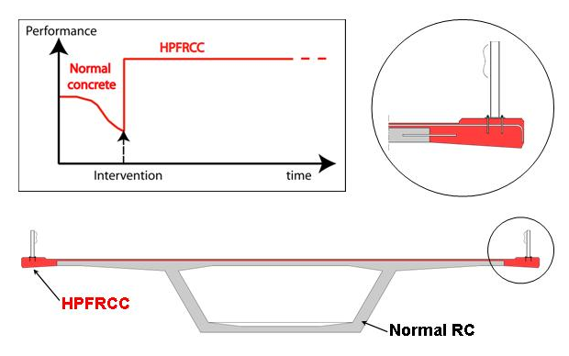
Figure 5.2: Conceptual approach for the application of ultra compact HPFRCC for the maintenance of reinforced concrete structures.
WP 14 is divided into 5 tasks, as follows:
- WP 14.1 Preliminary Study
- WP 14.2 Testing
- WP 14.3 Interpretation – modelling
- WP 14.4 Numerical parameter study
- WP 14.5 Specifications – documents for application

Task 14.1 Preliminary study

Description
The application of a new layer on an existing structure induces differential phenomena that can eventually lead to cracking and delamination of the new layer. In order to avoid these detrimental effects, it is necessary to take into consideration the evolution of the material properties of the new layer as well as the structural boundary conditions to which the new layer is subjected (degree of restraint, static system). Depending on the type of materials used for the new layer, different phenomena can lead to delamination or cracking: at early age, thermo-mechanical effects related to the hydration of binders and autogeneous shrinkage, and in the longer term, drying shrinkage. The aims of this task are twofold. Firstly to identify the phenomena that require further study with respect to the risk of delamination, transverse cracking and overall performance of the new layer. Secondly to select the materials that will be used in the main test series on the basis of their performance with respect to the processing (mixing, casting) as well as in the hardened state. Both experimental tests and numerical simulations will serve as a basis for the decisions. UHPFRC (ultra compact HPFRCC) materials will be used. The matrix will be identical for all the mixes and the fibrous composition will be varied according to the particular application.
Three aspects will be more specifically investigated in order to select appropriate materials for the main test series:
- Effect of the composition (fibre mix) on the workability. The properties in the fresh state (rheological e.g. workability) will serve as a basis to define the range of possible applications for specific mixes. As far as possible, self-compacting materials will be sought.
- Effect of the geometry of the element to be cast (wall or plate) on the mechanical properties (tensile and flexural behaviour).
- Effect of the composition of the fibrous mix on the mechanical properties (tensile and flexural behaviour on plates).

Justification
The state-of-the-art report will provide a sound basis for the main scientific work. It will summarise previous works on the rehabilitation of existing structures with HPFRCC and give the overall context of the issues to be considered when applying new layers of HPFRCC on existing structures. As different fibre mixes are available, it is important to select the most appropriate for a particular application. This selection has to be done on the basis of the properties in the fresh and hardened states, by means of preliminary experiments and numerical simulations.

Timetable
The preliminary study will last from month 1 to month 18. The state-of–the-art report will be finalised by month 8. Casting of specimens and tests on materials in the fresh state: month 10. Tensile and bending tests: month 11 and 12. Milestone M4: Identification of most significant phenomena for defining the main test program: month 6, Deliverable D13: Report on preliminary studies for the use of HPFRCC, month 18.

Participants
The state-of-the-art review will be performed by TRL under the leadership of Richard Woodward with the support of sub-contractor University of Wales, Cardiff, under the supervision of EPFL-MCS (Emmanuel Denarié). LCPC (Pierre Rossi) will provide the designs for the materials to be tested as well as the individual components. EPFL-MCS (Emmanuel Denarié, assisted by a post-doctoral student and a doctoral student) will be responsible for the fabrication of the specimens, testing, numerical simulations and interpretation of the results.

Task 14.2 Testing

Description
This task will include testing in the laboratory and pilot field trials. Both specimens and structural components will be used. The early age behaviour will be studied in detail owing to its special importance with respect to the creation of residual stresses in the material that is added to existing structural components. A TSTM (Temperature-Stress Testing Machine) will be used to investigate the early age behaviour and to characterise the autogeneous shrinkage and the viscoelastic behaviour. The long-term behaviour will be studied using creep and fatigue tests performed on material specimens and on hybrid structural elements. The mechanical interaction of HPFRCC materials with reinforcement bars will be studied.
The mechanical compatibility between the old concrete and the new layer of HPFRCC will be addressed through the characterisation of the time dependent behaviour of the new layer (principal stresses, shrinkage, thermo-mechanical effects, viscous deformations, onset and development of micro-cracking and cracking) at an early age and in the long-term. The influence of the geometry of the element to be repaired (cast as a wall or as a plate, as well as effect of the thickness) on the orientation of the fibres and on the resulting mechanical properties will be investigated. Tests will be performed to characterise the adhesion of the new layer to the substrate (“old concrete”).
The physico-chemical compatibility and protective function of the new layer will be addressed by testing the transport properties of HPFRCC materials both undamaged and at various levels of damage to simulate micro cracking induced by mechanical actions on structures. Water permeability, capillary sorption and moisture diffusivity as well as air permeability will be studied.
The statistical distribution of the properties (mechanical and physical/permeability) will be determined for use in probabilistic design methods. Both laboratory experiments and on-site field trials on large surfaces will be used to provide data.
Structural tests: In a preliminary phase, structural elements of ordinary concrete will be prepared to serve as a substrate for the new layers of HPFRCC to be cast in subsequent steps. They will be stored for three months before preparation of the surface by removing 3 cm of concrete using high water pressure hydro jetting. The new layers will be cast in two stages, corresponding to batches 2 (month 14) and 3 (month 17). Two series of tests on hybrid structural elements are planned, with different geometries and different conditions of loading (creep and fatigue).
Material tests: both mechanical properties and transport properties will be investigated. Tensile and flexural tests on plate elements will be undertaken for the different kinds of materials selected after completion of milestone M12 (task 14.1). The direction of casting of the elements will depend on the application: horizontal for repair layers on bridge decks, and vertical for repair layers on tunnel or gallery walls. The effect of damage on the permeability of the HPFRCC will be investigated from month 11 to 23.
The properties and the processing of the HPFRCC in the fresh state (rheology, maximum slopes, surfacing techniques, curing) will be studied .in more detail during batching sequence 3, month 17.

Justification
Experimental tests on small scale specimens as well as on hybrid structural elements, both in the laboratory and in pilot tests on-site will help demonstrate the applicability of the proposed method, determine the relevant properties and identify critical aspects not detected during the preliminary study. Laboratory tests on small-scale samples will provide material properties. Tests on structural elements under different conditions of restraint will help characterise (1) the interaction of the material properties with the restraint imposed by the existing structure to the new layer, and (2) their structural response to various types of actions.
Pilot tests of application on site will help determine the statistical variation of the mechanical properties and permeability, on real structures.
The results of this task will serve as a basis for the interpretation and modeling (task 14.3), numerical parameter study (task 14.4) and specifications – documents for application (task 14.5).

Timetable
This task will last from month 9 to month 30. The most significant part of the testing in the laboratory will be performed until month 24 and will serve as a basis for further tasks within this work package. The testing has been extended till month 30 in order to fully benefit from the long term tests on small scale specimens and on hybrid structural elements. The pilot tests on site will take place from month 21 to 30.
Milestones: M12: selection of materials for main test series: month 12, M18: choice of on site applications for pilot field trials with HPFRCC: month 21.
Deliverables: D18: report on laboratory tests on HPFRCC: month 24, D22: test report on on-site field trials with HPFRCC: month 30.

Participants
LCPC – Pierre Rossi will provide mix designs for the materials to be tested as well as the individual components. EPFL-MCS (Emmanuel Denarié, assisted by a post-doctoral student and a doctoral student) will be responsible for the fabrication of the specimens and hybrid structural elements, and their testing.

Task 14.3 Interpretation – modelling

Description
Interpretation of results and modelling will run concurrently with the testing. The aim will be to provide feedback for the testing with respect to the study of different materials and to make the first steps towards their optimisation for maintenance. The interpretation will also include the determination of the significant properties, models and phenomena that will be studied using numerical simulation. Figure 5.3 summarises the interrelations between modelling and experimental testing. The numerical modelling will use the results from Task 14.2 to address the following four main aspects:
- Material properties: mechanical properties in uniaxial tension and compression, at an early age and in the long-term, bond - adhesion to the substrate. Creep and fatigue models will be determined. Special attention will be given to the accurate modelling (1) of the hardening properties of the HPFRCC in uniaxial tension and (2) of the evolution of the autogeneous shrinkage and viscoelastic behaviour with time.
- Early age structural behaviour (thermo-mechanical effects, autogeneous shrinkage and creep).
- Long-term structural behaviour (drying shrinkage and creep).
- Structural behaviour at ultimate limit state.

Justification
The full exploitation of the experimental results both at the material and at the structural level requires a model of the observed phenomena. The models developed in this task will be used for the numerical parameter study performed in Task 14.4, and for further applications after completion of the project.

Timetable
This task will be undertaken between months 12 and 30 and will run concurrently with the testing and numerical parameter study.
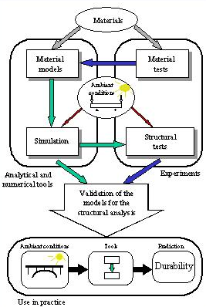
Figure 5.3: Flow chart for the interrelation between modelling and testing

Participants
EPFL-MCS (Emmanuel Denarié, assisted by a post-doctoral student and a doctoral student) will be responsible for this task, with the support of Pierre Rossi – LCPC for the interpretation of the test results, and the discussions on the models, and FEMMASSE b.v. (under subcontract to TRL) for implementation in finite element codes.

Task 14.4 Numerical parameter study

Description
This task will involve numerical simulations of typical structural components and their maintenance, repair or strengthening using HPFRCC materials for various geometries and boundary conditions. Simulations will be based on the interpretation of the laboratory and field testing with a view to extending and completing the study. Special attention will be given to:
- Effect of the thickness of the new layer
- Effect of the static system of the overall structure
- Conditions for delamination and influence of reinforcing bars in the new layer
- Effect of the ambient climatological conditions at the time of casting, on the development of i) the mechanical behaviour at an early age and ii) principal stresses

Justification
The numerical parameter study extends the results obtained in the experimental tests on the basis of the models identified in task 14.3, with a view to the use of HPFRCC in different practical applications. The results of this task and of tasks 14.2 and 14.3 will serve as a basis for the data to be provided in task 14.5: specification – documents for application.

Timetable
This task will last from month 21 to 33.
Deliverable D26: Modelling of HPFRCC in hybrid structures: month 33.

Participants
EPFL-MCS (Emmanuel Denarié, assisted by a post-doctoral student and a doctoral student) will be responsible for this task, with the support of Pierre Rossi – LCPC for the discussions on the models, and FEMMASSE b.v. (under subcontract to TRL) for provision of the finite element codes.

Task 14.5 Specifications – documents for application

Description
The final task of work package 14 will compile specifications for the use and further optimisation of HPFRCC for maintenance of highway structures. This will cover processing, test methods and compliance criteria, as well as numerical simulation and design with appropriate limit state criteria. This task will be divided into five sub-tasks, each one dedicated to a critical step for the application of HPFRCC for rehabilitation of concrete highway structures.
- Guidelines for choice of materials
- Guideline for design of repairs or reinforcements with HPFRCC
- Guidelines for processing HPFRCC
- Guidelines for testing HPFRCC
- Compliance criteria.
Finally, the works in WP 14 are closely related to those in WP 12 and 16. Deliverable D 31 from WP 12 will include large contribution from the works in WP 14.

Justification
This task will help summarise all relevant information for the practical application of HPFRCC for rehabilitation of concrete structures. Relevant documents for each level of the application process have to be provided, from the design and choice of the materials, to the recommended testing procedures and the compliance criteria.

Timetable
This task will last from month 24 to 33 and run partially concurrently and benefit from task 14.4 Numerical parameter study.

Participants
EPFL-MCS (Emmanuel Denarié, assisted by a post-doctoral student and a doctoral student) will be responsible for this task, with the support of the other partners of the work package: Pierre Rossi – LCPC and Richard Woodward – TRL.

WP 15: Survey of highway structures

Objectives
The aim of WP 15 ‘Survey of highway structures’ is to provide an updated inventory and assessment of highway structures in selected EEA and CE countries, and Guidelines for optimised assessment of highway structures.
Table 5.15 gives concise description of the work package. Figure A.13 gives detailed overview of tasks to be completed in WP 15.

Tasks
WP 15 is divided into 5 tasks, as follows:
- WP 15.1 Data collection
- WP 15.2 Condition assessment
- WP 15.3 Loading
- WP 15.4 Structural safety
- WP 15.5 Survey

Task 15.1 Data collection

Description
Several European and international committees have in recent years for different purposes collected information about highway structures. However, none of them have collected all data required to provide a comprehensive survey of highway structures in CE and EEA countries. In most cases they were limited to specific data and from only a few CEE countries.
The purpose of data collection in SAMARIS is to obtain the missing information with minimum inconvenience to the end-users who will be asked to complete the questionnaires. They have received similar requests in the past and may therefore be discouraged from completing another questionnaire. This will be prevented by:
Table 5.15: Description of Work Package 15 ‘Survey of highway structures’
Work package Title: ‘Survey of highway structures’ |  |  | WP No. 15
Starting date: Month No. 1 |  | Duration: 36 months | Total Effort: 106
Partners involved | R&D Task / Activity of partner |  | Effort:
ZAG | WP leader, condition & safety assessment, CE country |  | 22
IBDiM | Condition & safety assessment, CE country |  | 17
TCD | Load modelling |  | 10
UPC | Condition & safety assessment |  | 5
UCD | Condition assessment & Load modelling |  | 42
TRL | Bridge management |  | 2
EPFL | Input from EEA country |  | 2
FRA | End user, input from CE (EU) country |  | 1
ŘSD | End user, input from CE country |  | 1
KTI | End user, input from CE country |  | 1
NPRA | End user, input from EEA country |  | 1
GDPR | End user, input from CE country |  | 1
DRSC | End user, input from CE country |  | 1
Objectives
To provide an updated inventory and assessment of highway structures in EEA and CE countries. To propose procedures for optimised assessment of highway structures taking into account site-specific parameters.
Description of Work/tasks
Task 15.1: Data collection. Collect data on highway structures from selected EEA and CE countries.
Task 15.2: Condition. Evaluation of condition assessment procedures from selected EEA and CE countries.
Task 15.3: Loading. Examine existing assessment load models. Propose optimised load models based on experimental data and performed WIM measurements.
Task 15.4: Structural Safety. Evaluate structural safety assessment procedures in selected countries. Propose optimised and easy-to-use safety assessment procedures.
Task 15.5: Updated Survey. Prepare report on analysis of the highway structures in selected EEA and CE countries and Guidelines for optimised assessment of highway structures.
Deliverables
Deliverable D19: State-of-the-art report on assessment of structures in selected EEA and CE countries. |  |  | Date due: Month 24
Deliverable D30: Guidelines for optimised assessment of highway structures. |  |  | Date due: Month 33
Milestones and criteria
Milestone M11: Collection of structural data.  All questionnaires completed and returned. |  |  | Date due: Month 12
Milestone M16: Collection of traffic data.  Database on traffic data and WIM measurements available. |  |  | Date due: Month 18
Interrelation with other work packages
All other Work Packages in the structures stream
- preparing a concise questionnaire, which will already contain information provided previously in, and which will just have to be confirmed,
- subcontracting six of the CE and EEA countries where representatives of Road administrations or their authorised representatives will be directly involved in preparation of the survey and by
- sending blank questionnaires only to those countries where data is not available.
To get a wider picture on highway structures in Europe, the questionnaires will also be sent to other CEE countries, such as the Baltic States, and to those countries that have members in FEHRL (the Forum of European National Highway Research Laboratories). Consortium members will use their personal contacts wherever possible to obtain answers to the questionnaires.
In general, the questionnaires will contain information about the stock of structures, their structural (deterioration) and loading conditions (which loading schemes are used under different circumstances) and about the procedures used for structural safety assessment.
The main sources of available information (EU Fourth FW project BRIME, COST actions 323 and 345, PIARC committee C11, FIB documents) are discussed in the following subchapters.

Justification
Data collection will provide essential information for all other tasks from WP 15 and also WP 12.

Timetable
This task will last from month 1 to 18. All questionnaires should be returned by the end of month 12 and the results evaluated during the remaining period.

Participants
Task 15.1 will be lead by ZAG (Mr. Aleš Žnidarič) with the help of all other WP 15 task leaders. It will also include contribution from subcontracted end-users from 6 CE and EEA countries.

Task 15.2 Condition assessment

Description
The condition assessment problem has been studied previously in a number of projects, as well as in many publications on management of engineering structures. All previous studies stress the importance of proper and accurate condition assessment, which is one of the main parameters on which the decision making process in bridge management is based. Moreover, condition assessment enables severe damage to be avoided by finding and restoring deterioration in its initiation phase. It also plays a key role in safety of deteriorated structures by providing a realistic estimate of their reduced carrying capacity. A further objective of this task is to evaluate efficiency of the repair or strengthening methods used and the suitability of the materials used in the repair work.
The results of two recent European projects give the most valuable and useful inputs for work in WP 15. These are the BRIME project from the 4th Framework Programme, finished in 1999, and COST 345 action “Procedures Required for Assessing Highway Structures”, finished in year 2002. Some publications, mainly originated from PIARC and OECD, also provide information on condition assessment.
Task 15.2 will be done in three subtasks:
- Literature survey which will give an overview of existing procedures for condition assessment and the data available.
- Evaluation of questionnaires for information on codes, tools and procedures and condition rating procedures used in the countries surveyed.
- Elaboration of the “Handbook of damages”. A draft internet application was set-up within the COST 345 action which gives descriptions and photographs of numerous examples of damages observed during bridge inspections. This application will be upgraded technically (data will be reorganised and search tools added) and with respect to its content (missing information will be added).

Justification
It has been decided during the SAMARIS proposal phase that WP 15 will deal mainly with five CE countries, one of them (Austria) being the EU member and four others (Czech Republic, Hungary, Slovenia and Poland) undergoing the EU accession process. In addition, Norway as the EEA country will also be thoroughly studied. With the help of Task 15.1 this task will collect and evaluate the condition assessment practices adopted by the national road authorities in these countries and will be compared with the procedures used in some other EC countries.
The reviews of existing literature showed that the most complete and accurate source for future work is the BRIME project. Its reports are finished and approved and cover the following countries: Austria, Denmark, France, Germany, Norway, Slovenia, United Kingdom and the United States. They provide for these countries information on condition assessment, condition rating and evaluation function practices.
COST 345 action has finished recently, but the Final Report has not been printed yet (it is available in electronic form). This report is valuable as it already contains data from two auxiliary CE countries, the Czech Republic and Poland. That information is however less detailed and needs further investigation.
The results of these two projects clearly show that condition assessment practices differ considerably between countries. Part of the questionnaire prepared for Task 15.1, which relates condition assessment, should give answers to the following questions:
- Are there any codes or rules for structure condition assessment? If so, the reference number and titles should be provided.
- What are the “tools” for condition assessment used by highway authorities?
- Are the results of inspections used to produce a condition rating for a structure?
- If so, how are the results of inspection used to obtain a condition rating for a structure? Give the short description of the algorithm.
- What are the condition ratings used for?

Timetable
This task will last from month 4 to 24. The first four months are reserved for the literature survey, with the other two subtasks starting in month 8 and 10.

Participants
Task 15.2 will be lead by IBDiM (Mr. Tomasz Wierzbicki) with the help of all other WP 15 members.

Task 15.3 Loading

Description
The aim of WP 5, ‘Survey of highway structures’, is to provide an updated inventory and assessment of highway structures in EEA and CE countries. The Work Package has been subdivided into four tasks. The task ‘Loading’ is mainly focused on existing bridge structures where realistic assessments of the live load to which they are subjected can significantly influence the results of the structural assessments, in some cases leading to considerable savings in rehabilitation or replacement costs. The task aims to examine loading conditions on existing structures and to propose procedures for optimised dead and live load modelling in structural safety assessment. The aspects of loading to be addressed include: dead load; true traffic load; static and dynamic traffic load. The objectives of the task will be achieved through a combination of desk studies, computer analyses and field experiments. Following a task group meeting in Dublin, Ireland in February 2003, it was decided that given the overlap between the task areas and their individual goals, which in each case appeared to relate predominantly to field data collection, the optimal experimental strategy would be to devise experiments which would prove beneficial to all. An advantage of this policy would be consistency in the examples provided to outline principles/methodologies proposed for assessment. It was decided that initially two highway bridge structures would be selected for extensive collection of data relating to dead and live load characteristics. Additional structures may also be selected during the course of the project. A bridge in Poland has been selected for instrumentation and monitoring. Approval has been obtained from the Polish authorities to use the structure. It was decided that selection of the second structure would be made at a later date in line with the combined objectives of each subsection of the task. These combined objectives relate to location, traffic intensity, geometry, number of lanes, material, dynamic characteristics, condition of the structure and approach. They also include ease of instrumentation and the feasibility of long term monitoring. Further discussion of the experimental objectives related to each sub-sections is provided in the following.

Dead Loads
In assessing an existing structure the engineer is faced with far less uncertainty regarding loading than at the design stage. This is especially true in relation to dead loads. Rather than approximating variables such as surfacing depth and applying large partial safety factors, the engineer can measure the parameters on site. The purpose of this sub-section is to evaluate procedures used to establish dead loads in structural assessment. The evaluations will be based on codes, bridge inspections and testing.
Experiments performed in relation to this sub-section of the task will be carried out on the bridges selected for monitoring. The advantage of such a step is that it will provide consistency in the examples provided in the final report of the task. Initially measurements will be performed on the composite steel bridge identified in Poland. Having demonstrated application of techniques for this type of structure, the criteria for additional structures may require that they be constructed from different materials, to increase the scope of the results.

True Traffic Loading
Determination of the traffic loading to which existing structures are subject can also benefit from reduced uncertainty at the assessment stage. Reduction in the uncertainty can be achieved through measurement of the traffic to which the structure is subjected. Improvement in the accuracy of weigh in motion (WIM) technology in recent years has provided the ability to collect reliable unbiased traffic statistics in real time. This data may be used in simulation to determine characteristic load effects (i.e. maximum bending moments or shear forces to which the structure is subjected during its design or remaining lifetime) in a similar manner to which extreme wind or floods are predicted. Theoretical traffic load models, which provide closed form solutions for characteristic load effects may be calibrated against such data to reflect variations in traffic intensity and gross vehicle weight distribution at a particular site or on a particular network. This section will address procedures for determining traffic load models to identify differences between traffic composition in EU, EEA and CE countries. The analysis will be based on available WIM data and on measurements performed for this purpose.
Although extensive WIM data is available for European traffic its principal limitation lies in the duration for which recording was performed. Generally a period of one week has been adopted for measurement and considered acceptable for code calibration, where the period chosen has not been considered representative, i.e. not during holidays or demonstrations. Clearly, it is preferable to collect data over a longer period and in various seasons to determine whether there are seasonal variations in traffic loading. The experiments performed as part of this task, on the Polish bridge and others, will instrument the structures chosen for longer periods and through various seasons/years to provide a more comprehensive database of traffic statistics.

Live Load Modelling
To last the whole life-time of the structure, new bridges are designed on the basis of a notional pattern of loading, usually presented in codes as generalised conservative loading schemes. Assessment of existing bridges on the other hand can be optimised considerably if specific assessment loading schemes or even site-specific load models are applied. Such load models are rarely used around Europe, which often leads to unnecessarily frequent interventions on bridges or even unnecessary replacement. To optimise the bridge assessment procedures, live load models for bridge assessment will be proposed. They will be derived so as to relate logically to the derivation procedure used for the Eurocode, EC1, Part 3 and will be applicable to WIM data measured in any country to account of local traffic conditions.
The models will be far more robust that any previously derived due to the extensive database of traffic statistics, which will be available for their calibration as a result of the measurements, performed as part of this task.

Dynamic Loading
The Eurocode for bridge traffic loading incorporates dynamic impact factors based on experiments carried out using single truck crossing events. Such an approach is excessively conservative as dynamic effects are lower when two or more trucks are crossing the bridge simultaneously which generally generates a more serious loading event than that due to a single vehicle. To optimise the dynamic loading in the assessment of bridges, it is proposed to develop a computer model to calculate dynamic impact factors for multiple truck crossing events. The theoretical result will be compared with field tests using two trucks of known weight. In addition, different bridges will be instrumented with a bridge WIM system, which can statistically evaluate impact factors of all loading events due to vehicles crossing the structure.
The SAMARIS project provides an opportunity to carry out dynamic measurement in tandem with WIM measurement on a scale not previously performed. It is expected that consideration of the requirements of the dynamic experiment, with regard to road roughness, structural condition and form will play a significant role in the selection of the structures to be used in this project. The result should be a solution to the dynamic problem for structures where it is most crucial, i.e. short to medium span bridges where the two-truck event governs the extreme load effect. These results will be fed back into the subtask on live load modelling to further optimise the traffic load model for bridges.

Timetable
This task will last from month 7 to 27. All sub-tasks will start between months 8 and 10. Experiments are scheduled for month 9 and 16.

Participants
Task 15.3 will be lead by TCD (Dr. Alan O’Connor) with the assistance of UCD, IBDiM and ZAG who will be in charge of the experiments. A doctoral student from UCD will also be involved in the research work.

Task 15.4 Structural safety

Description and justification
The main objective of this task is to determine the methodology used by different highway administrations in different countries to assess the structural safety of existing highway structures (bridges, retaining walls, tunnels…). In this context “structural safety assessment” means the calculation of a value that takes into account both the loading applied to the structure and the resistance of the structure. Therefore it is more than a simple assessment of condition, where only the actual condition of the structure is of interest and is used to calculate a condition rating. The methodology used for structural assessment may be expressed in a code or recommendation or may be just an interim method of practice for internal use by an Administration. All cases are of interest. Based on the information obtained on the different methods used by the different Administrations (some will be simpler and approximate and others more complex and accurate) the next step will be the definition of a proposal for structural safety assessment that may be adopted and used in different countries. This should result in a uniform, optimised and easy-to-use safety assessment method. Besides the information obtained directly from the Road Administrations, the general recommendations and background issued by several International Organisations (RILEM, JCSS, ISO, FIB, PIARC …) will be also considered. Methods used in other non-European countries (Canada, USA …) will be also investigated.
In order to accomplish this task, information will be obtained from all the countries in the SAMARIS project. The procedures for assessment of structural safety vary from country to country (even non-existent in some of them), therefore based on the responses obtained from all partners, more specific information will be collected from selected countries representative of EU, EEA and CE countries. This will be used to investigate differences in more depth as well as identifying any similarities of the methods used in those selected countries. An attempt will be made to define a minimum common practice that could be accepted in all them (looking for “consensus”).
Therefore, the proposed work plan for the task 15.4 (Structural Safety) will be as follows:
- Preparation of the questionnaire and mailing to all countries and/or Highway Administrations involved in SAMARIS (see first draft of questionnaire in the annex )
- Preparation of a state-of-the-art report on the techniques used worldwide for the structural safety assessment of existing highway structures. To this end, the following information will be gathered:
- codes, recommendations and standards used in the SAMARIS countries (for the countries that answered where those codes or interim rules exist),
- codes, recommendations and standards used in other countries (European and non-European),
- codes or recommendations developed by International Bodies (FIB, ACI, JCCS, ISO, PIARC…).
- Selection of countries representative of the different techniques used and also representative of the EU, EEA and CE countries.
- Comparative study (main goals and pitfalls) on the different techniques used in the selected SAMARIS countries and worldwide.
- Definition of a methodology for the structural safety assessment of existing highway structures. This should take into account:
- the type of highway structures contained in the inventory of European countries,
- the most available and used techniques for condition assessment (resistance part),
- the most available and used techniques for the load updating (load part),
- the definition of optimised traffic load models (directly related to WP15.3),
- the definition of target safety levels,
- the objectives searched in the structural safety assessment: calculation of safety for individual structures, inclusion of reliability values in management systems of a group of structures or bridges, use of reliability values for life-cycle cost analysis …,
- the procedure must be as accurate and user-friendly as possible,
- the procedure must be as general as possible, with a format that can be applied to any existing structure (bridge, retaining wall, tunnel…),
- other conditions derived during the development of the SAMARIS project and the interaction with other WP.

Timetable
This task will last from month 4 to 30. All sub-tasks will start between months 8 and 10.

Participants
Task 15.4 will be lead by UPC (Prof. Joan Casas) with the assistance of ZAG, UCD, IBDiM and TCD.

Task 15.5 Survey

Description and justification
Based on the answers provided in tasks 15.1 to 15.4 a survey of highway structures in CE in EEA countries will be generated. If possible, results from other EE countries will be included as well. All results will be related to the available information from the EU countries. This Task Survey will be also responsible for the two deliverables of the WP 15.

Timetable
This task will last from month 17 to 30. Deliverable D19 is due at the end of month 24 and deliverable D30 at the end of month 33.

Participants
Task 15.5 will be lead by UCD (Prof. Eugene O’Brien) with the assistance of all other WP members. A doctoral student from UCD will contribute considerably to the outcomes of this work task.

Project Management and Administration

WP 1: Project management

Objectives
WP 1 manages the project and sees that its milestones and deliveries are achieved in accordance with the plan and budget.

Tasks
WP 1 is divided into 7 tasks:
- Task 1.1 Organisation and documentation of Contractors’ Committee meetings
- Task 1.2 Organisation and documentation of Management Committee meetings
- Task 1.3 Scientific coordination of the project’s pavement stream
- Task 1.4 Scientific coordination of the project’s structure stream
- Task 1.5 Production of Midterm assessment report
- Task 1.6 Administrative and financial management of the project
- Task 1.7 Maintaining a list of all project documents on project home page
A summary description of WP1 in tabular form is shown in Table 6.16.

Task 1.1 Organisation and documentation of Contractors’ Committee meetings
All 23 contractors are represented on the Contractors’ Committee, which is convened every 6 months or as deemed necessary by the project coordinator, who also chairs its meetings. This body takes all necessary decisions to keep the project on track within the allocated resources and takes remedial action in case of any significant deviations.
The committee may if necessary make agreements to protect the knowledge of any partner in order to facilitate cooperation. And the committee may agree subject to the clauses of the contract with the Commission to change the internal distribution of funding between members. All such agreements must be approved by all contractors.
Meetings are prepared by the project coordinator and all contractors are informed about the venue and time of the meeting at least 6 weeks in advance. Contractors will on these meetings be given a status of the project by the management committee. Any contractor may request items to be discussed on these meetings. Such requests must be presented to the project coordinator at least 2 weeks before the meeting. The project coordinator will circulate minutes from the meetings within on month after the meeting.
Table 6.16: Description of Work Package 1 ‘Project management’
Work package Title: ‘Project management’ |  |  | WP No. 1
Starting date: Month No. 1 |  | Duration: 36 months | Total Effort: 23
Partners involved | R&D Task / Activity of partner |  | Effort:
DRI | WP leader, |  | 11
LCPC | Scientific coordination of pavement stream of research |  | 6
ZAG | Scientific coordination of structure stream of research |  | 6
Objectives
To manage the project according to plans and budget and liaise between Commission and contractors
Description of Work/tasks
Task 1.1 Organisation and documentation of Contractors’ Committee meetings
Task 1.2 Organisation and documentation of Management Committee meetings
Task 1.3 Scientific coordination of the project’s pavement stream
Task 1.4 Scientific coordination of the project’s structure stream
Task 1.5 Production of Midterm assessment report
Task 1.6 Administrative and financial management of the project
Task 1.7 Maintaining a list of all project documents on project home page
Deliverables
D14: Mid-term Assessment report |  |  | Date due: Month 18
Annual Progress reports
Milestones and criteria
Milestone M17: Mid-term assessment completed. Project progress and results are satisfactory and plans have been adjusted if and as necessary |  |  | Date due: Month 19
Interrelation with other work packages
All other Work Packages in the project

Task 1.2 Organisation and documentation of Management Committee meetings
The management committee consist of the project co-ordinator (chair), the two scientific co-ordinators and the work package leaders. This body meets quarterly and oversees in particular the scientific progress of the project. Frequent contacts between the project co-ordinator and the two scientific co-ordinators between the formal meetings to further ascertain that progress is smooth and continuous. The management committee will normally observe and analyse situations that may require the attention of the contractors’ committee and prepare recommendations for interventions.
SAMARIS was planned on the initiative of FEHRL (Forum of European Highway Research Laboratories) which according to its rules for FEHRL based projects under the European framework programmes has appointed a member of its executive committee (Mr. Robin Sébille from LCPC) to follow the project, so as to be able to intervene together with the project coordinator if a FEHRL member among the contractors fails to perform satisfactorily.

Task 1.3 Scientific co-ordination of the project’s pavement stream
The co-ordination and conduct of research in the project’s pavement stream, i.e. work packages 2 through 6 is the joint responsibility of the work package leaders and their scientific coordinator, Dr. Jean-Michel Piau from LCPC. The scientific coordinator oversees the QA process and ascertains that deliverables are reviewed and verified (if required) before becoming validated and approved for delivery to the Commission.

Task 1.4 Scientific co-ordination of the project’s structure stream
The co-ordination and conduct of research in the project’s pavement stream, i.e. work packages 12 through 15 is the joint responsibility of the work package leaders and their scientific coordinator, Mr. Aleš Žnidarič from ZAG. The scientific coordinator oversees the QA process and ascertains that deliverables are reviewed and verified (if required) before becoming validated and approved for delivery to the Commission.

Task 1.5 Conduct of Midterm assessment
The project coordinator organises a midterm assessment of the project to be conducted in a meeting with participation of the Contractors Committee, the Management Committee and the Commission representative before the end of the 19th month of the project. The assessment is based on a midterm status report, which will cover all completed work and work in progress and budget status and form the basis for any decisions to adjust the remaining work plan as needed. Procedures and processes to encourage and support the practical exploitation of results will be discussed and assessed.

Task 1.6 Administrative and financial management of the project
The work package includes all activities by the project coordinator and his assistant acting as the two-way channel of all information between the Commission and the contractors in compliance with Article 2 of Annex II (General Conditions) of the contract. These activities include in particular:
- submission to the Commission of periodic cost statements based on information from all contractors,
- submission to the Commission periodic activity and progress reports based on declarations from contractors,
- submission to the Commission of all other deliverables of the project, including the summary of the technological implementation plan,
- receipt and all payments from the Commission for onward distribution to contractors.
Also, the project coordinator has the role of advisor to contractors on all matters related to their contractual rights and obligations.

Task 1.7 Maintaining a list of all project documents on project home page
All records of management meetings, budget tables, cost and progress statements, project rules and procedures, milestone results and all deliverables in final draft or approved version will be placed on the private web page for easy access by project members.
For a description of the project web site see paragraph 6.3 of this report.

Quality Assurance and Control

General
The quality assurance plan for the SAMARIS project will be simple, yet efficient. It will be based on the ISO standard 9004:2000 “Quality management systems – Guidelines for performance improvements”, on its chapter 7.3 on “Design and development”. This chapter specifies that in a design and development of a product (in this case a research project) the organisation (management) should determine:
- The design and development stages (milestones and deliverables).
- The review, verification and validation procedures appropriate.
- The responsibilities and authorities for actions.
Components under topic a) have already been thought about during the project preparation phase and are finalised in this document. Topic b) and c) are discussed below.

Milestones and deliverables
Fulfilment of milestones and deliverables will be followed by the MG. Their status will be available on private part of the SAMARIS web page.

Review, verification and validation procedures

Project reviews
Systematic reviews will be performed in accordance with planned arrangements:
- To evaluate results according to the requirements (plan).
- To identify any problems and propose necessary actions.
Records of the results of the reviews and any necessary actions will be maintained. The project reviews will be done by the Management group (MG).

Deliverable reviews
Deliverable reviews will be done by the research coordinators (RC) of the relevant project stream and will be approved at the MG meetings. If a RC is the submitter of the deliverable the MG appoints another project member to do the review.

Deliverable verifications
Deliverable verification process will ensure that the outputs (results) meet the requirements specified in the work plan. Again, records of the results of the reviews and any necessary actions will be maintained. When appropriate, the verifications will be done by senior scientists of the principal contractors who are not working on deliverable in question. They will report to the MG on their findings. Verifications will be performed before the proposed deliverables are approved for dissemination. Inception, mid-term and final report are verified by the European Commission.

Deliverable validations
Deliverable validation process is intended to ensure that the outputs (results) meet requirements of the end-users. Members of the Reference Group of End-users (RG), which has been established of representatives of public road authorities from the EU and Central European countries and from European professional associations (see chapter 7.2), will be invited to validate the main SAMARIS public deliverables.
Deliverables of internal nature, which will be prepared to support working process, will not be submitted to verification and validation.

Control of project changes
All changes will be identified and records maintained. The changes will be reviewed and verified as appropriate and approved before implementation. This process will include:
- evaluation of the effect of the changes on constituent parts of results already delivered and
- procedures for informing all interested parties about the changes.
Document that changes are based on is the Inception report (deliverable D2).

Responsibilities
Responsibilities for scientific output of the project are shared between the MG (SC), the WP leaders and the Task leaders.
Task leaders are directly responsible for the quality of work performed in their tasks. They report progress, problems and changes to their WP leaders. Every 3 months before the MG meeting WP leaders send their QA reports (included as a special chapter in their Progress reports) to the MG for review. MG approves the QA reports or/and takes necessary changes.
The two scientific coordinators will maintain records of all QA reports for each individual stream.

QA reports
Scientific progress of the project will be maintained and followed with the PM (Project Management) software MS Project. This will for each Task, WG and project stream show at any time give information about:
- when the task has started,
- how much has been completed,
- which are the critical paths and how they influence related tasks.
The QA programme for documents and other deliverables will run through the private part of the SAMARIS web page. These pages are supported by a SQL database of all uploaded documents, with special emphasis on the deliverables, and the scripting language for dynamic HTML presentations, PHP. The interface will provide tools for automatic unique numbering of all uploaded documents according to the rules described in chapter 6.2.6 and keep tracks on all changes (draft versions). In addition, it will for all main deliverables follow their QA status:
- when and by whom it was submitted,
- when and by whom it was reviewed, verified and validated,
- was it approved or changes were required,
- if changes were required would this influence other tasks of the project.
A condensed version of the QA status (compliance with the milestones, status of approval of deliverables) will be available on the private (protected) part of the SAMARIS web page.

Numbering of SAMARIS Documents
All SAMARIS documents:
- have a standard cover sheet,
- are numbered in a unique and unambiguous way.
Cover sheets are included into two templates available on the private part of the SAMARIS web page (http://samaris.zag.si/). The first one (SAMARIS_document.dot) is intended for simpler documents, such as minutes of the meetings. The second one (SAMARIS_report.dot) will be used for reports as it contains tables of contents, figures and tables, a table for QA information and is ready for double-sided printing.
For numbering of documents the following procedure will be used:
- each number starts with SAM to identify a SAMARIS documents, followed by
- a 2- or 3-letter code, specifying part of SAMARIS that submitted it:
- GE: General project documents
- MG: Management group
- CC: Contractors committee
- PA: Pavements stream
- ST: Structures stream
- 01 to 16: Work package 1 to 16
- PPP: Acronym of the project partner
- followed by type of the document, preceded by a hyphen:
- MI: Minutes
- PR: Progress report
- DE: Main deliverable according to the project proposal
- CS: Cost statement
- QA: Quality assurance document
- OT: other non-classified documents
- followed by successive number of the document of that type, written with 2 digits (e.g.: 03, 12), and
- followed by a slash character and version of the document; final versions of the documents do not have the version number.
Some examples:
- SAM-CC-MI03/1: Minutes of the 3rd Contractors committee meeting, draft 1
- SAM-GE-OT15: Non-classified general document No. 15
- SAM-03-PR02: 2nd Progress report of WP 3, final version
- SAM-ZAG-CS05: ZAG’s 5th Cost statement
- SAM-16-DE01/1: Deliverable 1 of WP 16, version 1, etc.
Filenames of files posted on the SAMARIS web page match the document numbers, except that all dividing characters are replaced by an underscore (_) character and followed by the appropriate extension. The above examples would then change to:
- sam_cc_mi03_1.doc
- sam_ge_ot15.pdf
- sam_03_pr02.pdf
- sam_zag_cs05.xls
- sam_16_de01_1.doc.

Project web site
SAMARIS web page has been published on the ZAG’s server as the first deliverable of the project. Developed in the MS Front Page and supported by the PHP scripting language for dynamic HTML presentations it is divided into the public and private part. The private part is further split into the ‘Pavements’ and ‘Structures’ stream pages (Figure 6.4, right), the first ones hosted on the LCPC server. Pages also contain:
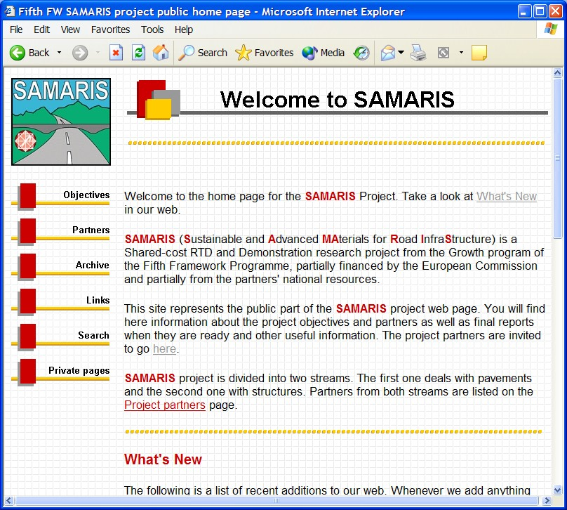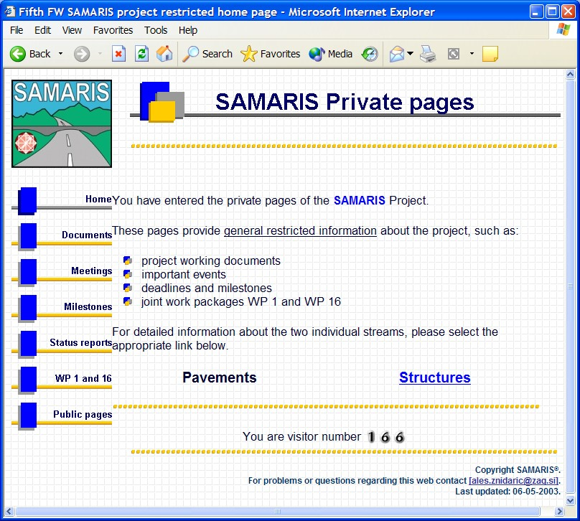
Figure 6.4: Opening pages of the public and private parts of SAMARIS web page
- description of objectives,
- general and detailed information about all partners (Figure 6.5),
- documents from meetings, organised by Work packages,
- QA status of the main deliverables,
- archive of other documents relevant to the project,
- searching tool for the documents.
All documents except the approved deliverables are posted on the private part of the web site.
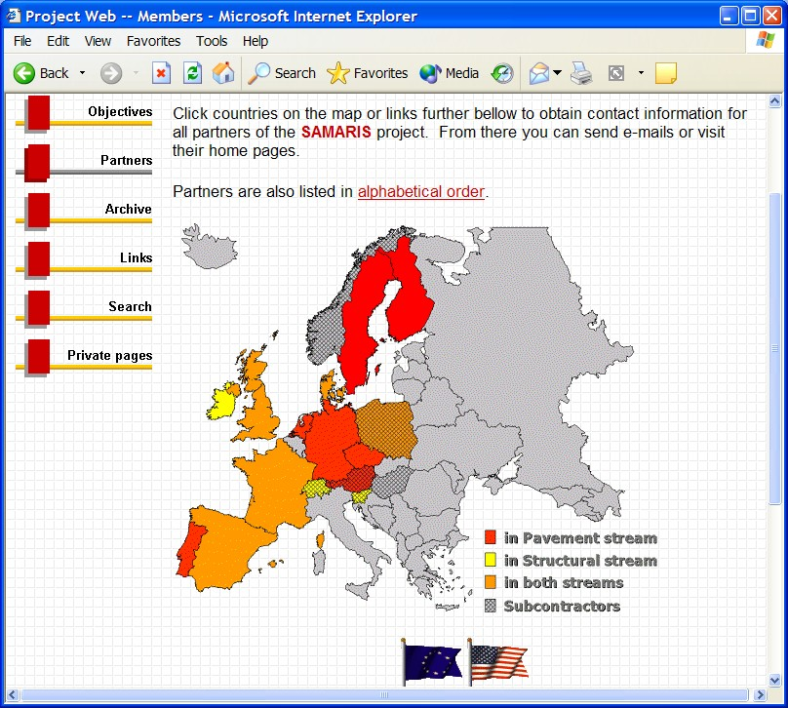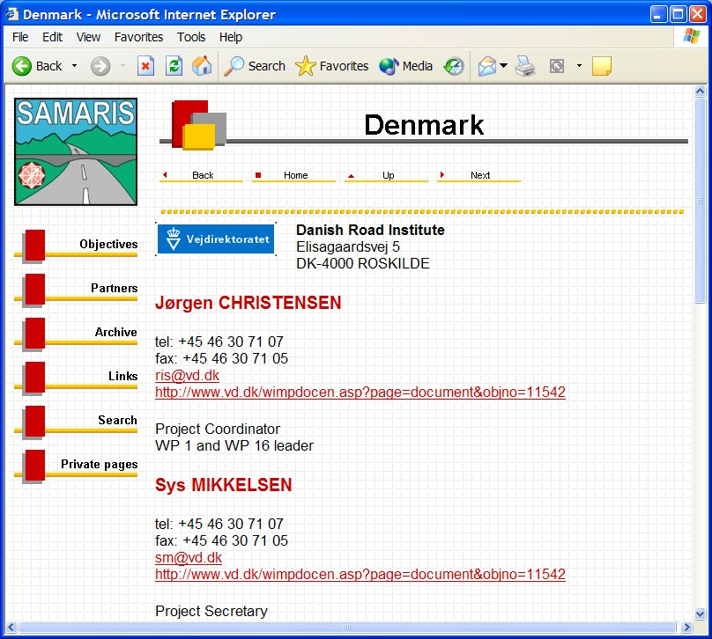
Figure 6.5: Main and detailed Partners page

Dissemination and exploitation of results

WP16: Dissemination and exploitation

Objectives
WP16 shall disseminate the outcomes of the project in ways that as far as possible result in their early implementation and exploitation.

Tasks
WP 7 is divided into six tasks:
- Task 16.1 Maintenance of project internet web site
- Task 16.2 Preparation and dissemination of information about and from the project
- Task 16.3 Organisation and subsequent contact with reference group of end users
- Task 16.4 Organisation and conduct of final seminar
- Task 16.5 Final report
- Task 16.6 Technological implementation plan
A summary description of WP1 in tabular form is shown in Table 7.17.

Task 16.1: Maintenance of project internet web site
The project internet web site is described in section 6.3 of this report. The internal pages were opened to project participants at the end of month 3, and work is in progress to complete the public pages by the end of month 6. These pages will be used for up-to-date information to the interested public about project plans, progress and results. These pages, along with the project internal web pages will be maintained and edited by scientific coordinator for the structure research stream in consultation with the WP16 leader and the scientific coordinator for the pavement research stream.

Task 16.2: Preparation and dissemination of information about and from the project
The continuous and major effort of WP16 is to develop materials about the project for publication and presentation in various media and fora. A project brochure (Deliverable D3) will be developed and printed in large numbers for distribution at occasions where road researchers, administrators and contractors gather for national or international events, using as far as possible the project members to achieve this wide spread of basic information about the project. Also, this task shall endeavour to produce articles for professional journals as well as papers for presentation at suitable scientific and professional meetings. All work package leaders are members of this work package with the purpose of contributing strongly to this task according to a staged publishing plan to be developed and agreed in the WP.
Table 7.17: Description of Work Package 16 ‘Dissemination and exploitation’
Work package Title: ‘Dissemination and Exploitation’ |  |  | WP No. 16
Starting date: Month No. 1 |  | Duration: 36 months | Total Effort: 32
Partners involved | R&D Task / Activity of partner |  | Effort:
DRI | WP leader, papers, briefing material, reference group contact, final seminar, final report, technological implementation plan |  | 8
LCPC | Papers, briefing materials, web site |  | 5
ZAG | Papers, briefing materials, web site |  | 6
TRL | Papers, briefing materials |  | 6
UCD | Papers, briefing materials |  | 2
CEDEX | Papers, briefing materials |  | 2
EPFL | Papers, briefing materials |  | 3
Objectives
To disseminate the results of the project in ways that as far as possible result in their early implementation and exploitation
Description of Work/tasks
Task 16.1 Maintenance of project internet web site
Task 16.2 Preparation and dissemination of information about and from the project
Task 16.3 Organisation and subsequent contact with reference group of end users
Task 16.4 Organisation of final seminar
Task 16.5 Final report
Task 16.6 Technological implementation plan
Deliverables
D1: Project internal internet web site |  |  | Due: Month 3
D3: Project Brochure |  |  | Due: Month 6
D32: Executive summary report of the project |  |  | Due: Month 36
D33: Briefing material to support presentations of project results |  |  | Due: Month 36
D34: Technological implementation plan |  |  | Due: Month 38
Milestones and criteria
M19: Final seminar organised / Preparations completed |  |  | Due: Month 33
Interrelation with other work packages
WP16 will work to disseminate, with the aim of achieving implementation and exploitation, the results of all scientific work packages. It will integrate these results in a final executive summary report.

Task 16.3: Organisation and subsequent contact with reference group of end users
The composition and role of the reference group of end users are described in section 7.2 below. It is an important task of work package 16 to seek relevant members for this group, to liaise with them throughout the project and to organise the events, where the group is convened to become updated on the progress and status of the project and to discuss plans and priorities. Three such events are foreseen. The first occasion is in June 2003, where the focus is on this inception report in the draft stage before final editing and submission to the Commission. The second event will be in second half of 2004, after mid-term assessment of the project and at a time when many deliverables have been completed. The last event will be the final project seminar, which is expected to attract a larger audience, but where the reference group of end users will form the core group and will be consulted in the preparation phase of deliverable 34, the technological implementation plan.

Task 16.4: Organisation and conduct of final seminar
The final event of the project after all research has been completed and reported is a seminar, to which the project intends to attract the attendance of fellow researchers as well as potential end users, including Commission officials. Current plans would let the seminar in addition to a general session have two special sessions: one dedicated to the situation in CE countries and one devoted to the members of CEN TC 227 (Road materials) and open to members of TC 154 (Aggregate) and TC 336 (Bituminous binders) who are responsible for drafting the European specifications for pavement materials.
Whilst the seminar will be organised and managed by the DRI, all scientific work package and task leaders are expected to provide the presentations for the programme, and the final executive summary report shall be available for the event. Implementation issues will be given special emphasis on this occasion.

Task 16.5: Final report
The final report will be an executive summary of the findings and results as documented in the many deliveries of the project, concise and readable for the busy target group of end users. The report will also present the conclusions and recommendations, -including recommendations for the practical implementation of results in road infrastructure maintenance- , which result from the totality of individual findings. The reference group of end users will be consulted regarding the implementation recommendations, and a draft version of the report will be made available for the final seminar to allow discussions from this event to influence the final version of the report. It will have to be considered, if the final report should be separated into two separate parts, one covering the conclusions and recommendations based on the work in the pavement stream of research, and the other based on the structure research stream.

Task 16.6: Technological implementation plan
This deliverable is specified in the General Conditions of the contract with the Commission. It shall include a summary of the project and a forecast of the intentions of the contractors, as well as a description of their achievements regarding the use of the knowledge generated by the project. Hence, this plan is a summary of the individual and more comprehensive submissions by contractors to the Commission regarding the same issues. The technological implementation plan is due no later than two months after the end of the duration of the project.

Reference Group of End Users
The original proposal for project SAMARIS and the resulting contract with the Commission stipulate that a reference group of end users be established.

Role
The reference group is seen as having two distinct roles:
- to facilitate the introduction of the results of the project in road maintenance units in Europe and in the industries that provide services for these units.
- to serve as a dialog partner for the project when setting priorities and selecting instruments for effective dissemination and use of project results.
The planned arrangements for meetings of the group are explained in the description of the task 16.1 of WP16 in section 7.1.2 above.

Reference group members
At the time of drafting of this document the following are registered as members of the reference group:

Name | Representing
To be advised | General Directorate for Roads, France
Ms. Helen Wigdel | Norwegian Public Roads Administration
To be advised | Swedish National Road Administration
Mr. N.C. Skov Nielsen | Danish Road Directorate
Mr. Govert Sweere | Dutch Road Administration
Mr. John Williams | Highway Agency, United Kingdom
Mr. P. Maher | National Road Administration, Ireland
Dr. Rohleder | Federal Road Administration, Germany
Mr. Andras Rethati | Hungarian Road Administration
Mr. Istvan Molnar | Hungarian Road Administration
Ms. Meta Cestnik | Directorate of the Republic of Slovenia for Roads
Mr. Knut S. Soraas | Eurobitume
Mr. Egbert Beuving | European Asphalt Producers’ Association (EAPA)
Mr. Luc Rens | Cembureau
To be advised | European Concrete Society
Mr. Eirik Wulvik | Asfaltteknisk Institut, Norway

OTHER

Coordination with other projects

FORMAT
FORMAT is another project from the EU’s 5th Framework Programme focused on the study of road maintenance techniques. It started in the beginning of 2002. It especially aims at defining the most efficient techniques of road maintenance with high performance/cost ratio, being given that the cost calculation includes not only the direct costs but also the cost to users, such as those due to the disruption of traffic.
Considering the work plan of FORMAT, it may be concluded that it contains two main subjects of interest for SAMARIS, both included in the technical work package WP3 of FORMAT, led by LNEC, Portugal (leader Maria de Lurdes Antunes). One topic deals with the selection of the repair techniques to be studied in depth by FORMAT; the other one deals with the results of the full scale experimentations to be undertaken during the project, especially the one programmed on the LCPC fatigue test track, concerning asphalt pavements. This information will be especially valuable in SAMARIS for tasks 4.1, 5.1 and WP6.
Reciprocally regarding SAMARIS’ work plan, the main interesting outputs for FORMAT are the survey expected in WP6 about the recycling by-products used in Europe for road construction or maintenance and those expected from WP5 about the detailed database of full-scale experimentation and the modelling of rutting.
Note that the SAMARIS group has already received from FORMAT the inception report (D2) as well as the survey report (D3) on the selection of maintenance techniques.
Besides, it has also been decided that each group would take the opportunity of the planned workshops and major meetings to invite speakers from the other group to present the work and progress realised in their project. This was already the case during the Lausanne meeting of SAMARIS’ reference group, where Jean-Claude Turtschy from LAVOC presented the main guidelines of FORMAT.

REHABCON
The SAMARIS consortium has established informal links with REHABCON (Rehabilitation of concrete structures), a fifth framework project that is being funded under the Innovations Programme. It started on 1 June 2001 and will run for three-years. It is concerned with developing a management system for the maintenance and rehabilitation of the existing concrete infrastructure (building; transport systems; services etc) and continues on from the CONTECVET project which developed a validated user’s manual for the assessment of deteriorated concrete structures. . The consortium is a mix of end users, research institutes, and industrial organisations (contractors and material suppliers), the majority of which have collaborated successfully on previous projects. Three countries are represented: Sweden, Spain and the UK.
The two main components of the project are
- a review of available repair and upgrading systems against defined performance requirements and
- the integration of repair technology into inspection and assessment technology to produce methodologies and tools which can be involved in different management systems.
The prime technical tasks relate to repair technology, including the establishment of performance criteria. The non-technical tasks relate to the development of a management system, incorporating both assessment and repair, and are closely linked to the market research conducted for the project. Provision has been made to test the system in the field, on structures made available by owner-partners; this will be finalised during the Definition Phase. Considerable weight is given to dissemination and to take-up in practice.

BITSPEC and continuing activities
BitSpec can be described as an information gathering process in order to facilitate the European standardisation towards the next generation of performance based specification for bituminous binders of all sorts (both normal paving grade and polymer modified bitumens). Bit-Spec was conducted as a collaboration of many stakeholders (CEN, Eurobitume, EAPA, FEHRL and IISRP) and consisted of 10 regional events throughout Europe and a concluding seminar, which was held in Brussels on the 12th and 13th June 2003.
The conclusions from these activities will be an important input to CEN TC336 WG1 TG5 for development of a specification framework for paving grade bitumens. This framework will in a transition period be subjected to a validation project conducted by FEHRL in order to validate and document the links from proposed binder specifications to end performance of the pavement.
This validation project will benefit from SAMARIS as the output of WP 5 “Performance based specifications” will include models for permanent deformation of bituminous materials, which have been calibrated and validated against accelerated loading test and field data. As permanent deformation is one of the most important failure modes for pavements linked to the properties of the binder positive synergy will exist between SAMARIS and the forthcoming validation project.

First meeting with Reference Group of End Users

Participation
The first meeting with the Reference Group of End Users took place at EPFL in Lausanne on the 11th of June 2003 with 9 members of the reference group and 20 project members in attendance. The meeting consisted of project presentations alternating with question and answer periods. A representative from the FORMAT project (Jean-Paul Turtschy from LAVOC at EPFL) attended part of the meeting and was given the opportunity to make a brief presentation of the FORMAT project.

Results
The Q&A periods highlighted the context in which the end users saw the project.
They emphasised the importance of presenting the results to match the success criteria of those end users in road administrations who are directly responsible for the choice of strategies and techniques for maintenance and construction.
Cost saving is the driving factor for implementing new techniques, but costs may be influenced very differently by national pricing schemes for waste disposal. Also, national principles, including rates of discount, for cost-benefit analyses differ considerably and may result in different implementation levels for the expected results of the project.
Some concern was expressed about the image (and the quality of the output) of the road sector, if it was opened up too much to the use of recycled and secondary materials. The project should aim for high standards for such materials.
The importance of co-ordinating closely with CEN was emphasised and the group was assured that the project had very close links to the relevant CEN working groups through double memberships, including CEN group chairmanships, of several project members.
The probability of success or failure of structure repairs should be considered, at least qualitatively, and the repair strategy for structures should integrate all types of repair, not only the new high-tech methods.
The end users encouraged the project to continue to seek members for the reference group, including representatives from environmental authorities and perhaps the consulting engineering industry.
The group was informed about the project’s internet web pages and it was agreed that they should be advised by e-mail, whenever new results are accessible, which are considered relevant for them.
Finally, it was agreed that the project could seek the assistance of the reference group for the validation reviews in the document QA process, i.e. end users will undertake to evaluate the validity of reports as sources of new information to be considered for practical use in the road sector.

Detailed overview of tasks to be completed in Work Packages
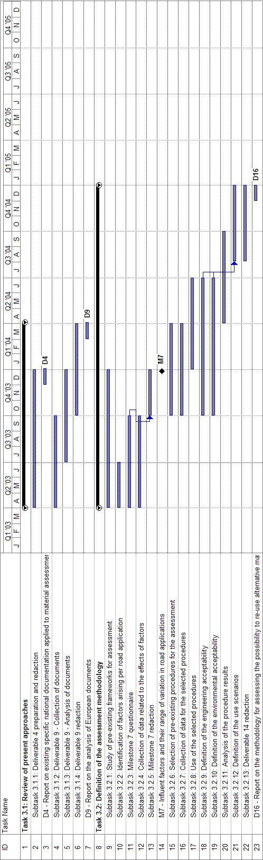
Figure A.6: Detailed overview of tasks to be completed in WP 3
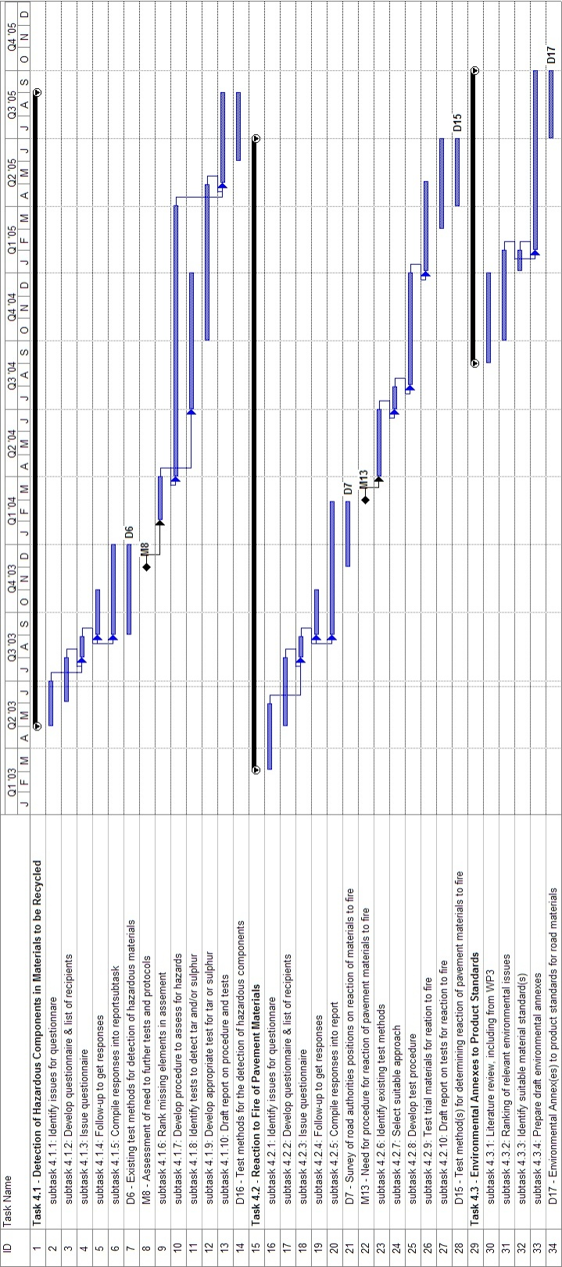
Figure A.7: Detailed overview of tasks to be completed in WP 4
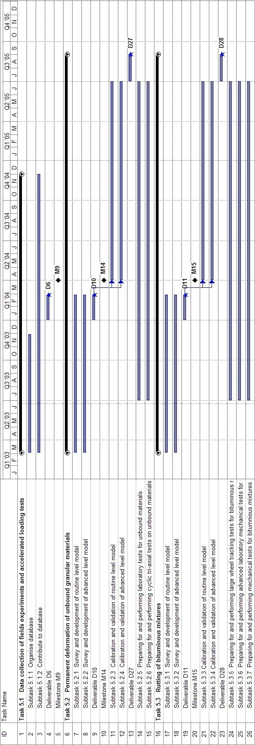
Figure A.8: Detailed overview of tasks to be completed in WP 5
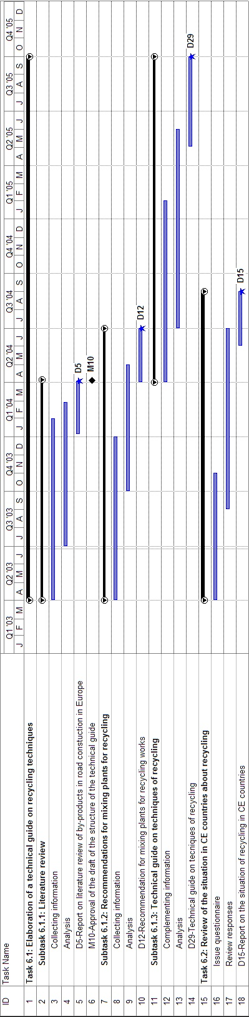
Figure A.9: Detailed overview of tasks to be completed in WP 6
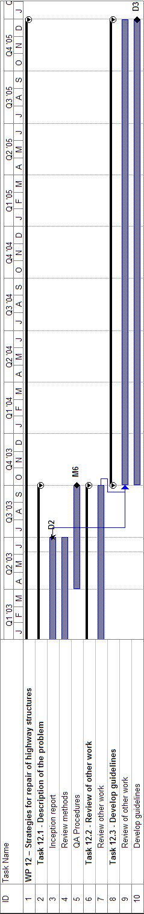
Figure A.10: Detailed overview of tasks to be completed in WP 12
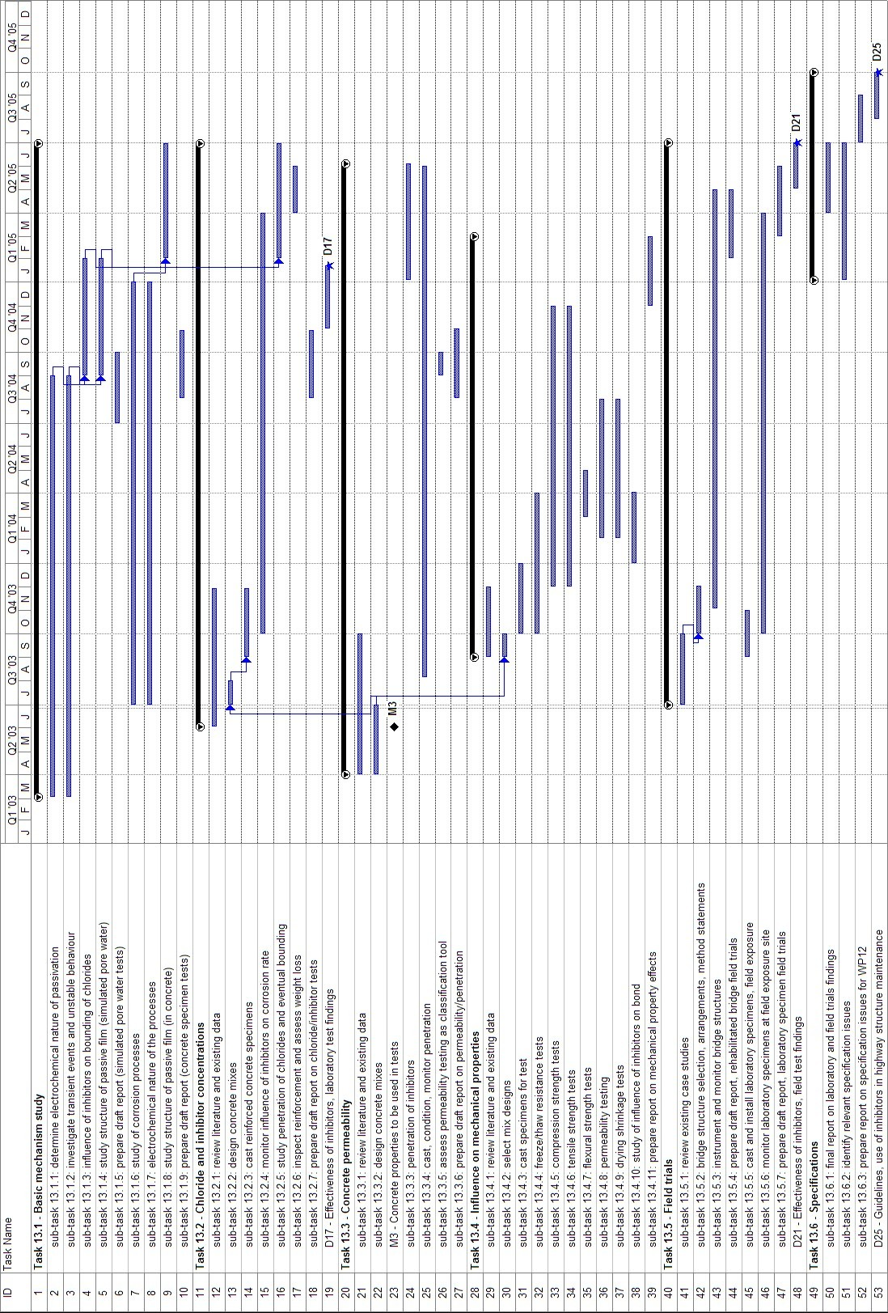
Figure A.11: Detailed overview of tasks to be completed in WP 13
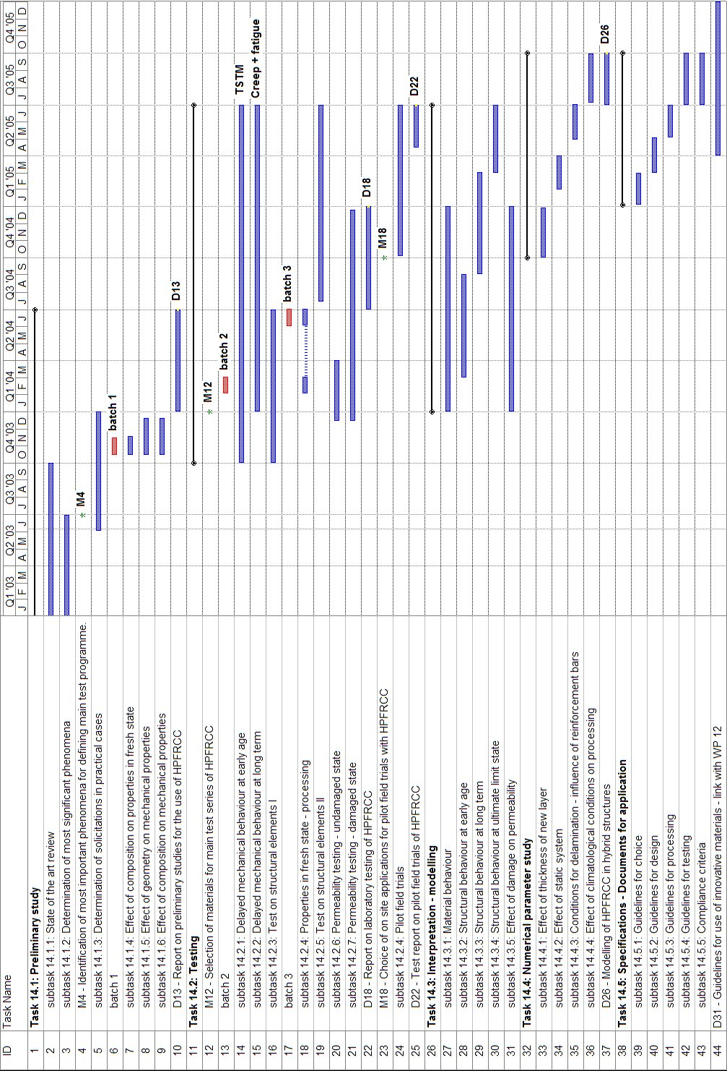
Figure A.12: Detailed overview of tasks to be completed in WP 14
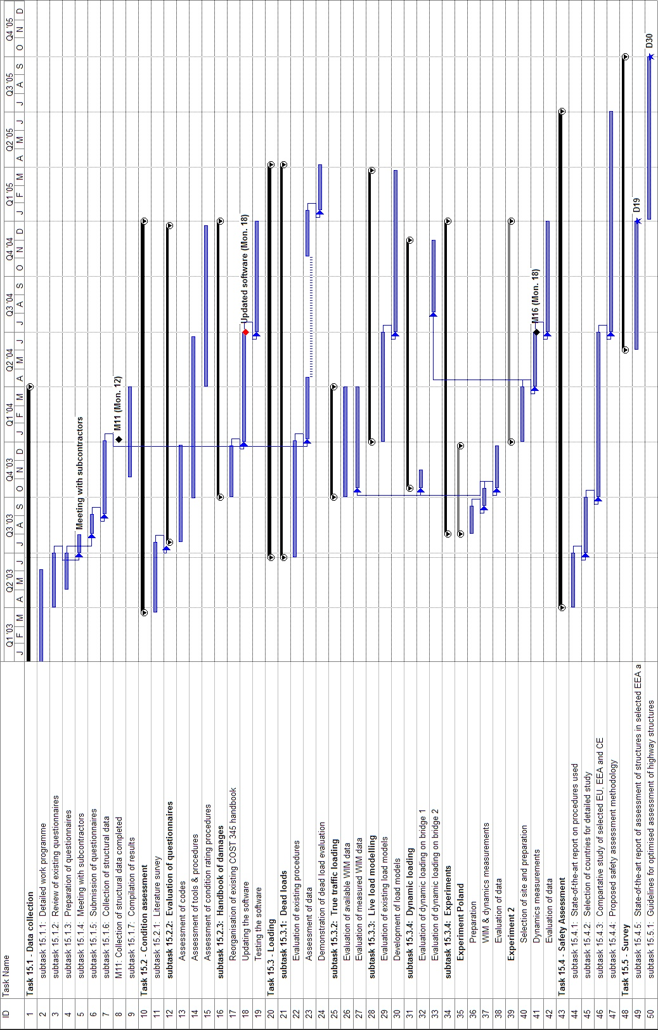
Figure A.13: Detailed overview of tasks to be completed in WP 15

? Some general considerations of the programme below will be valid for both granular materials and bituminous materials. Mechanical models generally include 2 steps: - To formulate constitutive behaviour for materials at the local level - To solve the structural problem at global scale, taking into account the cinematic, stress equilibrium and constitutive equations, as well as the boundary conditions (load, imposed displacements).The considerations below refer to these two aspects.

